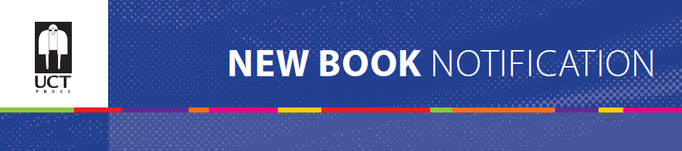
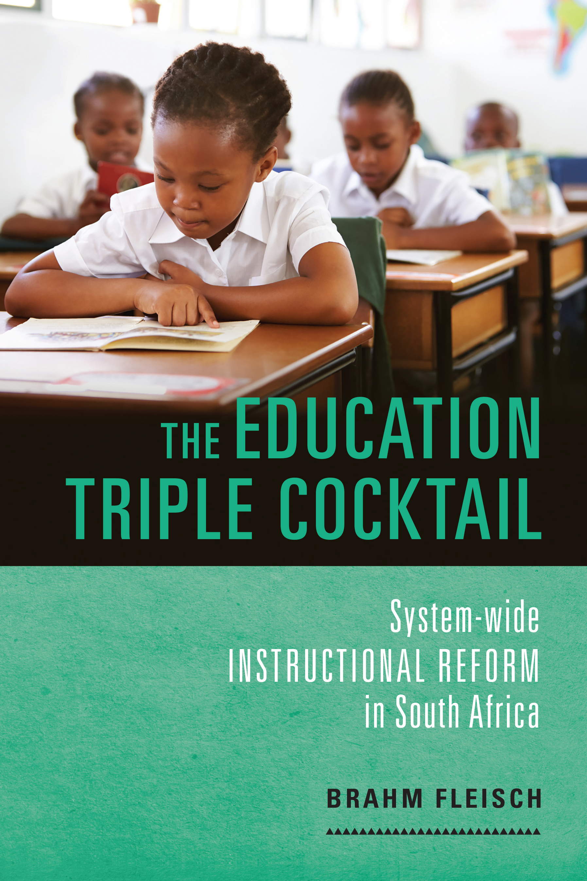
The Education Triple Cocktail
System-wide instructional reform in South Africa
Author: Brahm Fleisch
ISBN: 9781775822462 (print)
9781775822479 (webpdf)
Size: 245 x 168mm
Extent: 180 pages
Format: Soft cover
Pub date: July 2018
BISAC: EDU037000
BIC: JN
THEMA: JNDG
Recommended Retail Price: R315 (incl. VAT)

The Education Triple Cocktail: System-wide Instructional Reform in South Africa brings together rigorous quantitative and qualitative research on a new approach to improving foundational teaching and learning for primary schoolchildren who are being educated in working-class urban areas and rural communities in resource-constrained systems like South Africa. At the core is the theory and evidence for a powerful new interlocking and mutually reinforcing change model. Inspired by the AIDS treatment story, the approach brings together structured daily lesson plans, high-quality and appropriate educational materials, and one-on-one instructional coaching to help teachers transform their instructional practices in early grade classrooms and thereby improve learning outcomes. For education systems defined by low levels of early grade learning and profoundly unequal outcomes, The Education Triple Cocktail offers a theoretically informed, evidence-based way forward.

CONTENTS
Chapter 1: Introduction

Chapter 2: Not achieved
Introduction
New evidence of the bimodal pattern of achievement
Reading progress and the PIRLS 2006, 2011 and 2016
Reports of the National Education Evaluation and Development Unit
Annual National Assessments
Reading Catch-Up Programme
Conclusion

Chapter 3: Why policy fails, and the pivot to instruction
Introduction
Policy interventions
Beyond input-output and school effectiveness models
Instruction
Systems of instruction
Instruction in systems
Conclusion

Chapter 4: Practices of literacy teaching
Introduction
Two instructional practices in literacy teaching
Choral reading aloud as the instructional core
Systematic reading instruction
Conclusion

Chapter 5: Learning from research
Introduction
READ
Molteno
CLE literacy intervention
Reading is FUNdamental
Family Literacy Project
Additive Bilingual Education Project
Systematic Method for Reading Success (SMRS
Conclusion.

Chapter 6: Change at the instructional core
Introduction
What the research literature tells us about system-wide reform
The instructional turn
The education triple cocktail
Conclusion

Chapter 7: The Reading Catch-Up Programme: a case study of
change at the instructional core
Introduction
The Intersen Catch-Up Programme
Teachers’ talk
Evaluation
Conclusion

Chapter 8: Compelling evidence
Introduction
What the international literature tells us
GPLMS
The Pinetown Study
The Early Grade Reading Study
Conclusion: What we know

Chapter 9: Conclusion.
Change is not an event, it is a journey
R&D and the triple cocktail components
Policy
Leadership

Bibliography
Index

Recommended for
Scholars, researchers, policy-makers, NGOs, practising teachers and schools and departments of education. It will also be of interest to those interested in systemic evaluations, literacy development and curriculum, as well as parents of primary school children.

About the author
Brahm Fleisch is Professor of Education Policy in the Division of Education Leadership, Policy and Skills at the University of the Witwatersrand, Johannesburg. His books include: Primary Education in Crisis: Why South African Schoolchildren Underachieve in Reading and Mathematics (Juta: 2008) and, (co-authored with Stu Woolman), The Constitution in the Classroom: Law and Education in South Africa, 1994-2008 (Pretoria University Law Press, 2009). His current research and professional work focus on successful system-wide instructional reform. Since 2010, Brahm has served as the advisor of the Gauteng Department of Education and National Education Collaboration Trust.

