

**Accounting for All 3e**

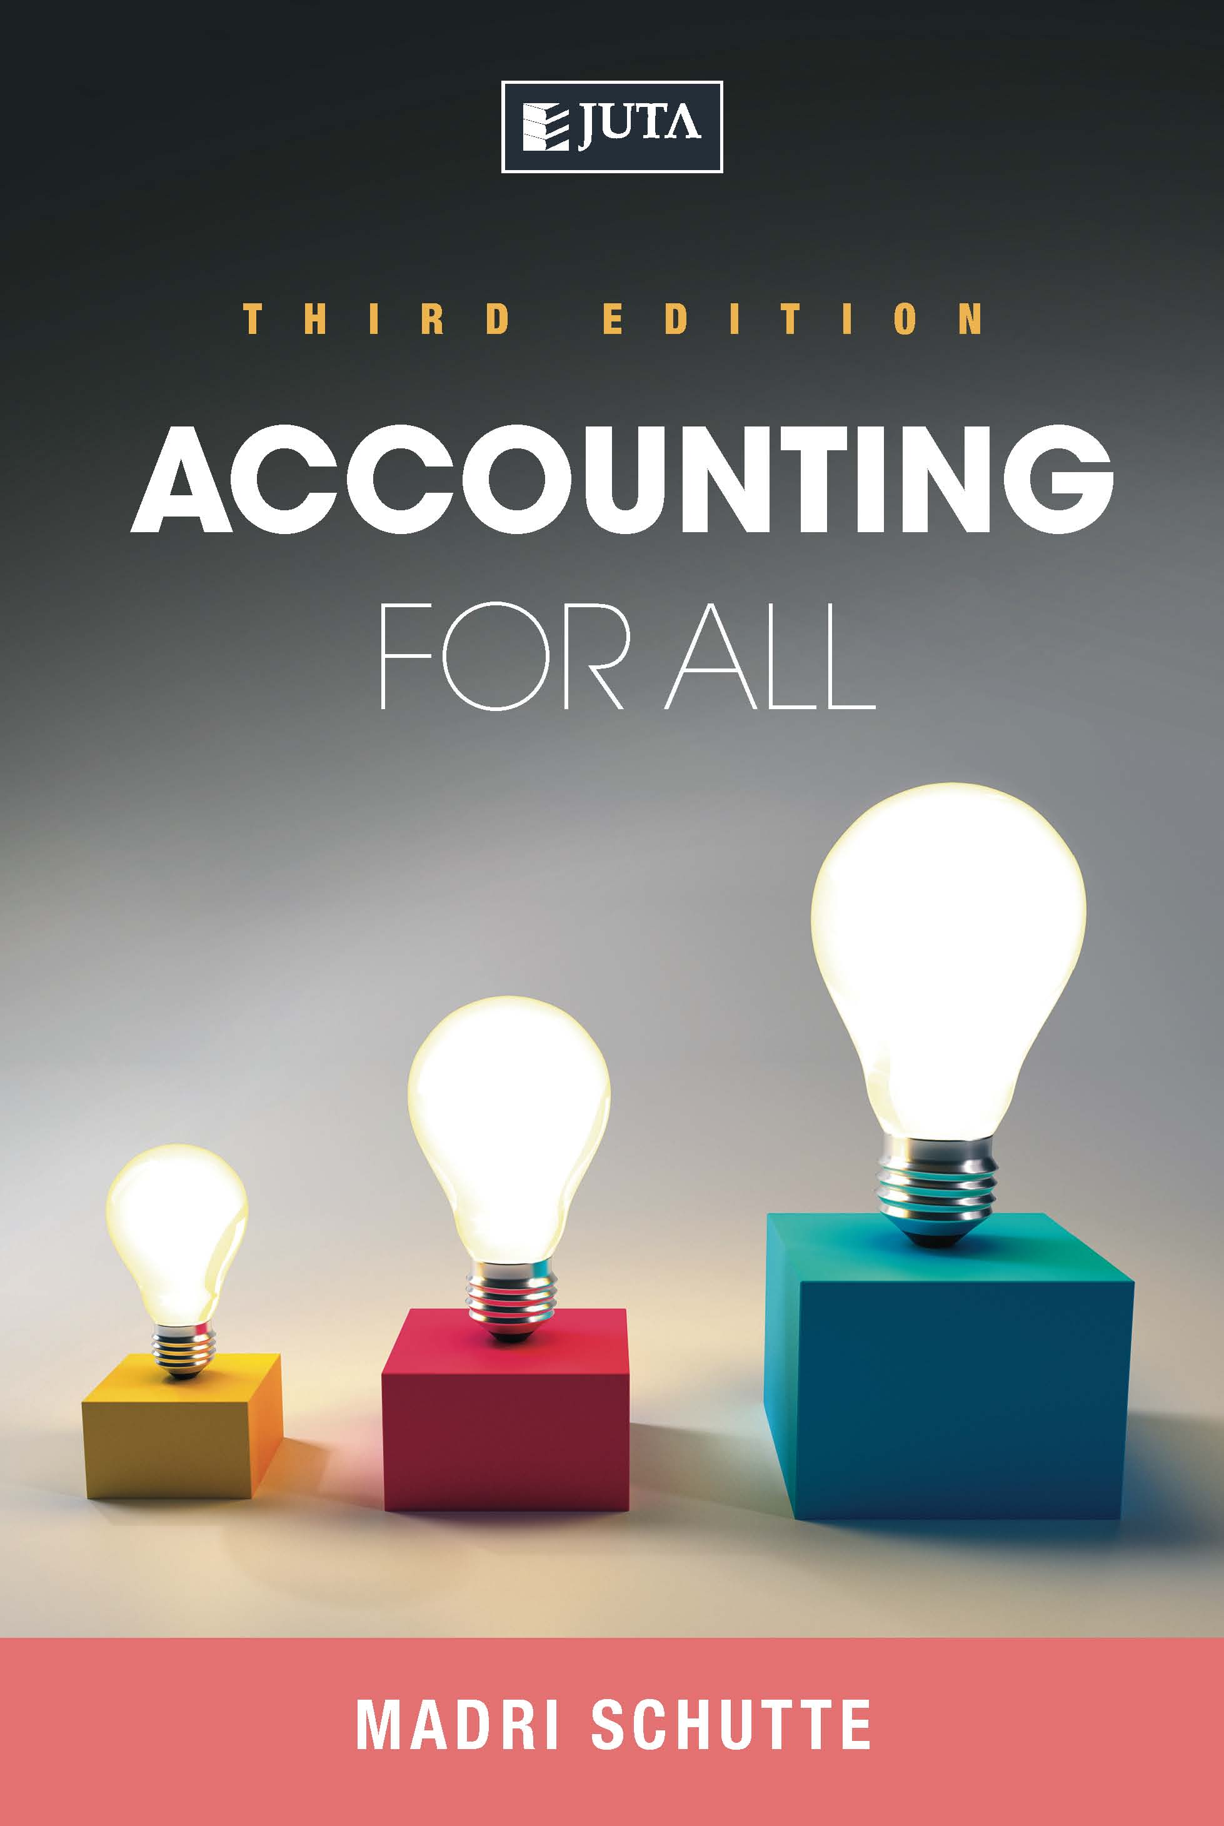

**Edition: 3rd Edition**

**Published: 9/25/2018**

**Author/Editors:** Madri Schutte

**ISBN:** 9781485129745

**eISBN:** 9781485129752

**Format: Softcover**

**Extent: 680 pages**

**Retail price: R589.00** (incl. VAT, excl. delivery.) WebPDF R550

***Accounting for All* 3rd edition aims to help students master introductory accounting courses, and covers the key topics in the financial accounting and cost accounting disciplines.**

**Now updated, it has been further enhanced by two new topics - partnerships and non-profit organisations (NPOs) - giving students a broader coverage of the business environment.**

**Contents:**

1. Basic concepts in accountancy – accounting processs
2. Business transactions and source documents
3. Recording transactions (double-entry system)
4. Introduction to VAT
5. Books of prime entry
6. Bank reconciliation statement
7. The trial balance
8. Non-current assets – depreciation
9. Inventory
10. Year-end adjustments
11. Financial statements of a sole trader
12. Financial statements of companies
13. Partnerships
14. Statement of cash flow
15. Partnerships
16. Non-profit organisations
17. Interpretation of financial statements
18. Basic cost accounting
19. Manufacturing concern
20. Cost behaviour
21. Budgets
22. Cost-volume-profit analysis
23. Payroll
24. Business ethics

**Key Features:**

The study of accounting is often perceived as daunting, but the author has written in an easy-to-understand style. The teaching methodology takes a step-by-step approach, and is supported by extensive explanatory examples and revision questions. It also enables students to work through each chapter independently.

**Support Material:**

Lecturer support material is made available to prescribing institutions.

**Recommended for:**

*Accounting for All* will benefit any student who does not have an accounting background but needs a fundamental understanding of the financial and cost accounting principles and concepts as they apply to the world of business.

**About the editors:**

Madri Schutte has a Phd. in Business Management. She is currently a full-time lecturer at the Tshwane University of Technology (TUT), where she teaches Accounting for Personnel Practitioners as well as Industrial Accounting for Engineers.

She has lectured extensively on MBA cost accounting, as well as other financial accounting and cost accounting service modules, and has written other financial accounting and cost accounting textbooks. She has spent more than 25 years in private practice and is a member of the South African Institute of Professional Accountants (SAIPA).