

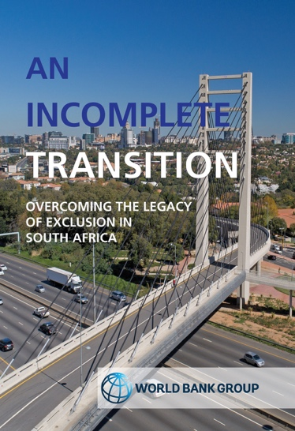
An Incomplete Transition
Overcoming the legacy of exclusion in South Africa

Edition: 1
Published: May 14, 2018
Editors: The World Bank Group
ISBN: 9781775822639 (print)
9781775822660 (web pdf)
Format: Soft Cover
Extent: 202 pages
Retail price: R250,00 / $23,00
BIC: KCG; KCM
BISAC: BUS068000
THEMA: KCG; KCM; 1HFM

Website Link: An Incomplete Transition
Video: Discussion of some of the main topics covered in the book. Please click here.
To order online visit www.juta.co.za or contact a customer service agent on 021 659 2300
In preparation for its 2019-2022 Country Partnership Framework with South Africa, the World Bank Group has drafted a Systematic Country Diagnostic (SCD) which forms the basis of this book. Its aim is to strengthen understanding of the constraints in achieving two goals in South Africa: to eliminate poverty by 2030, and to boost shared prosperity. These goals are enshrined in South Africa’s Vision 2030 in the National Development Plan. This book is the result of consultations and conversations with key government departments, the National Planning Commission, the private sector, academics and trade unions. It identifies five broad policy priorities: to build South Africa’s skills base; to reduce the highly skewed distribution of land and productive assets; to increase competitiveness and the country’s participation in global and regional value chains; to overcome apartheid spatial patterns; and to increase the country’s strategic adaptation to climate change. The key obstacle to growth that has been identified is ‘the legacy of exclusion’. Undoing this is a long-term process, but renewed commitment by the political leadership to strengthen institutions and rebuild the social contract present an enormous opportunity in achieving progress towards South Africa’s Vision 2030.
CONTENTS
Abbreviations and acronyms
List of tables, figures, boxes and CGEs
Executive summary

Chapter 1: An incomplete transition: poverty, inequality, and the legacy of exclusion in South Africa
1.1. A history of exclusion in South Africa
1.2. Exclusion in land markets and restrictions to free movement
1.3. Exclusion in labour markets
1.4. Exclusion in capital and product markets.
1.5. Progress since 1994 and poverty and inequality today
1.6. Overcoming exclusion and strengthening resilience to sustainably reduce poverty and inequality

Chapter 2: Resilience, economic growth, and jobs
2.1. Toward a more resilient and inclusive
2.2. Vulnerability and sustainability
2.2.1 Climate change and environmental sustainability
2.2.2. Social sustainability
2.2.3. Fiscal sustainability
2.2.4. External
2.2.5. Financial sustainability
2.3. Jobs to overcome exclusion and strengthen resilience
2.4. Economic growth for jobs and poverty reduction
2.4. Exclusion and investment
2.5. Exclusion, productivity, and competitiveness

Chapter 3: Employability, contestability, and competitiveness
3.1. Jobs to overcome
3.2. Employability
3.3. Contestability of labour markets
3.3. Contestability of product
3.4. Jobs in townships and the informal sector
3.5. Jobs in rural economies: agriculture, agribusiness, and sustainable tourism
3.6. Jobs from integrating into global value chains
3.7. Infrastructure for a competitive economy and

Chapter 4: State building for an inclusive transition
4.1. A capable government empowering South Africans
4.2. Strengthening accountability
4.3. Enhancing coordination, planning, monitoring, and evaluation
4.4. Strengthening government capacity and the civil service
4.5. Strengthening budget transparency and fiscal management
4.6. Strengthening governance of SOEs
4.7. Financing for the developmental state

Chapter 5: The World Bank Group’s view on priorities for reducing poverty and boosting shared prosperity
5.1. Toward greater inclusion
5.2. Root causes of poverty and inequality
5.3. The World Bank Group’s view on priorities for the twin goals
5.3. Governance constraints and low-hanging fruits for quick results

Annex 1: Consultations
Annex 3: The World Bank’s Computable General Equilibrium Model
Endnotes
Bibliography

Recommended for:
A general readership interested in South African Current Affairs, Economy and Economic Growth.

