

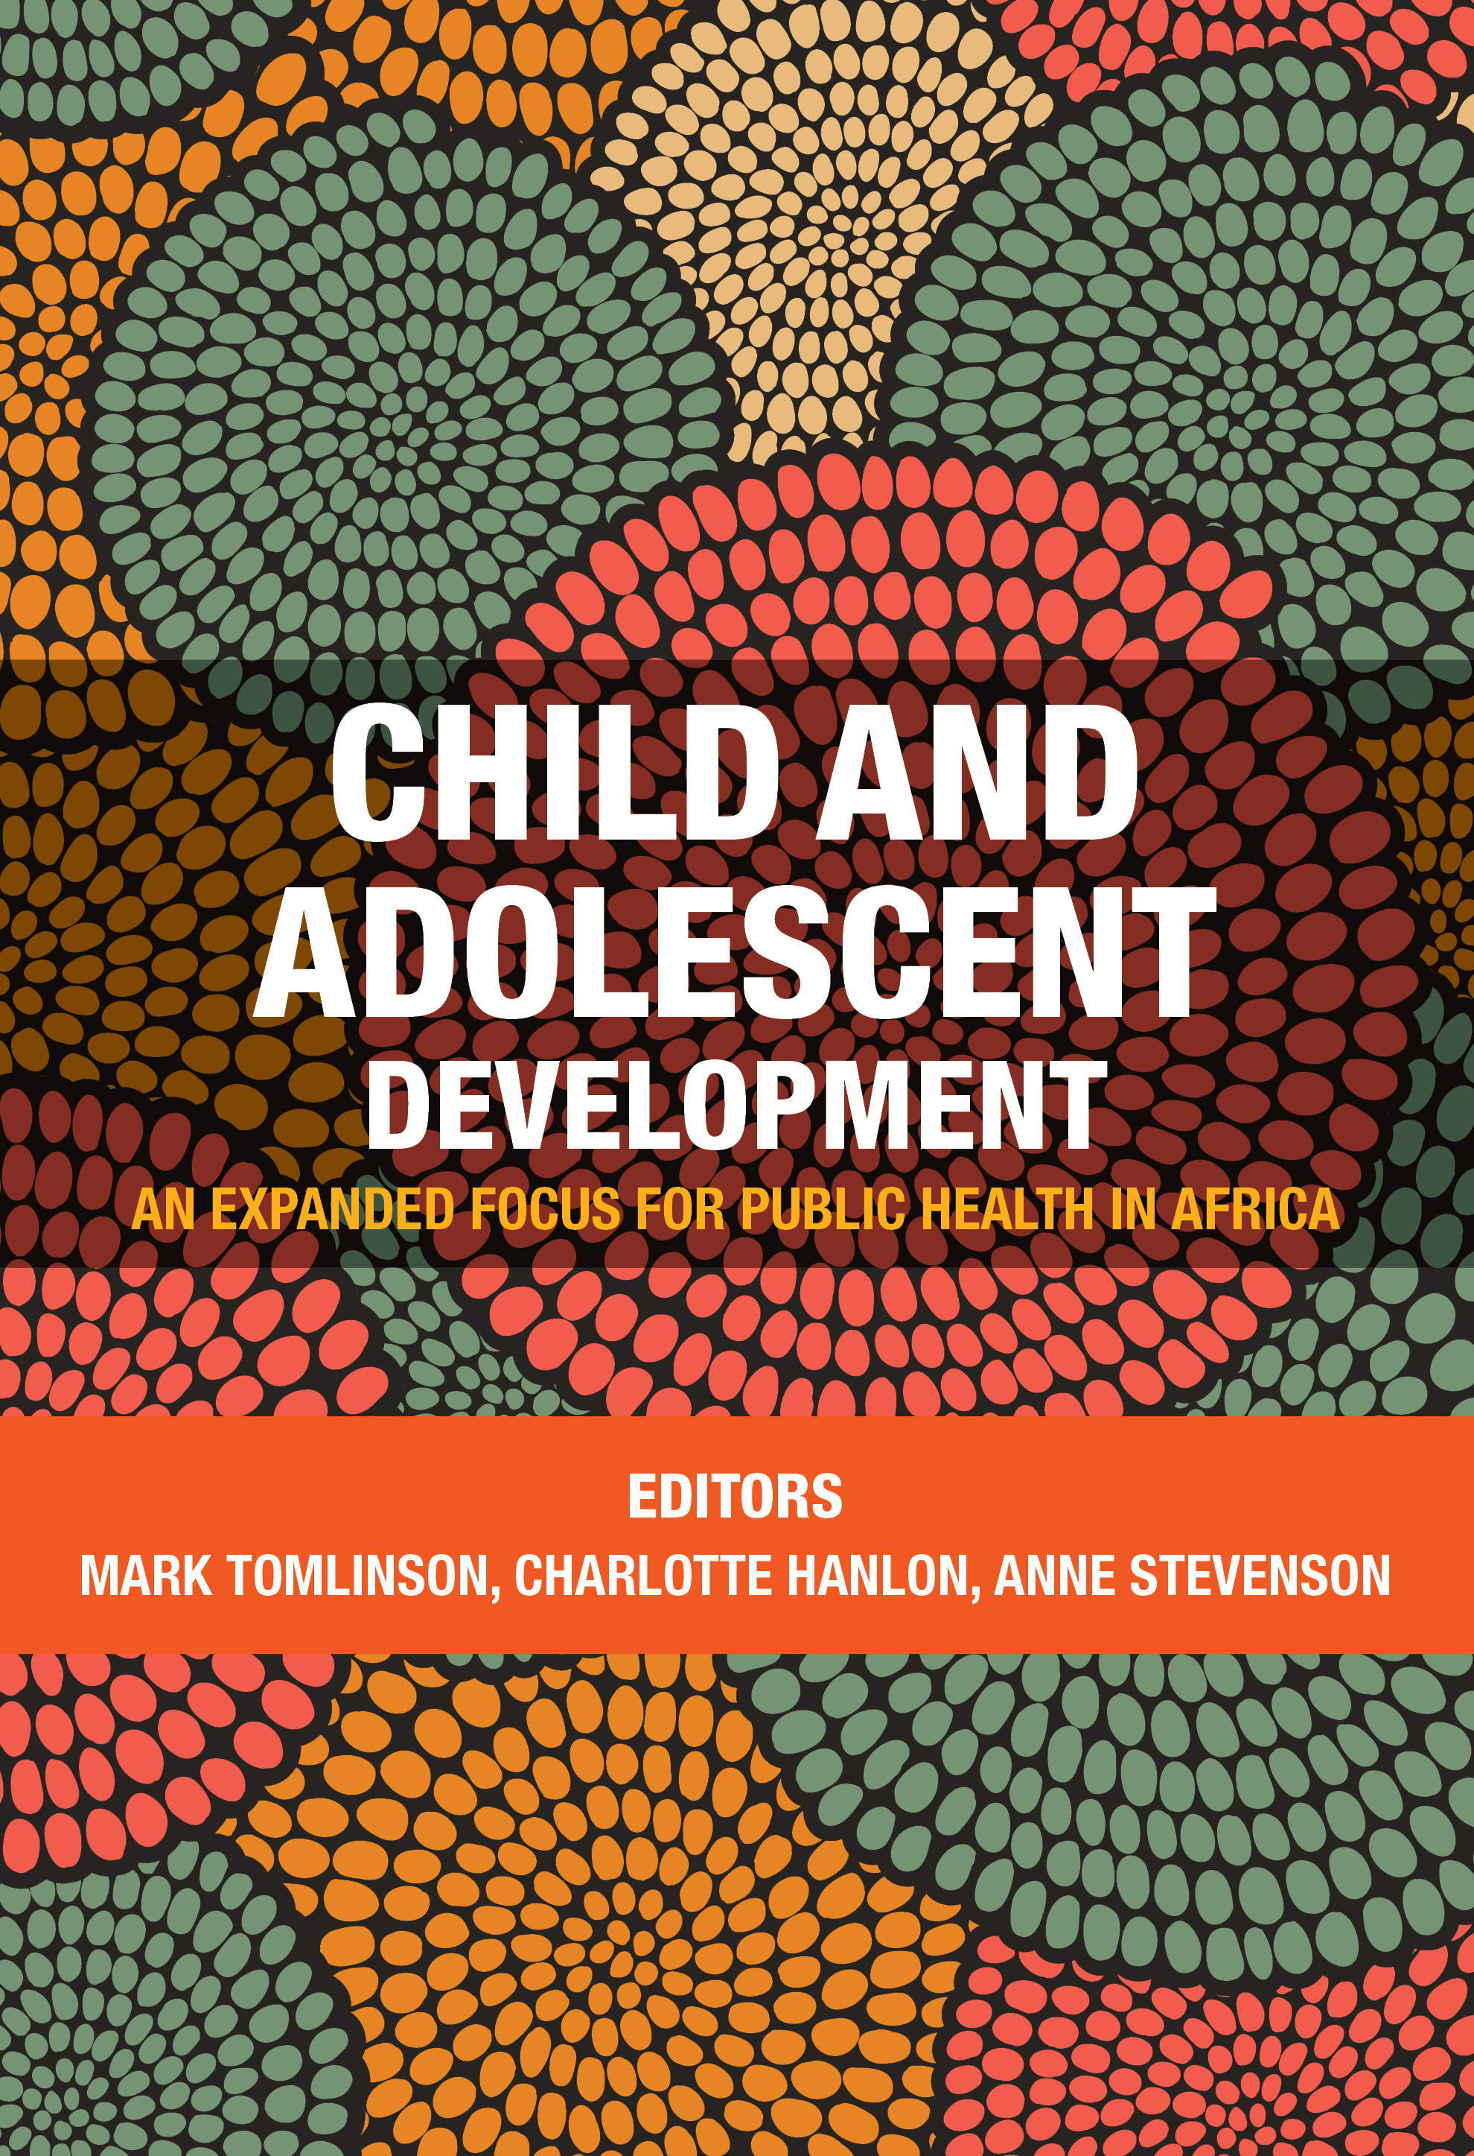
Child and Adolescent Development
An expanded focus for public health in Africa

Edition: 1
Published: April 4, 2018
Editors: M. Tomlinson, C. Hanlon, A. Stevenson
ISBN: 978-1-91989-551-2 (print)
978 1 77582 157 1 (web pdf)
978 1 77582 158 8 (mobi)
Format: Soft Cover
Extent: 360 pages
Retail price: R499,00
BIC: JMC
BISAC: PSY004000
THEMA: JMC, JMM

Global public health has improved vastly during the past 25 years, and especially in the survival of infants and young children. However, many of these children, particularly in Africa, continue to live in poverty and in unhealthy, unsupportive environments, and will not be able to meet their developmental potential. In other words, they will survive but not thrive. The UN’s Sustainable Development Goals (SDGs) stress sustainable development, not just survival and disease reduction, and the Global Strategy for Women’s, Children’s and Adolescents’ Health proposes a Survive (end preventable deaths), Thrive (ensure health and wellbeing) and Transform (expand enabling environments) agenda. For children to thrive they must make good developmental progress from birth until the end of adolescence.
Addressing the social determinants of developmental problems, this volume offers a broad, contextualised understanding of the factors that impact on children and adolescents in Africa. Unlike other works on the subject it is Africa-wide in its scope, with case studies in Ethiopia, Kenya, Malawi, Nigeria, Rwanda and South Africa. Covering mental health as well as physical and social development, it looks at policies and practice, culture and priorities for research, identifying challenges and proposing solutions.

CONTENTS
CHAPTER 1: Key issues affecting infant and child development in Africa - Mark Tomlinson (Stellenbosch University, South Africa), Charlotte Hanlon (Addis Ababa University, Ethiopia and King’s College, UK), and Anne Petersen (Harvard University, USA)
CHAPTER 2: Mental health policy in Africa: Gaps, needs and priorities for infants and children - Crick Lund (University of Cape Town, South Africa)
CHAPTER 3: Applying a mixed-methods model to planning and evaluating child mental health interventions in sub-Saharan Africa - Theresa Betancourt, Sarah Meyers-Ohki, Anne Stevenson (Harvard School of Public Health, François-Xavier Bagnoud Center for Health and Human Rights, USA); Christina Mushashi (Partners In Health, Rwanda)

CHAPTER 4: Culture and Attachment in Africa - Hiltrud Otto and Heidi Keller (University of Osnabrueck, Germany)

CHAPTER 5: The Nigerian adolescent: Perspectives on physical, mental, social growth and development - Olayinka O. Omigbodun, Tolulope T. Bella-Awusah (University of Ibadan, Nigeria)

CHAPTER 6: Infant and child development: Key considerations for a broad vision of health research - Jane Chege (World Vision International, Zambia), Jennifer Franz-Vasdeki (Independent Research Consultant, Geneva), Stefan Germann (World Vision International, Geneva and Nelson Mandela Metro University, South Africa), Mesfin Loha (World Vision East Africa Regional Office, Nairobi) and Thiago Luchesi (World Vision International, Geneva and Geneva Graduate Institute for International Development).
CHAPTER 7: Child development and HIV/AIDS in sub-Saharan Africa: Identifying challenges and planning solutions - Lucie Cluver, Mark Orkin, Mark Boyes (Oxford University, UK); Roshan Baban, Lebo Madisha
CHAPTER 8: Maternal depression and child development: Existing sub-Saharan Africa evidence and an Ethiopian example - Charlotte Hanlon (Addis Ababa University, Ethiopia and King’s College, UK)
CHAPTER 9: Childhood cognitive development and its correlates in sub-Saharan Africa: What should we be measuring in the context of urban poverty? - Penny Holding (International Centre for Behavioural Studies, Kenya); Jean Christophe Fotso, Patricia A. Elung’ata (African Population and Health Research Center, Nairobi, Kenya)
CHAPTER 10: The birth to twenty study - Linda Richter, Sara Naicker, Shane A Norris (HSRC and MRC/Wits Developmental Pathways for Health Research Unit)
CHAPTER 11: Malawi: Cultural conceptualisations of child development - Melissa Gladstone (University of Liverpool, UK), Mary Phiri (Sub-Saharan Africa Family Enrichment, Zambia)
CHAPTER 12: Infant Mental Health Research in Africa: Call for Action for Research in the Next Ten Years - Mark Tomlinson (Stellenbosch University, South Africa), Barak Morgan (University of Cape Town)
CHAPTER 13: Conclusions and the way forward - Anne Petersen (University of Michigan, USA), Peter Baguma (Uganda), Noel Malanda (Kenya).

Recommended for:
Academics, students and practitioners in psychology, including developmental psychology, child clinical psychology, developmental psychopathology, psychiatry, human ecology, and in schools of education. It will also be of interest to nurses and paediatricians, health workers and those interested in early childhood development.

About the editors:
Dr Mark Tomlinson is Associate Professor in the Department of Psychology at the University of Stellenbosch and is the Regional Editor (Africa) for the international journal Global: The Journal of Human Population Health and Development.
Dr Charlotte Hanlon is Associate Professor at Addis Ababa University, Ethiopia, and Clinical Senior Lecturer in Global Mental Health at King’s College, London. She is a member of the Royal College of Psychiatrists and sits on the Editorial Board of the Ethiopian Medical Journal. She has written numerous journal articles on the cultural aspects of measuring mental disorders, women’s mental health, mental health services and systems research, intervention trials, child mental health and development, non-communicable diseases and mental health.
Anne Stevenson is Programme Manager for the Chester M. Pierce, MD Division of Global Psychiatry at Massachusetts General Hospital, where she manages a portfolio of more than 10 international mental health studies and collaborations. She has extensive experience managing healthcare and research programmes in Boston, Rwanda, and Ghana.

