

**Questions on South African Tax**

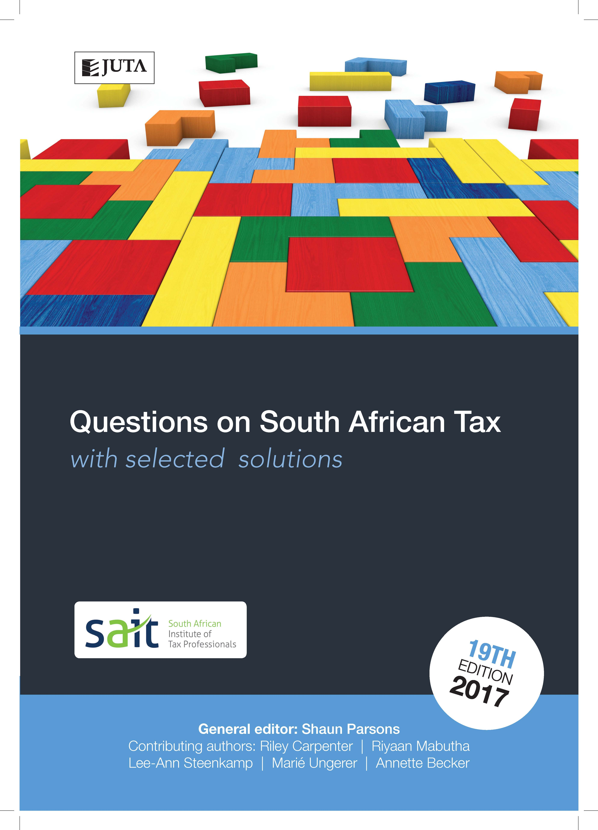

**with selected solutions**

**Edition: 19th edition**

**Published: 12 January 2018**

**Author/Editors:** **Parsons S**

**ISBN:** 9781485125266

**eISBN:** 9781485125341

**Format: Soft cover**

**Extent: 334** pages

**Retail price:** R335 (incl. VAT, excl. delivery.)

***Questions on SA Tax*** 19th edition is the second publication in the Questions on SA Tax series designed to provide comprehensive tutorial coverage to taxation students. This book covers foundational topics and those typically dealt with in the study of tax at an undergraduate level.

This tutorial book includes questions and selected solutions on South African income tax, estate duty and value-added tax. Up-to-date questions are graded, allowing students to develop their abilities from an introductory to an advanced level.

A selection of tutorial solutions is included in the book, and solutions to all questions are provided to lecturers at prescribing institutions. Mark plans are allocated to solutions.

**Contents**

Chapter 1: Gross Income

Chapter 2: Exempt Income

Chapter 3: General Deduction Formula

Chapter 4: Other Deductions

Chapter 5: Capital Allowances and Recoupments

Chapter 6: Trading Stock

Chapter 7: Individuals

Chapter 8: Fringe Benefits, Allowances and Share Gains

Chapter 9: Employees’ Tax

Chapter 10: Capital Gains Tax

Chapter 11: Donations Tax and Estate Duty

Chapter 12: Value-Added Tax

Chapter 13: Integrated Questions

**Recommended for:**

Undergraduate taxation students at universities, universities of technology and private HE institutions undertaking their first year of tax study.