

**Introductory Questions on South African Tax**

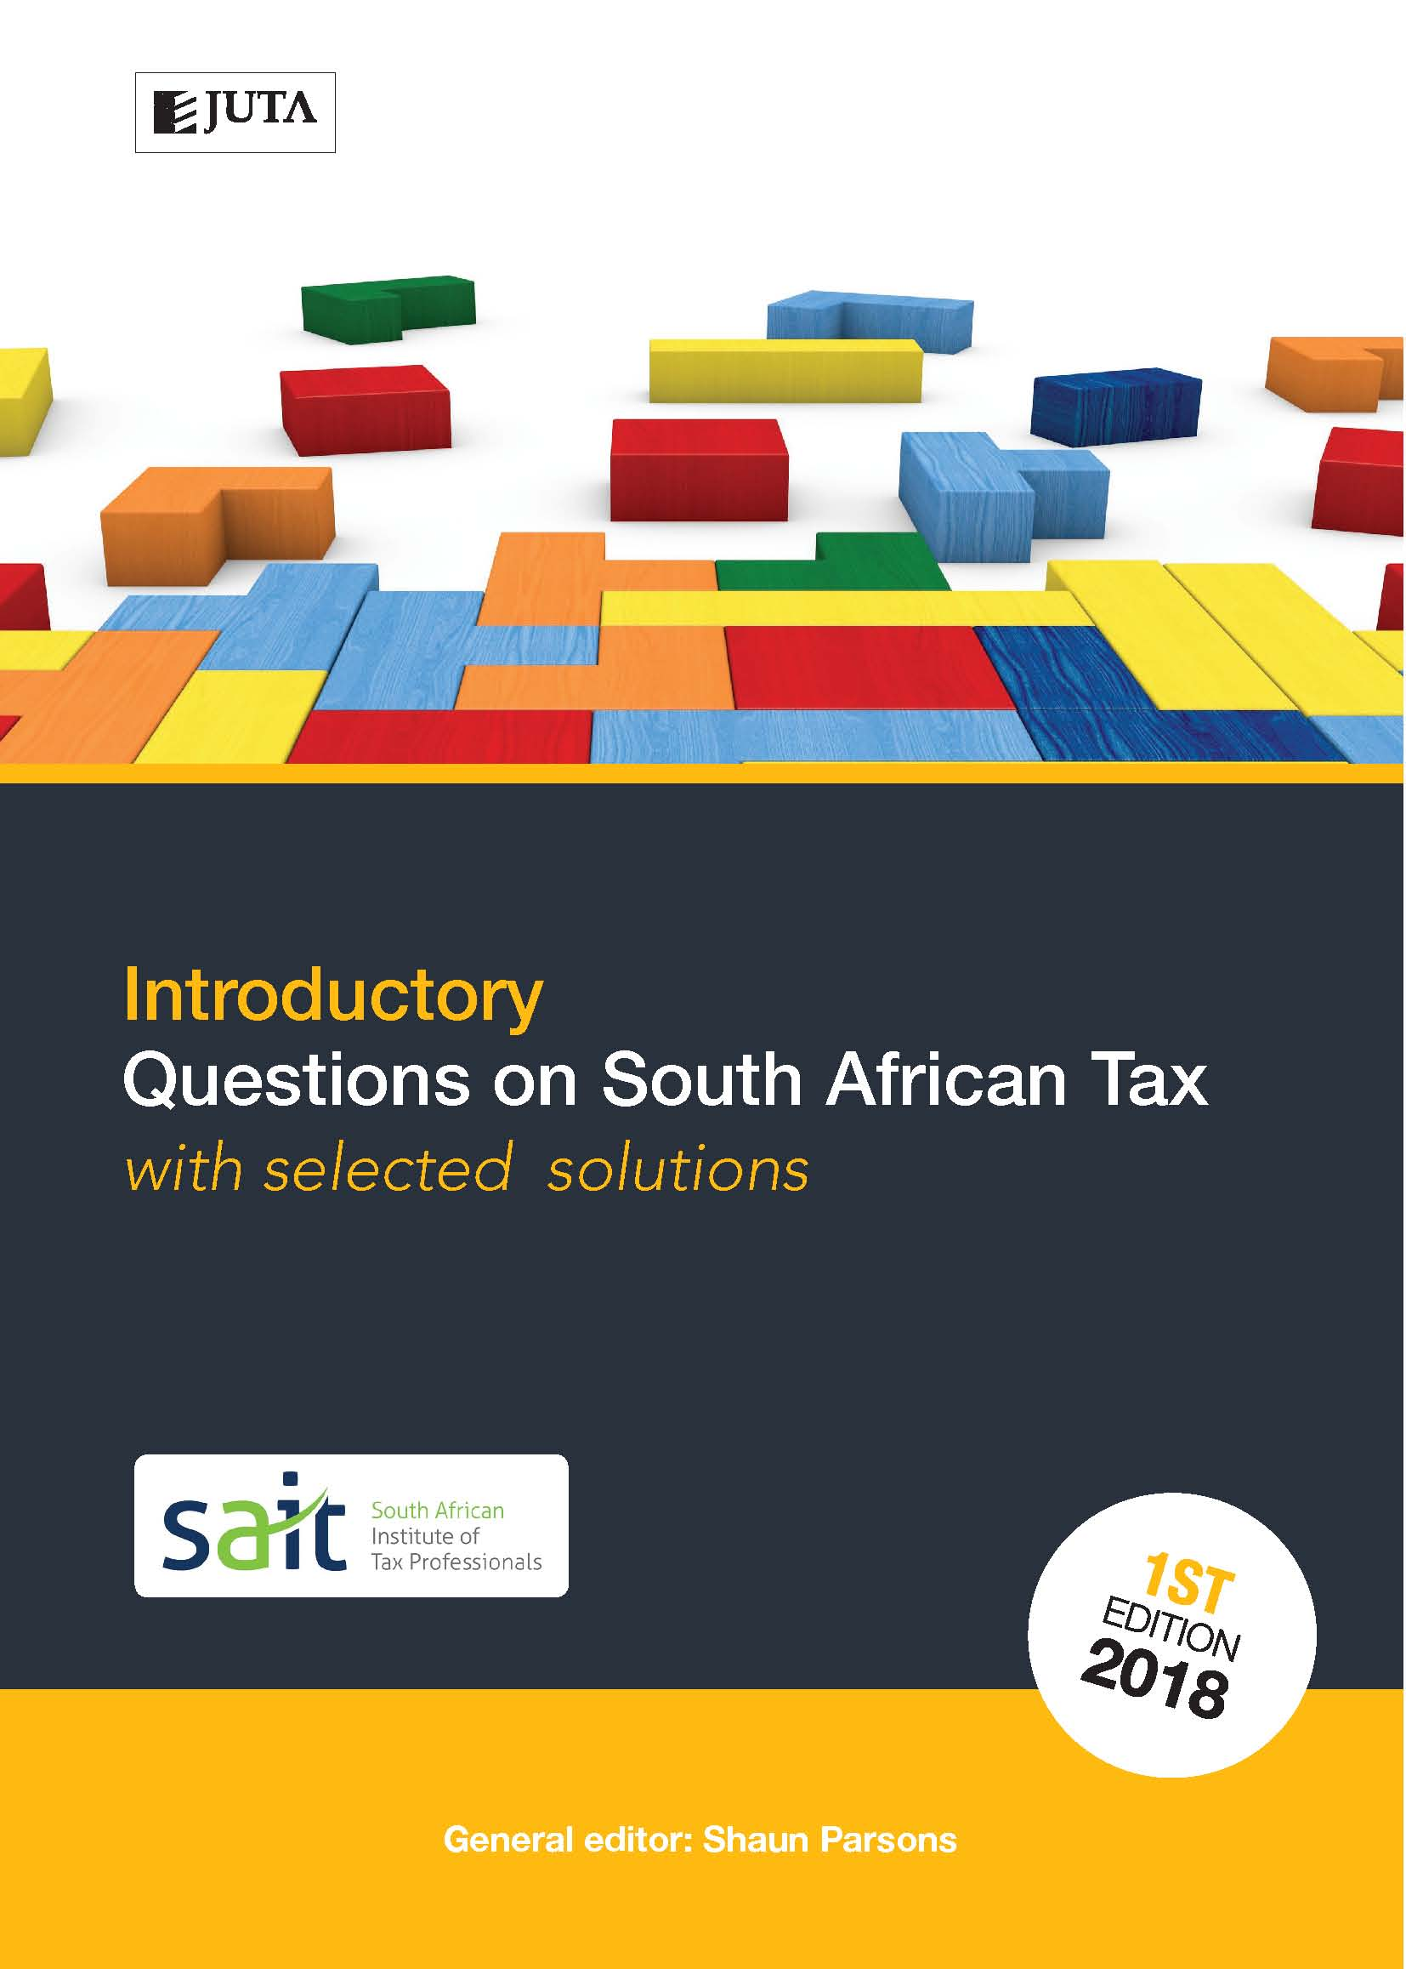

**with selected solutions**

**Edition: 1st edition**

**Published:** 10 January 2018

**Author/Editors:** Mabutha M, Singh D

**ISBN:** 9781485125280

**eISBN:** 9781485125365

**Format:** Soft cover

**Extent:** Approx 250

**Retail price:** TBC (incl. VAT, excl. delivery.)

***Introductory Questions on SA Tax*** is the first of three publications in the Questions on SA Tax series designed to provide comprehensive tutorial coverage to taxation students. This book covers foundational topics typically dealt with in the first year of the study of tax at an undergraduate level.

This tutorial book includes questions and selected solutions on South African income tax and value-added tax. Up-to-date questions are graded, allowing students to develop their abilities at an introductory level.

A selection of tutorial solutions is included in the book, and solutions to all questions are provided to lecturers at prescribing institutions. Mark plans are allocated to solutions.

**Contents:**

Chapter 1: Introduction to Taxation

Chapter 2: Gross Income

Chapter 3: Specific Inclusion and Exemptions

Chapter 4 General Deductions

Chapter 5: Special Deductions

Chapter 6: Trading Stock and Capital Allowances

Chapter 7: Capital Gains Tax

Chapter 8: Individuals

Chapter 9: VAT

Chapter 10: Integrated Questions

**Recommended for:**

Undergraduate taxation students at universities, universities of technology and private HE institutions undertaking their first year of tax study.