

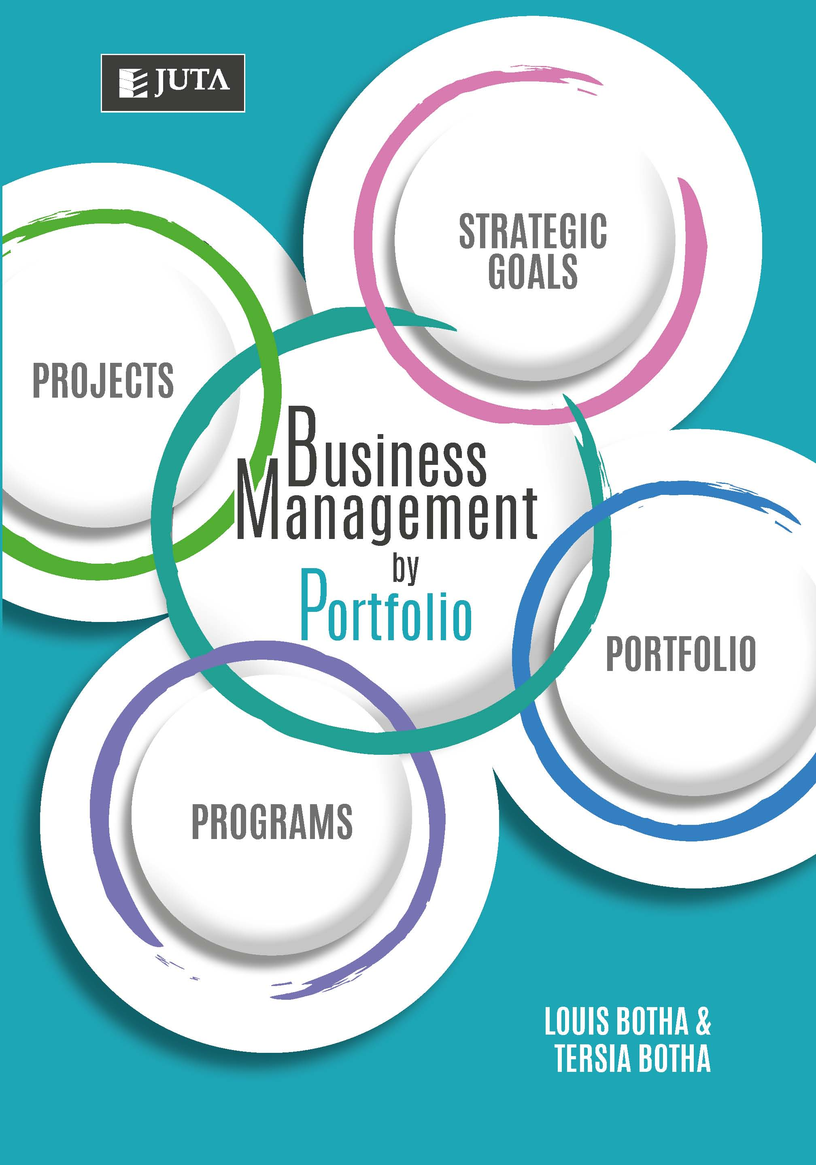

**Business Management by Portfolio**

**Edition: 1st edition**

**Published: 22 December 2017**

**Author/Editors:** Botha L, Botha T

**ISBN:** 9781485125167

**Format: Soft cover**

**Extent: 448 pages**

**Retail price:** R510 (incl. VAT, excl. delivery.)

**Website Link:** [Business Management by Portfolio](https://juta.co.za/products/business-management-by-portfolio-1e/)

**Business management, project management and portfolio management can prove challenging in any context, whether individually or collectively. The first textbook to integrate general management and project portfolio management, Business Management by Portfolio explains the science behind these concepts. It also explains how this approach results in a people-oriented philosophy which attracts (and maintains) talented, creative, and goal-oriented individuals in a dynamic environment because it offers ample opportunities for growth and self-actualisation.**

**Though many theories claim to incorporate efficiency alongside value-based leadership, current management theory and practice demand more. Business Management by Portfolio addresses additional management skills, which include: optimal resource- and risk-management, cost-effective strategy implementation, and customer satisfaction, while guiding readers through these concepts by means of relevant contemporary examples**

**Contents:**

**Chapter 1: Business Portfolio Management Framework**

**Chapter 2: Business Leadership, Management and Teamwork**

**Chapter 3: Business Planning by Portfolio**

**Chapter 4: Business Relationship Management by Portfolio**

**Chapter 5: Business Marketing Management by Portfolio**

**Chapter 6: Business Communication Management by Portfolio**

**Chapter 7: Estimation in Business Management by Portfolio**

**Chapter 8: Detail Business Planning by Portfolio**

**Chapter 9: Business Financial Management by Portfolio**

**Chapter 10: Business Risk Management by Portfolio**

**Chapter 11: Business Quality Management by Portfolio**

**Chapter 12: Business Procurement Management by Portfolio**

**Chapter 13: Business Information Management by Portfolio**

**Chapter 14: Managing Organisation Change**

**Chapter 15: Business Execution Management by Portfolio**

**Recommended for:**

**Whether you’re an experienced leader, management pundit or entrepreneur looking to better understand the structures, methodologies and practical incorporation of project management with general management theory, this highly anticipated text provides invaluable insight into an exemplary business philosophy geared toward creating successful organisations, making this unique, user-friendly, resource-filled manual an absolute must-have for Students of Business Management and professionals alike.**

**Key Benefits:**

* **Accessible and relatable definitions of theory and best practice**
* **Valuable diagrammatic representations of key concepts**
* **Easy-to-follow workflows which precede every chapter**
* **Useful templates that make practising Business Management by Portfolio easier**
* **Beneficial chapter summaries to aid revision**
* **A well-designed integrative case study which builds on knowledge throughout the text, and culminates in an illuminating example of real-world application.**

**About the editors:**

**Louis J Botha (Managing Director of Davis&Dean – an international rapid skills development company) and Tersia Botha (Associate Professor in the Department of Business Management at the Unisa) are experienced professionals and authors who have spent many years researching and applying a variety of methods in the fields of business and project management. As leading experts in the Business Management by Portfolio approach, their authoritative text is an invaluable addition to any manager’s bookshelf.**