

**Advanced Questions on South African Tax with selected solutions**

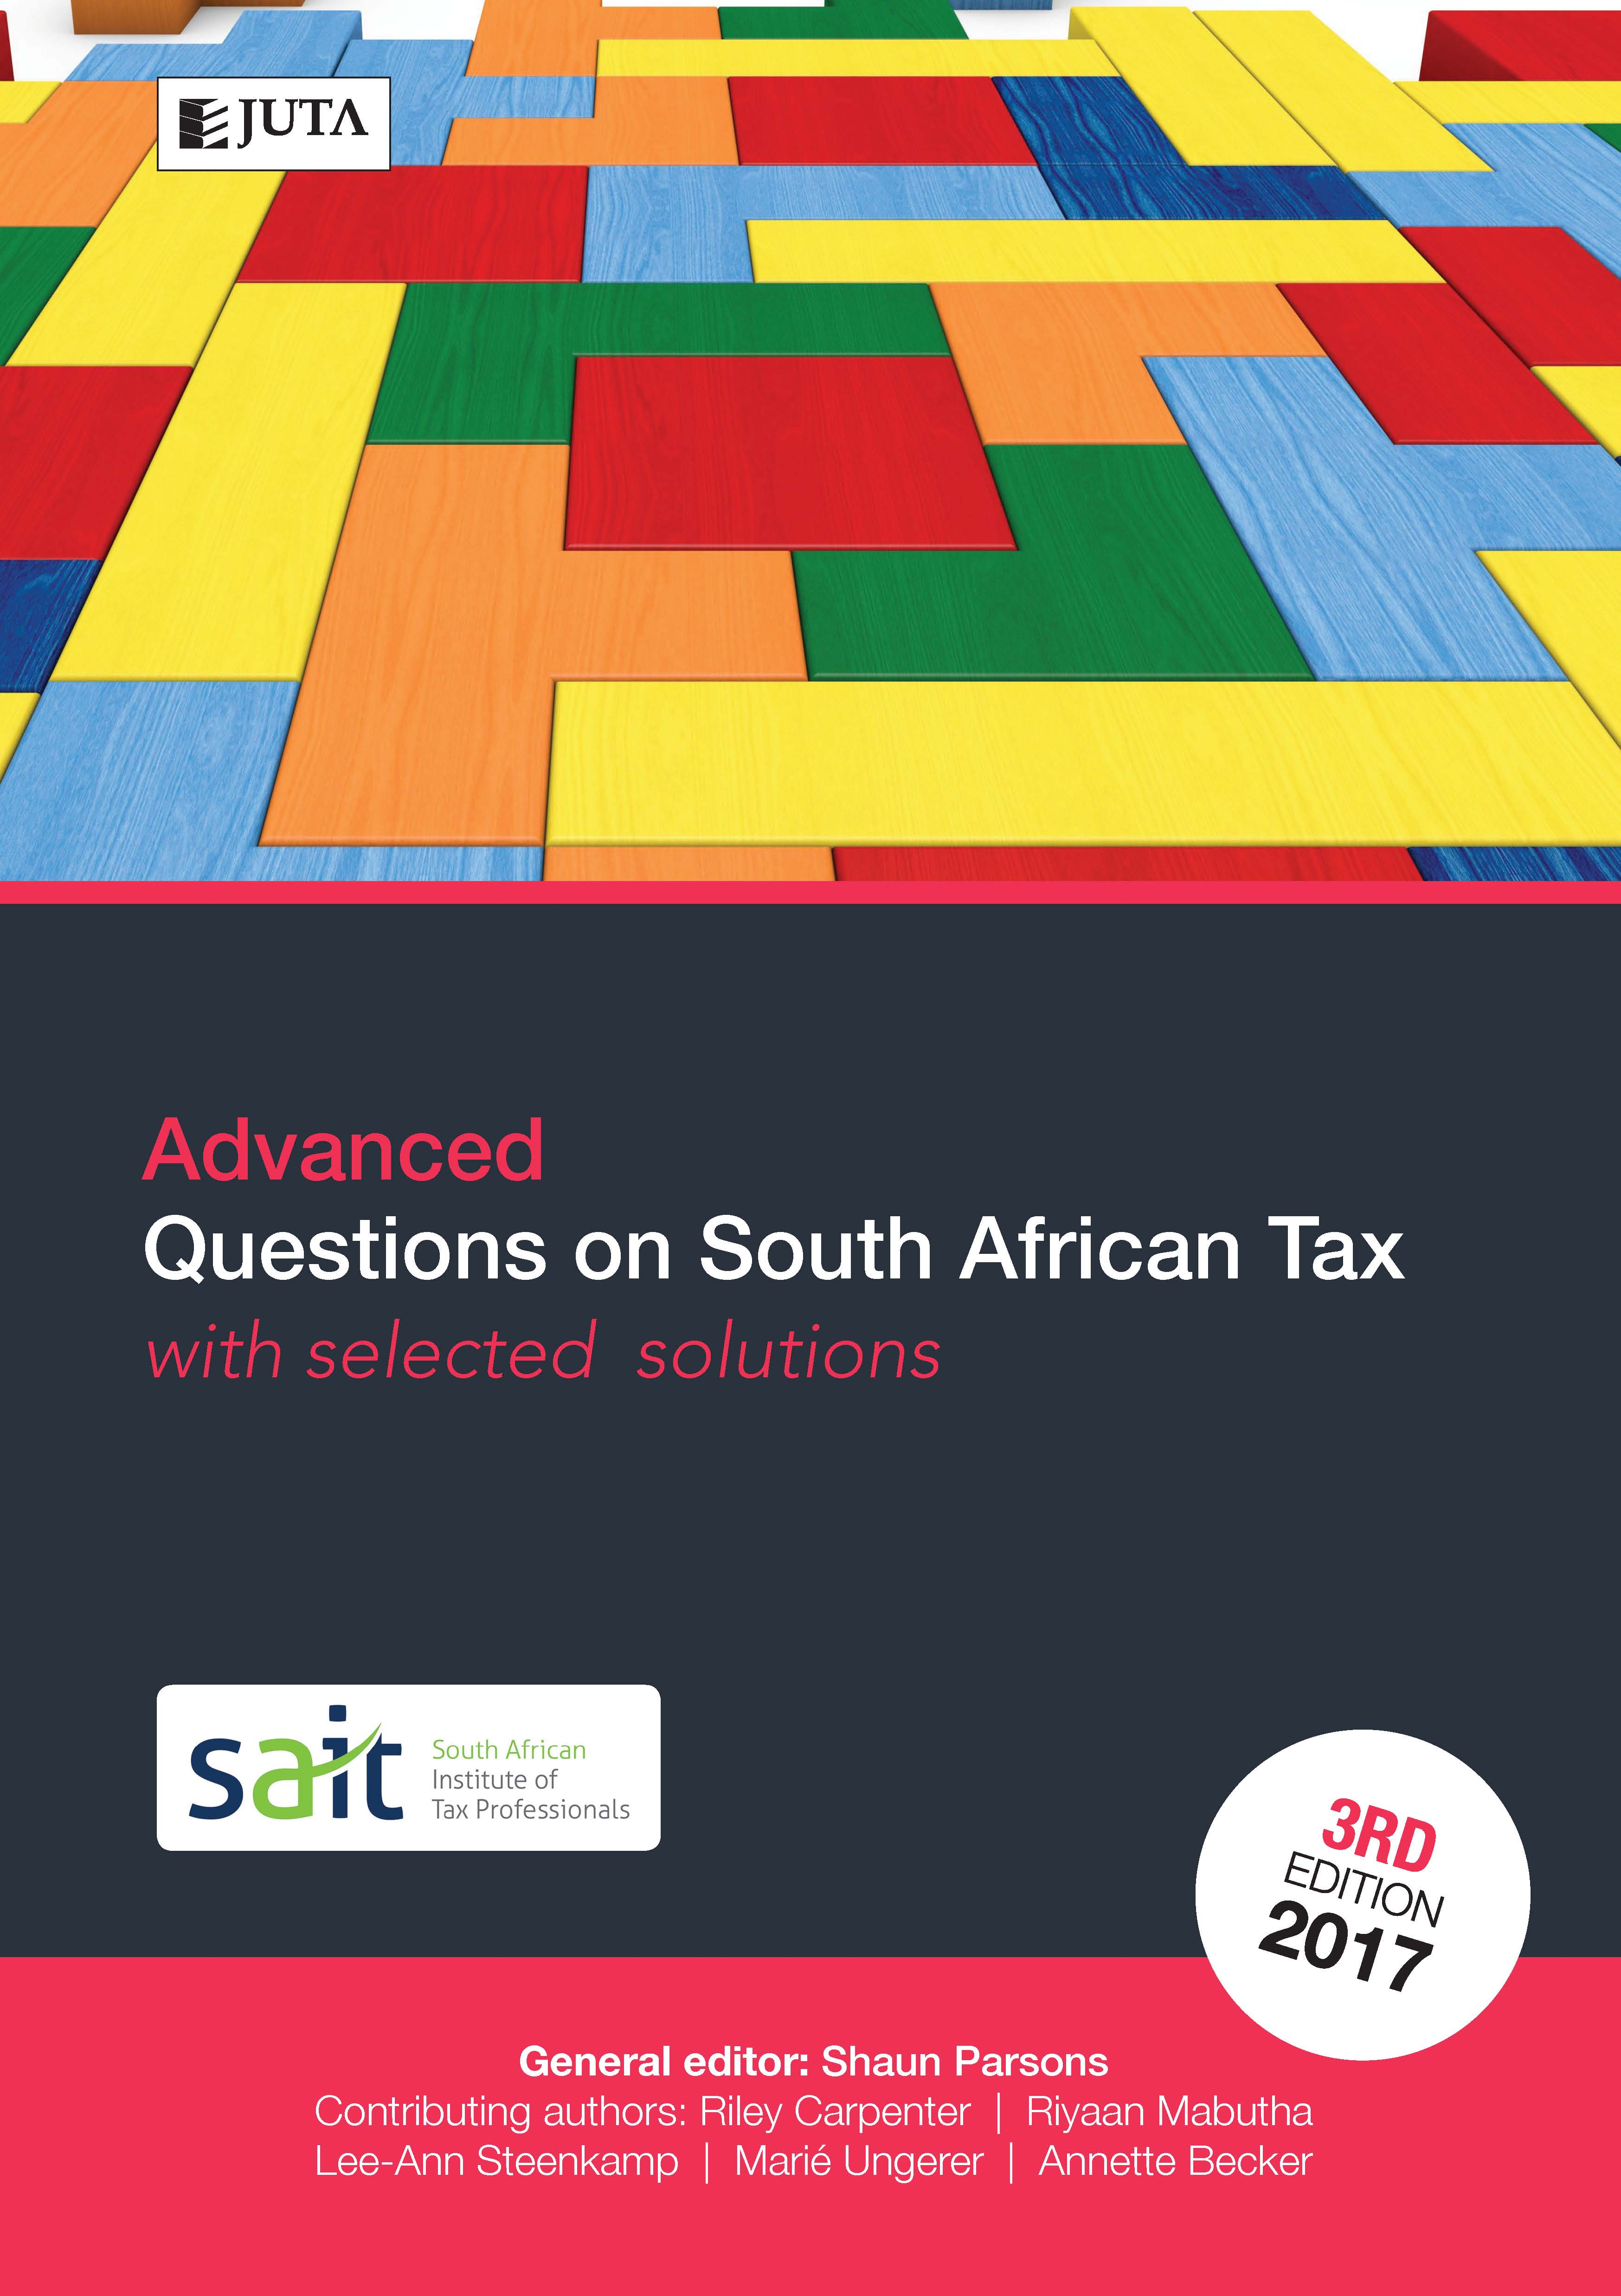

**Edition: 3rd edition**

**Published:** 10 Jan 2018

**Author/Editors:** Parsons S, Becker A, Carpenter R, Mabutha M, Steenkamp L, Ungerer M

**ISBN:** 9781485125273

**eISBN:** 9781485125358

**Format: Softcover**

**Extent: 365 pages**

**Retail price:** R335 (incl. VAT, excl. delivery.)

**Website Link:** [Advanced Questions on South African Tax 3e](https://juta.co.za/products/?filter_fields_dropdown=field_title&title=Advanced+Questions+on+South+African+Tax+&isbn=&authors__last_name=&year=&keyword)

***Advanced Questions on SA Tax*** 3rd edition is the third and final publication in the Question on SA Tax series designed to provide comprehensive tutorial coverage to taxation students. This book covers advanced topics and integrated questions. Its complementary publications, Introductory Questions on SA Tax and Questions on SA Tax, cover foundational topics and those typically dealt with in the study of tax at an undergraduate level.

This tutorial book includes questions and selected solutions on South African income tax, estate duty and value-added tax. Up-to-date questions are graded, allowing students to develop their abilities from an introductory to an advanced level.

A selection of tutorial solutions is included in the book, and solutions to all questions are provided to lecturers at prescribing institutions. Mark plans are allocated to solutions.

**Contents**

Chapter 1: Capital allowance and recoupments

Chapter 2: Assessed losses and debt reduction

Chapter 3: Financial instruments

Chapter 4: Dividends, foreign dividends and dividends tax

Chapter 5: Fringe benefits, allowances and share gains

Chapter 6: Employees tax and provisional tax

Chapter 7: Retirement benefits and planning

Chapter 8: Investment income – residents and non-residents

Chapter 9: Capital gains tax

Chapter 10: Donations tax and estate duty

Chapter 11: Taxation of trusts and estates

Chapter 12: Estate planning

Chapter 13: Value-added tax

Chapter 14: Tax avoidance, administration, objection and appeal

Chapter 15: Integrated questions

Chapter 16: Foundations

**Recommended for:**

Post graduate taxation students at universities, universities of technology and private HE institutions.