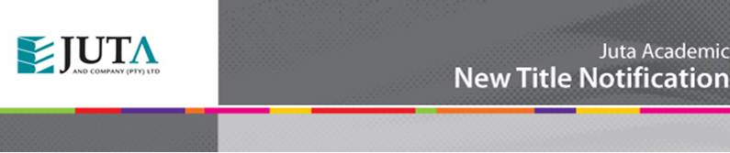

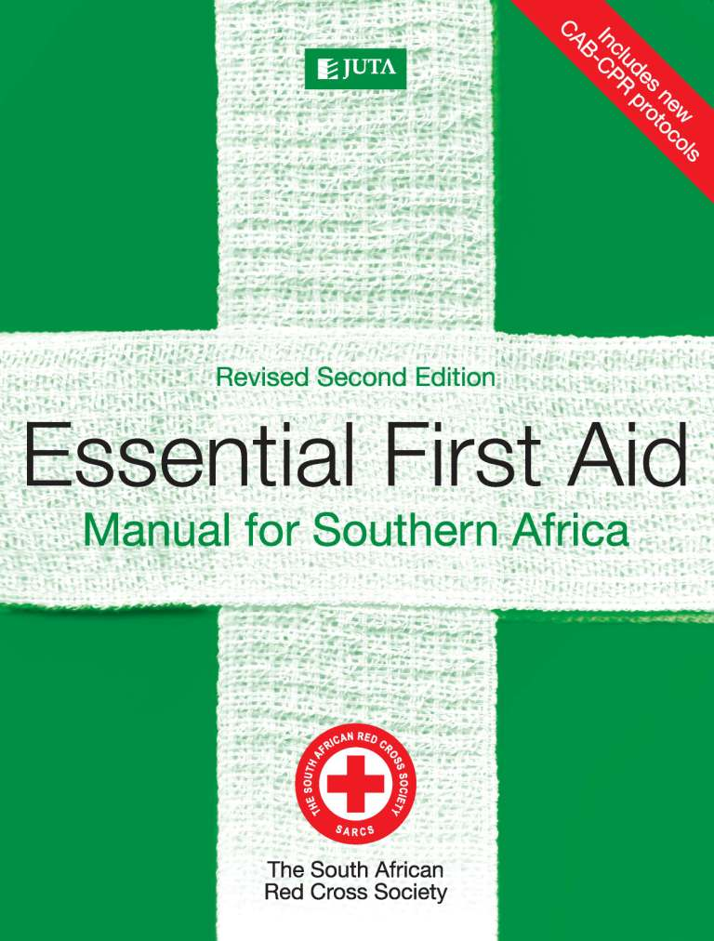

**Essential First Aid**

**Manual for Southern Africa**

**Edition: 2nd Revised edition**

**Published: 2016**

**Authors: SA Red Cross Society**

**ISBN: 9780702180583**

**eISBN: 9780702195532**

**Format: Soft cover**

**Extent: 180 pages**

**Retail price: R179.00** (incl. VAT, excl. delivery.)

***Essential First Aid: Revised Second Edition* provides you with everything you need to know to act effectively in medical and first aid emergencies. Written by a team of experienced Red Cross first aid trainers, the manual teaches you to recognise and assess emergency situations and medical conditions, and guides you in providing appropriate first aid treatment.  
  
This material is aligned with Unit Standard 119567.**

**Contents:**

**Module 1: The principles of first aid  
Module 2: Action in an emergency  
Module 3: Elementary anatomy and physiology  
Module 4: Multiple casualties and injuries  
Module 5: Major first aid techniques  
Module 6: The recovery position  
Module 7: Asphyxia  
Module 8: Shock  
Module 9: Wounds and bleeding   
Module 10: Burns  
Module 11: Bites and stings  
Module 12: Environmental conditions   
Module 13: Poisons  
Module 14: Dressings and bandages  
Module 15: Fractures, dislocations and soft-tissue injuries  
Module 16: Spinal injury  
Module 17: Moving the casualty  
Module 18: Emergency Childbirth**

**Of interest and benefit to:**

**• Anyone who wants to keep a first-aid book in the home, office, classroom  
• Levels 1-3 First Aid courses  
• First aid courses run in nursing colleges and medical schools.**

**Key Benefits:**

**• Updated to include new sections on emergency childbirth  
• CPR protocols completely up-to-date  
• Each module includes self-assessment and a case study  
• Simple and clear language, user-friendly design.**