

## **Basic First Aid**

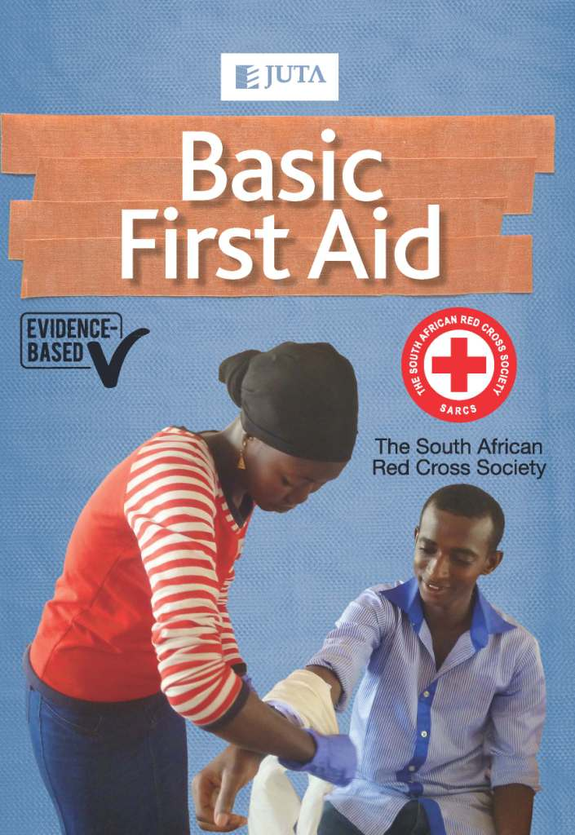

**Edition: 1st edition**

**Published: 2013**

**Author: South African Red Cross Society**

**ISBN: 9780702198038**

**eISBN: 9780702197321**

**Format: Soft cover**

**Extent: 88 pages**

**Retail price: R142.00** (incl. VAT, excl. delivery.)

**Basic First Aid** seeks to equip first aiders with the basic skills needed to effectively manage an emergency situation before the arrival of emergency care providers. The manual describes the most up-to-date basic first aid techniques for use in situations where there are limited or no resources available. It outlines step-by-step processes for a first aider to follow and administer to an ill or injured person before the arrival of emergency medical care on the accident scene or before transporting the casualty to a medical facility. Drawing on evidence-based practice and careful research into various emergency cases, this manual provides practical examples and methods to allow the first aider to provide the right kind of assistance in a medical emergency.

**Contents:**

**Unit 1 General principles of first aid**  
• What it means to be a first aider  
• Key points to remember as a first aider  
• How to protect against infection  
• Four main steps to deal with an emergency  
**Unit 2 Basic life support**  
• Unconsciousness  
• What to do when a casualty is not breathing  
• Cardiopulmonary resuscitation (CPR)  
• Choking  
• Fainting  
**Unit 3 Injuries**  
• Wounds  
• Bleeding  
• Shock  
• Burns  
• Broken and dislocated limbs  
• Injuries to the head, neck and back  
• Bites  
• Poisonings  
**Unit 4 Medical conditions**  
• Stroke   
• Heart attack  
• Fits  
**Unit 5 Community health conditions**  
• Malaria  
• Diarrhoea  
• Cholera  
• Rashes

**Unit 6 Emergency childbirth**  
**Unit 7 Moving a casualty**  
• What a first aider needs to remember  
• How to lift a casualty  
• What is the most appropriate technique to use?  
• Appendix 1 First aid materials  
• Index

**Key Benefits:**

* User-friendly; accessible language
* Numerous illustrations