Questions on SA Tax
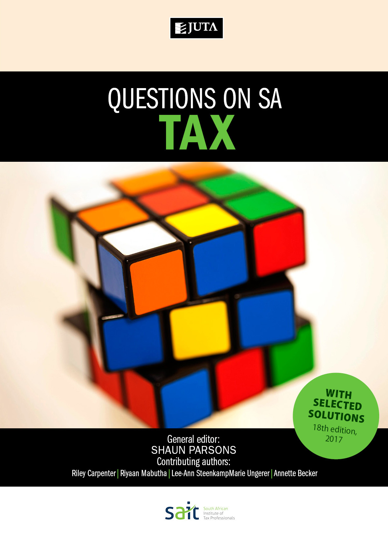

Edition: 18th Edition
Published: January 2017
Author/Editors: S Parson (Editor), A Becker, R Carpenter, R Mabutha, L Steenkamp & M Ungerer
ISBN: 9781485121053
Format: Soft cover
Extent: 334 pages
Retail price: R330

Bundle
Bundle includes Questions on SA Tax and Advanced Questions on SA Tax
Questions on SA Tax - Pack (2017)
Soft cover
Printed 9781485121138
R595
Questions on SA Tax 18th edition is the first of two publications designed together to provide comprehensive tutorial coverage to taxation students over a two-year basis. This book covers foundational topics and those typically dealt with in the first year of tax study. Its complementary publication, Advanced Questions on SA Tax, covers more advanced topics and integrated questions.
This tutorial book includes questions and selected solutions on South African income tax, estate duty and value-added tax. Up-to-date questions are graded, allowing students to develop their abilities from an introductory to an advanced level.
A selection of tutorial solutions is included in the book, and solutions to all questions are provided to lecturers at prescribing institutions. Mark plans are allocated to solutions.
Questions on SA Tax
Content:
General and Trading
Chapter 1: Gross Income 1
Chapter 2: Exempt Income 32
Chapter 3: General Deduction Formula 51
Chapter 4: Other Deductions 66
Chapter 5: Capital Allowances and Recoupments 87
Chapter 6: Trading Stock 121
Individuals
Chapter 7: Individuals 137
Chapter 8: Fringe Benefits, Allowances and Share Gains 170
Chapter 9: Employees’ Tax 193

Capital Gains Tax
Chapter 10: Capital Gains Tax 219
Wealth Taxes
Chapter 11: Donations Tax and Estate Duty 232
Value-Added Tax
Chapter 12: Value-Added Tax 261
Integration
Chapter 13: Integrated Questions

Recommended for:
Undergraduate taxation students at universities, universities of technology and private HE institutions
Key Features:
- covers foundational topics and those typically dealt with in the first year of tax study
- questions are graded
- selected solutions are provided
- mark allocations
- Relevant topics for each year of study
- Relevant types of questions for each year of study
- Selected solutions in the text for self-study
- Reviewed by experts in the field

JUTA ACADEMIC SALES CONSULTANTS:
Order Details:
Juta & Company Limited
P O Box 14373, Lansdowne, 7779
Tel: 021 6592300
E-mail: orders@juta.co.za
Eastern Cape, KwaZulu Natal, Lesotho, Swaziland and Mpumalanga
Gladman Buthelezi
Address: 19 Hurst Grove, Clifton Place, 1st Floor, Musgrave, Durban, 4001,
Tel: 031 304 4335;
Fax: 031 337 1819;
Cell: 083 702 2425
E-Mail: gbuthelezi@juta.co.za
Namibia, Western Cape and Eastern Cape ( Port Elizabeth)
Janine Gentle
1st Floor, Sunclare Building, 21 Dreyer Street, Claremont, Cape Town
Tel: 021 659 2300
Fax: 021 659 2647
Cell: 072 375 8006
E-mail: jgentle@juta.co.za
Gauteng, KwaZulu-Natal, Eastern Cape and Free State
Jennie Bowen
60 Wilkes Road Prestbury, Pietermaritzburg 3201
Cell: 083 367 9720
E-mail: jbowen@juta.co.za
Gauteng and North-West Province
Marie Botha
Norfolk House, Sandton Close 2, 3rd Floor, c/o 5th and Norwich Roads, Sandton
Tel: 011 217 7234
Fax: 011 883 8564
Cell: 083 399 9042
E-mail: mbotha@juta.co.za
Gauteng, Limpopo, Mpumalanga, Venda and Botswana
Pieter Smith
Norfolk House, Sandton Close 2,3rd Floor,c/o 5th and Norwich Roads, Sandton
Tel: 011 217 7200
Fax: 011 883 8465
Cell: 083 283 7055
E-mail: psmith@juta.co.za

Contact Details:

