An Introduction to Applied Calculus
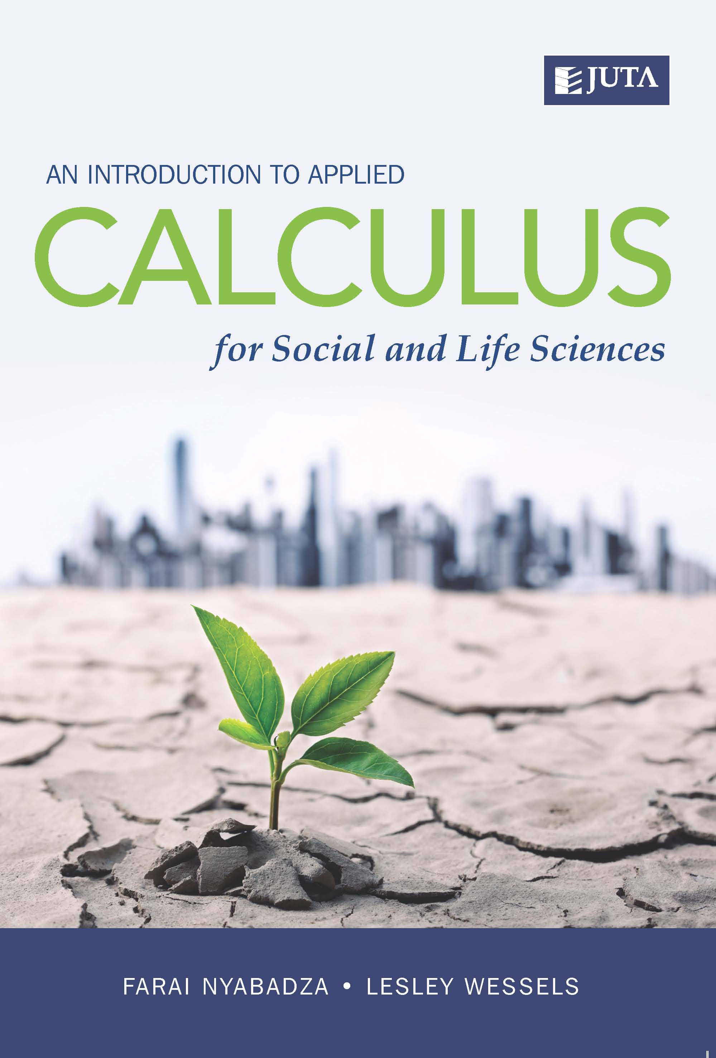
for Social and Life Sciences
Edition: 1st Edition
Published: November 2016
Author/Editors: Farai Nyabadza, Lesley Wessels
ISBN: 9781485117179
Format: Paperback
Extent: 256 pages
Retail price: R325

An Introduction to Applied Calculus for Social and Life Sciences is designed primarily for students majoring in Social Sciences and Life Sciences. It prepares students to deal with mathematical problems which arise from real-life problems encountered in other areas of study, such as Agriculture, Forestry, Biochemistry, Biology and the Biomedical Sciences. It is also of value to anyone intending to develop foundational undergraduate calculus for the Physical Sciences.
Recommended for:
- Provides undergraduate life science students with a succinct overview of major mathematical concepts that are essential for modern biology
- Covers all the major quantitative concepts that national reports have identified as the ideal components of an entry-level course for life science students
Contents:
- Algebraic Reviews

- Linear and Quadratic Equations

- Inequalities and Absolute Values

- Functions

- Limits

- Differentiation

- Derivatives of Exponential and Logarithmic Functions

- Applications of Differentiation

- Integration

- Modelling with Differential Equations

Contact Details:
JUTA ACADEMIC SALES CONSULTANTS:
Order Details:
Juta & Company Limited
P O Box 14373, Lansdowne, 7779
Tel: 021 6592300
E-mail: orders@juta.co.za
Eastern Cape, KwaZulu Natal, Lesotho, Swaziland and Mpumalanga
Gladman Buthelezi
Address: 19 Hurst Grove, Clifton Place, 1st Floor, Musgrave, Durban, 4001,
Tel: 031 304 4335;
Fax: 031 337 1819;
Cell: 083 702 2425
E-Mail: gbuthelezi@juta.co.za
Namibia, Western Cape and Eastern Cape ( Port Elizabeth)
Janine Gentle
1st Floor, Sunclare Building, 21 Dreyer Street, Claremont, Cape Town
Tel: 021 659 2300
Fax: 021 659 2647
Cell: 072 375 8006
E-mail: jgentle@juta.co.za
Gauteng, KwaZulu-Natal, Eastern Cape and Free State
Jennie Bowen
60 Wilkes Road Prestbury, Pietermaritzburg 3201
Cell: 083 367 9720
E-mail: jbowen@juta.co.za
Gauteng and North-West Province
Marie Botha
Norfolk House, Sandton Close 2, 3rd Floor, c/o 5th and Norwich Roads, Sandton
Tel: 011 217 7234
Fax: 011 883 8564
Cell: 083 399 9042
E-mail: mbotha@juta.co.za
Gauteng, Limpopo, Mpumalanga, Venda and Botswana
Pieter Smith
Norfolk House, Sandton Close 2,3rd Floor,c/o 5th and Norwich Roads, Sandton
Tel: 011 217 7200
Fax: 011 883 8465
Cell: 083 283 7055
E-mail: psmith@juta.co.za

