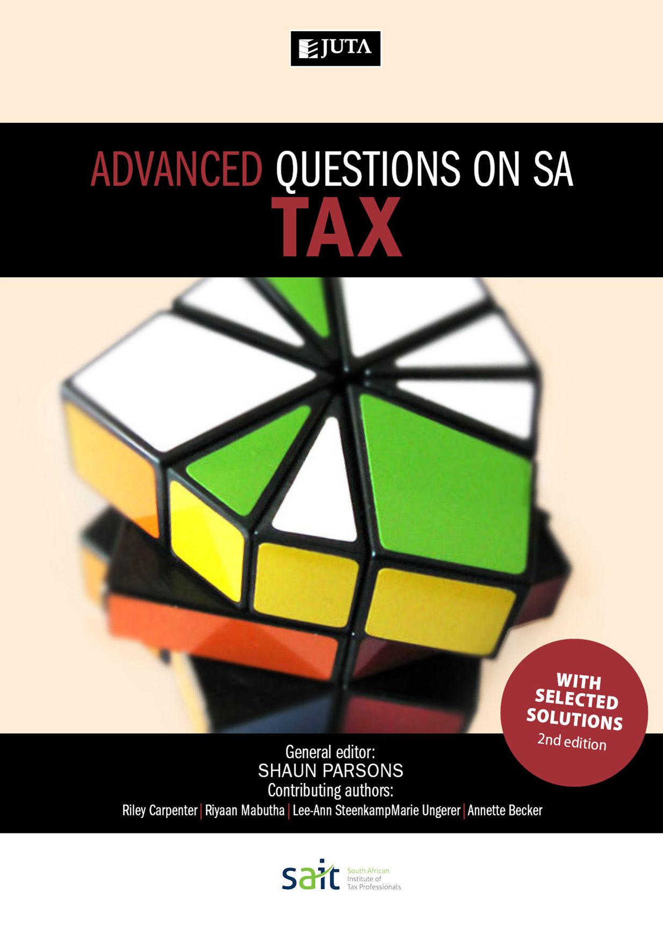
Advanced Questions on SA Tax 2e
Edition: 2nd Edition
Published: 2017
Author/Editors: Shaun Parsons
ISBN: 9781485121046
Format:
Extent: 324 pages
Retail price: R330
Tax bundle: QSAT+Advanced QSAT
ISBN: 9781485121138 Price: R595

Advanced Questions on SA Tax 2nd edition is the second of two publications designed together to provide comprehensive tutorial coverage to taxation students over a two-year basis. This book covers advanced topics and integrated questions. Its complementary publication, Questions on SA Tax, covers foundational topics and those typically dealt with in the first year of tax study.
This tutorial book includes questions and selected solutions on South African income tax, estate duty and value-added tax. Up-to-date questions are graded, allowing students to develop their abilities from an introductory to an advanced level. A selection of tutorial solutions is included in the book, and solutions to all questions are provided to lecturers at prescribing institutions. Mark plans are allocated to solutions.

Recommended for:
Post graduate taxation students at universities, universities of technology and private HE institutions

Contents:
- covers foundational topics and those typically dealt with in the first year of tax study
- questions are graded
- selected solutions are provided
- mark allocations
- Relevant topics for each year of study
- Relevant types of questions for each year of study
- Selected solutions in the text for self-study (key point for UNISA)
- Reviewed by experts in the field

JUTA ACADEMIC SALES CONSULTANTS:
Order Details:
Juta & Company Limited
P O Box 14373, Lansdowne, 7779
Tel: 021 6592300
E-mail: orders@juta.co.za
Eastern Cape, KwaZulu Natal, Lesotho, Swaziland and Mpumalanga
Gladman Buthelezi
Address: 19 Hurst Grove, Clifton Place, 1st Floor, Musgrave, Durban, 4001,
Tel: 031 304 4335;
Fax: 031 337 1819;
Cell: 083 702 2425
E-Mail: gbuthelezi@juta.co.za
Namibia, Western Cape and Eastern Cape ( Port Elizabeth)
Janine Gentle
1st Floor, Sunclare Building, 21 Dreyer Street, Claremont, Cape Town
Tel: 021 659 2300
Fax: 021 659 2647
Cell: 072 375 8006
E-mail: jgentle@juta.co.za
Gauteng, KwaZulu-Natal, Eastern Cape and Free State
Jennie Bowen
60 Wilkes Road Prestbury, Pietermaritzburg 3201
Cell: 083 367 9720
E-mail: jbowen@juta.co.za
Gauteng and North-West Province
Marie Botha
Norfolk House, Sandton Close 2, 3rd Floor, c/o 5th and Norwich Roads, Sandton
Tel: 011 217 7234
Fax: 011 883 8564
Cell: 083 399 9042
E-mail: mbotha@juta.co.za
Gauteng, Limpopo, Mpumalanga, Venda and Botswana
Pieter Smith
Norfolk House, Sandton Close 2,3rd Floor,c/o 5th and Norwich Roads, Sandton
Tel: 011 217 7200
Fax: 011 883 8465
Cell: 083 283 7055
E-mail: psmith@juta.co.za

Contact Details:

