Accounting for All
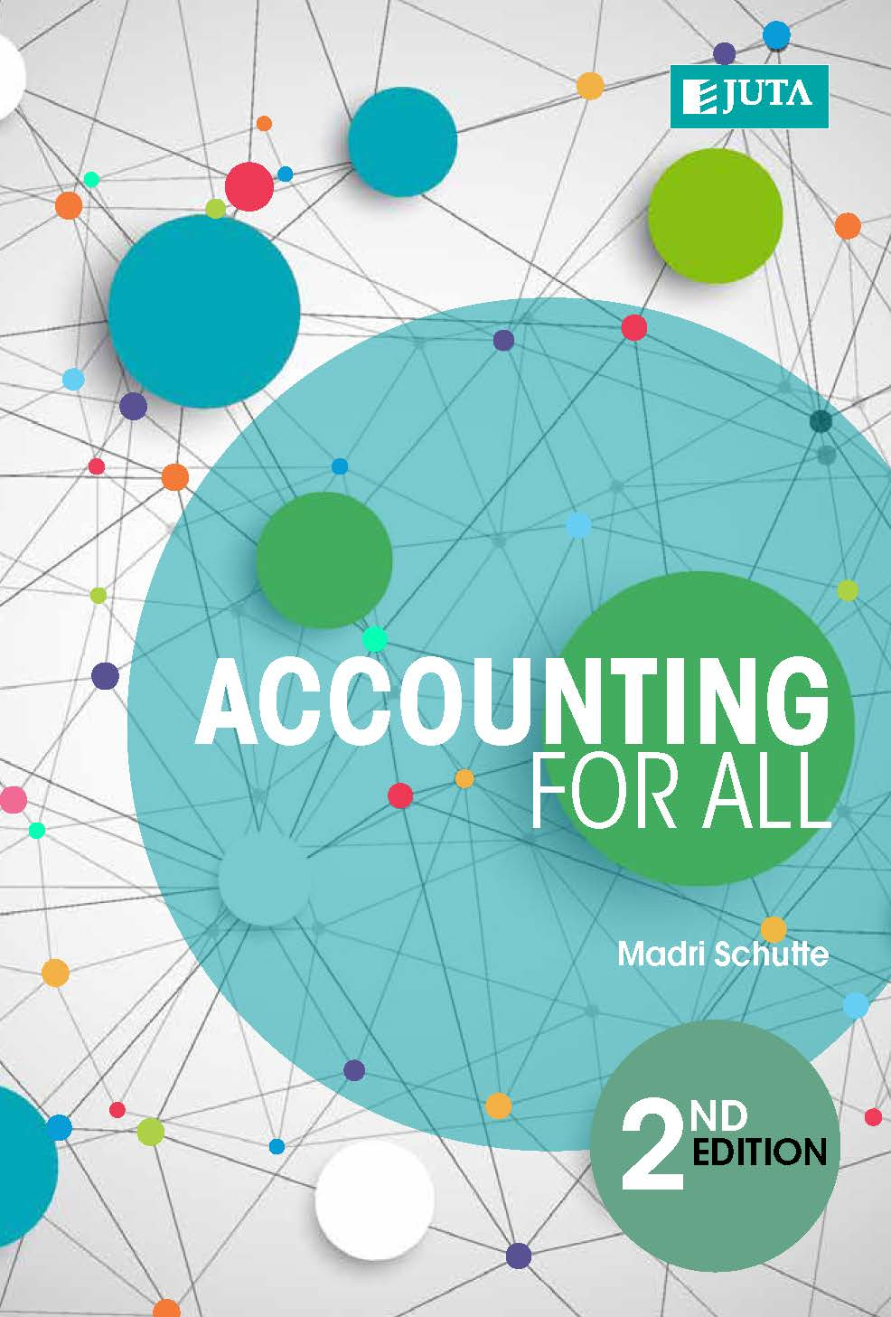

Edition: 2nd Edition
Published: 2017
Author/Editors: Madri Schutte
ISBN: 9781485121077
Format: Paperback
Extent: 702 pages
Retail price: R550

The aim of this book is to help students’ master financial accounting and cost accounting offered in introductory accounting courses for commerce or management programmes. Accounting for All is especially useful for students to whom financial accounting and cost accounting are not a major subject. The second edition has been updated to include two new topics, namely, partnerships and non-profit organisations (NPOs).
The content is written in an easy-to-understand manner and therefore enables students to work through each chapter on their own. The teaching methodology takes a step-by-step approach and is supported by extensive explanatory examples.

Recommended for:
Students who do not have an accounting background, but need a fundamental understanding of the financial and cost accounting principles and concepts as it applies to the world of business.
Key features:
Extensive examples • Lecturer support material (solutions and PowerPoints ®)

Contents:
Basic concepts in accountancy – accounting process • Business transactions and source documents • Recording transactions (double-entry system) • Introduction to VAT • Books of prime entry • Bank reconciliation statement • The trial balance • Non-current assets - depreciation • Inventory • Year-end adjustments • Financial statements of a sole trader • Financial statements of companies • Partnerships • Statement of cash flow • Partnerships • Non-profit organisations • Interpretation of financial statements • Basic cost accounting • Manufacturing concern • Cost behaviour • Budgets • Cost-volume-profit analysis • Payroll • Business ethics

JUTA ACADEMIC SALES CONSULTANTS:
Order Details:
Juta & Company Limited
P O Box 14373, Lansdowne, 7779
Tel: 021 6592300
E-mail: orders@juta.co.za
Eastern Cape, KwaZulu Natal, Lesotho, Swaziland and Mpumalanga
Gladman Buthelezi
Address: 19 Hurst Grove, Clifton Place, 1st Floor, Musgrave, Durban, 4001,
Tel: 031 304 4335;
Fax: 031 337 1819;
Cell: 083 702 2425
E-Mail: gbuthelezi@juta.co.za
Namibia, Western Cape and Eastern Cape ( Port Elizabeth)
Janine Gentle
1st Floor, Sunclare Building, 21 Dreyer Street, Claremont, Cape Town
Tel: 021 659 2300
Fax: 021 659 2647
Cell: 072 375 8006
E-mail: jgentle@juta.co.za
Gauteng, KwaZulu-Natal, Eastern Cape and Free State
Jennie Bowen
60 Wilkes Road Prestbury, Pietermaritzburg 3201
Cell: 083 367 9720
E-mail: jbowen@juta.co.za
Gauteng and North-West Province
Marie Botha
Norfolk House, Sandton Close 2, 3rd Floor, c/o 5th and Norwich Roads, Sandton
Tel: 011 217 7234
Fax: 011 883 8564
Cell: 083 399 9042
E-mail: mbotha@juta.co.za
Gauteng, Limpopo, Mpumalanga, Venda and Botswana
Pieter Smith
Norfolk House, Sandton Close 2,3rd Floor,c/o 5th and Norwich Roads, Sandton
Tel: 011 217 7200
Fax: 011 883 8465
Cell: 083 283 7055
E-mail: psmith@juta.co.za

Contact Details:

