Sales Management
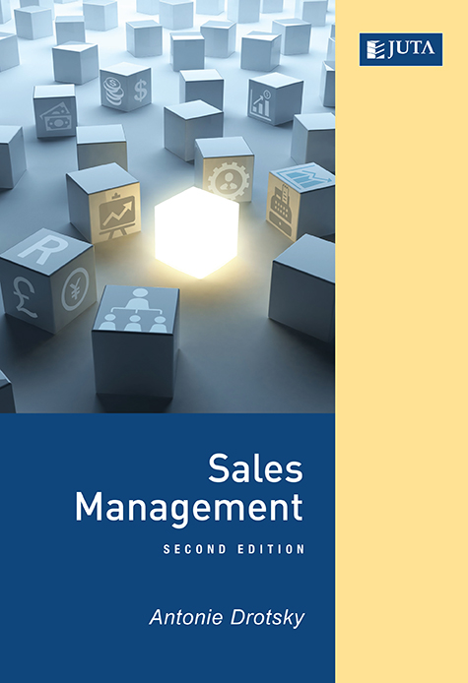
Edition: 2nd Edition
Published: December 2016
Author/Editors: A Drotsky
ISBN: 9781485121244
Format: Soft Cover
Extent: 272
Retail price: R380

Sales drive the business world and the economy. However, sales in any business need to be managed to ensure that the business achieves its objectives. This is where the function of sales management comes into the business structure: it plays the key role of ensuring that salespeople succeed at selling. The profitability of the organisation depends on how successfully sales managers lead their sales force.
The sales manager is responsible for the strategic planning of the sales force, which includes the management of the selling process and organising the sales activities within the sales department.
Recommended for:
The contributors to this book have both academic and industry perspectives on the field of sales management. This book will therefore benefit industry and academia. It will be a valuable resource for sales managers who want to improve their knowledge, salespeople who want to advance their careers and students studying marketing and sales.
Contents:
Chapter 1 Sales Careers and the Selling Process
Chapter 2 Organising the sales effort
Chapter 3 Sales forecasting and budgeting
Chapter 4 Territory and time management
Chapter 5 Recruitment and selection of salespersons
Chapter 6 Sales training
Chapter 7 Leadership
Chapter 8 Sales motivation
Chapter 9 Sales force remuneration – commission, base salaries, bonuses
Chapter 10 Evaluating sales force performance
Chapter 11 Sales promotions
Chapter 12 Sales metrics

About the editors:
Antonie Drotsky is a lecturer in the Department of Marketing, Logistics and Sport Management at Tshwane University of Technology.

JUTA ACADEMIC SALES CONSULTANTS:
Order Details:
Juta & Company Limited
P O Box 14373, Lansdowne, 7779
Tel: 021 6592300
E-mail: orders@juta.co.za
Eastern Cape, KwaZulu Natal, Lesotho, Swaziland and Mpumalanga
Gladman Buthelezi
Address: 19 Hurst Grove, Clifton Place, 1st Floor, Musgrave, Durban, 4001,
Tel: 031 304 4335;
Fax: 031 337 1819;
Cell: 083 702 2425
E-Mail: gbuthelezi@juta.co.za
Namibia, Western Cape and Eastern Cape ( Port Elizabeth)
Janine Gentle
1st Floor, Sunclare Building, 21 Dreyer Street, Claremont, Cape Town
Tel: 021 659 2300
Fax: 021 659 2647
Cell: 072 375 8006
E-mail: jgentle@juta.co.za
Gauteng, KwaZulu-Natal, Eastern Cape and Free State
Jennie Bowen
60 Wilkes Road Prestbury, Pietermaritzburg 3201
Cell: 083 367 9720
E-mail: jbowen@juta.co.za
Gauteng and North-West Province
Marie Botha
Norfolk House, Sandton Close 2, 3rd Floor, c/o 5th and Norwich Roads, Sandton
Tel: 011 217 7234
Fax: 011 883 8564
Cell: 083 399 9042
E-mail: mbotha@juta.co.za
Gauteng, Limpopo, Mpumalanga, Venda and Botswana
Pieter Smith
Norfolk House, Sandton Close 2,3rd Floor,c/o 5th and Norwich Roads, Sandton
Tel: 011 217 7200
Fax: 011 883 8465
Cell: 083 283 7055
E-mail: psmith@juta.co.za

Contact Details:

