Microeconomics: A southern African Perspective
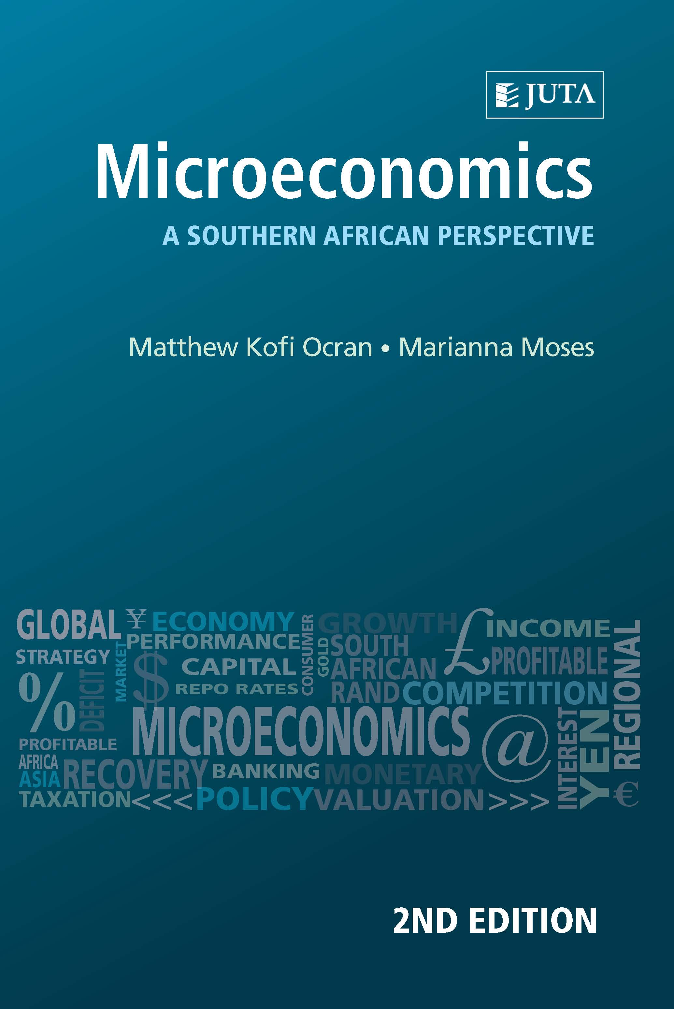

Edition: 2nd Edition
Published: 2016
Author/Editors: Matthew Kofi Ocran, Marianna Moses
ISBN: 9781485115816
Format: Paperback
Extent: 224 pages
Retail price: R200

This textbook provides a comprehensive introduction to micro-economic theory, set against a contemporary South African background. The book covers traditional theories of consumer and producer behaviour as prescribed in most introductory micro-economic modules. Each end of chapter includes a set of activities and self-evaluation exercises, while feedback to activities and answers to the exercises are found at the end of the book.
Contents:
Chapter 1: Introduction to economics
Chapter 2: Demand and supply
Chapter 3: Elasticity
Chapter 4: Consumer equilibrium – the cardinal utility approach
Chapter 5: Consumer equilibrium – the ordinal utility approach
Chapter 6: Production and cost
Chapter 7: Profit maximisation in a perfectly competitive market
Chapter 8: Determining prices and output in imperfect competitive markets

About the editors:
Mariana Moses holds an M.Com in Economics from the University of the Western Cape and formally joined the Department of Economics in 2007. Over the years she has taught core and elective economic modules, viz. macroeconomics, public finance and labour economics to undergraduate students, and recently facilitates advanced microeconomic modules. Her research interests are in labour and social development.

JUTA ACADEMIC SALES CONSULTANTS:
Order Details:
Juta & Company Limited
P O Box 14373, Lansdowne, 7779
Tel: 021 6592300
E-mail: orders@juta.co.za
Eastern Cape, KwaZulu Natal, Lesotho, Swaziland and Mpumalanga
Gladman Buthelezi
Address: 19 Hurst Grove, Clifton Place, 1st Floor, Musgrave, Durban, 4001,
Tel: 031 304 4335;
Fax: 031 337 1819;
Cell: 083 702 2425
E-Mail: gbuthelezi@juta.co.za
Namibia, Western Cape and Eastern Cape ( Port Elizabeth)
Janine Gentle
1st Floor, Sunclare Building, 21 Dreyer Street, Claremont, Cape Town
Tel: 021 659 2300
Fax: 021 659 2647
Cell: 072 375 8006
E-mail: jgentle@juta.co.za
Gauteng, KwaZulu-Natal, Eastern Cape and Free State
Jennie Bowen
60 Wilkes Road Prestbury, Pietermaritzburg 3201
Cell: 083 367 9720
E-mail: jbowen@juta.co.za
Gauteng and North-West Province
Marie Botha
Norfolk House, Sandton Close 2, 3rd Floor, c/o 5th and Norwich Roads, Sandton
Tel: 011 217 7234
Fax: 011 883 8564
Cell: 083 399 9042
E-mail: mbotha@juta.co.za
Gauteng, Limpopo, Mpumalanga, Venda and Botswana
Pieter Smith
Norfolk House, Sandton Close 2,3rd Floor,c/o 5th and Norwich Roads, Sandton
Tel: 011 217 7200
Fax: 011 883 8465
Cell: 083 283 7055
E-mail: psmith@juta.co.za

Contact Details:

