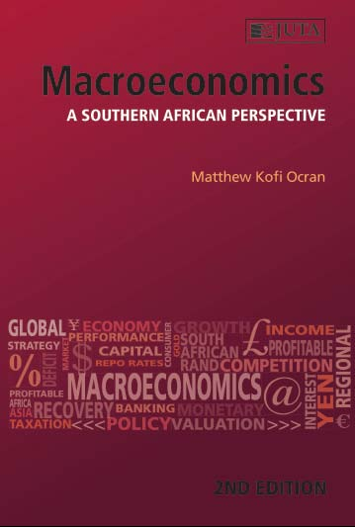

MACROECONOMICS:
SOUTHERN AFRICAN PERSPECTIVE 2e

Edition: 2nd Edition
Published: November 2016
Author/Editors: Matthew Kofi Ocran
ISBN: 9781485115823
Format: Soft cover
Extent: 204 pages
Retail price: R240.00

The book provides a thorough but concise exposure to macroeconomics to post school students as well as those studying economics for the first time. Following an introduction that gives an overview of macroeconomics as well as a brief discussion of the main macroeconomic problems that societies face, the book then looks at national income accounting and economic performance. The book looks at the unemployment problem. There is also a discussion of aggregate supply and demand theory, and the role of that theory in explaining the determinants of aggregate economic output and employment. The problem of inflation and is also discussed. The reality that the economies of most countries are interconnected with that of the rest of the world is discussed under open-economy. The book then discusses economic growth in both the short-run and the long run.

Contents:
Chapter 1: Introduction to macroeconomics
Chapter 2: National income accounting and economic performance
Chapter 3: Labour market and the problem of unemployment
Chapter 4: Aggregate demand and aggregate supply
Chapter 5: Money, prices and the problem of inflation
Chapter 6: Open macroeconomy: International trade, exchange rate and the balance of payment
Chapter 7: Economic growth in the short run
Chapter 8: Economic growth in the long run

Key Benefits:

• An extensive re-working of the old text and simplification of the material in the old book.
• Economic growth is an important consideration in the study of macroeconomics, it is presented in more refreshing way the new book
• For the first time the issue of economic growth variability in the short-run is highlighted and the relationship between long run growth in income per person and economic development is covered.
• One other important strength of the new textbook is that most of the material has been simplified and relevant examples from South Africa have been covered. All this has been done in addition to reducing the volume of the textbook considerably so that students can cover all the material in a semester or half a year.

Recommended for:

This text is suitable as a practical guide for undergraduate students studying economics for the first time, academics and managers.

Author information:

Matthew Kofi Ocran is Professor of Economics and Head of the Department of Economics at the University of the Western Cape. He is also a Visiting Professor of at the University of Cape Town’s Graduate School of Business. His research interests cover applied econometrics, financial economics, monetary policy and macro-econometric modeling, development economics, development finance. He also teaches macroeconomics at the undergraduate and the post-graduate levels.

Prof Ocran holds a BSc and MPhil degrees from the University of Ghana and a PhD from Stellenbosch University. He has taught numerous tertiary level economics courses in Ghana and South Africa, and for the last seven years he has successfully supervised 20 Masters in Commerce students and four PhDs in Economics and one in Development Finance. He has also served as an external examiner for five PhD candidates in economics for University of the North, Stellenbosch University, University of South Africa and the University of Kwazulu Natal.

He has won numerous prestigious academic awards and research grants from (among others) the Research Department of the International Monetary Fund (IMF) in Washington DC as an IMF/AERC Visiting Scholar (2006), and from the Nairobi-based African Economic Research Consortium (on two occasions). Matthew has published in a number of local and international academic journals; South Africa’s National Research Foundation (NRF) rates him as an established researcher

JUTA ACADEMIC SALES CONSULTANTS:
Order Details:
Juta & Company Limited
P O Box 14373, Lansdowne, 7779
Tel: 021 6592300
E-mail: orders@juta.co.za
Eastern Cape, KwaZulu Natal, Lesotho, Swaziland and Mpumalanga
Gladman Buthelezi
Address: 19 Hurst Grove, Clifton Place, 1st Floor, Musgrave, Durban, 4001,
Tel: 031 304 4335;
Fax: 031 337 1819;
Cell: 083 702 2425
E-Mail: gbuthelezi@juta.co.za
Namibia, Western Cape and Eastern Cape ( Port Elizabeth)
Janine Gentle
1st Floor, Sunclare Building, 21 Dreyer Street, Claremont, Cape Town
Tel: 021 659 2300
Fax: 021 659 2647
Cell: 072 375 8006
E-mail: jgentle@juta.co.za
Gauteng, KwaZulu-Natal, Eastern Cape and Free State
Jennie Bowen
60 Wilkes Road Prestbury, Pietermaritzburg 3201
Cell: 083 367 9720
E-mail: jbowen@juta.co.za
Gauteng and North-West Province
Marie Botha
Norfolk House, Sandton Close 2, 3rd Floor, c/o 5th and Norwich Roads, Sandton
Tel: 011 217 7234
Fax: 011 883 8564
Cell: 083 399 9042
E-mail: mbotha@juta.co.za
Gauteng, Limpopo, Mpumalanga, Venda and Botswana
Pieter Smith
Norfolk House, Sandton Close 2,3rd Floor,c/o 5th and Norwich Roads, Sandton
Tel: 011 217 7200
Fax: 011 883 8465
Cell: 083 283 7055
E-mail: psmith@juta.co.za

