E-Commerce for IT Professionals
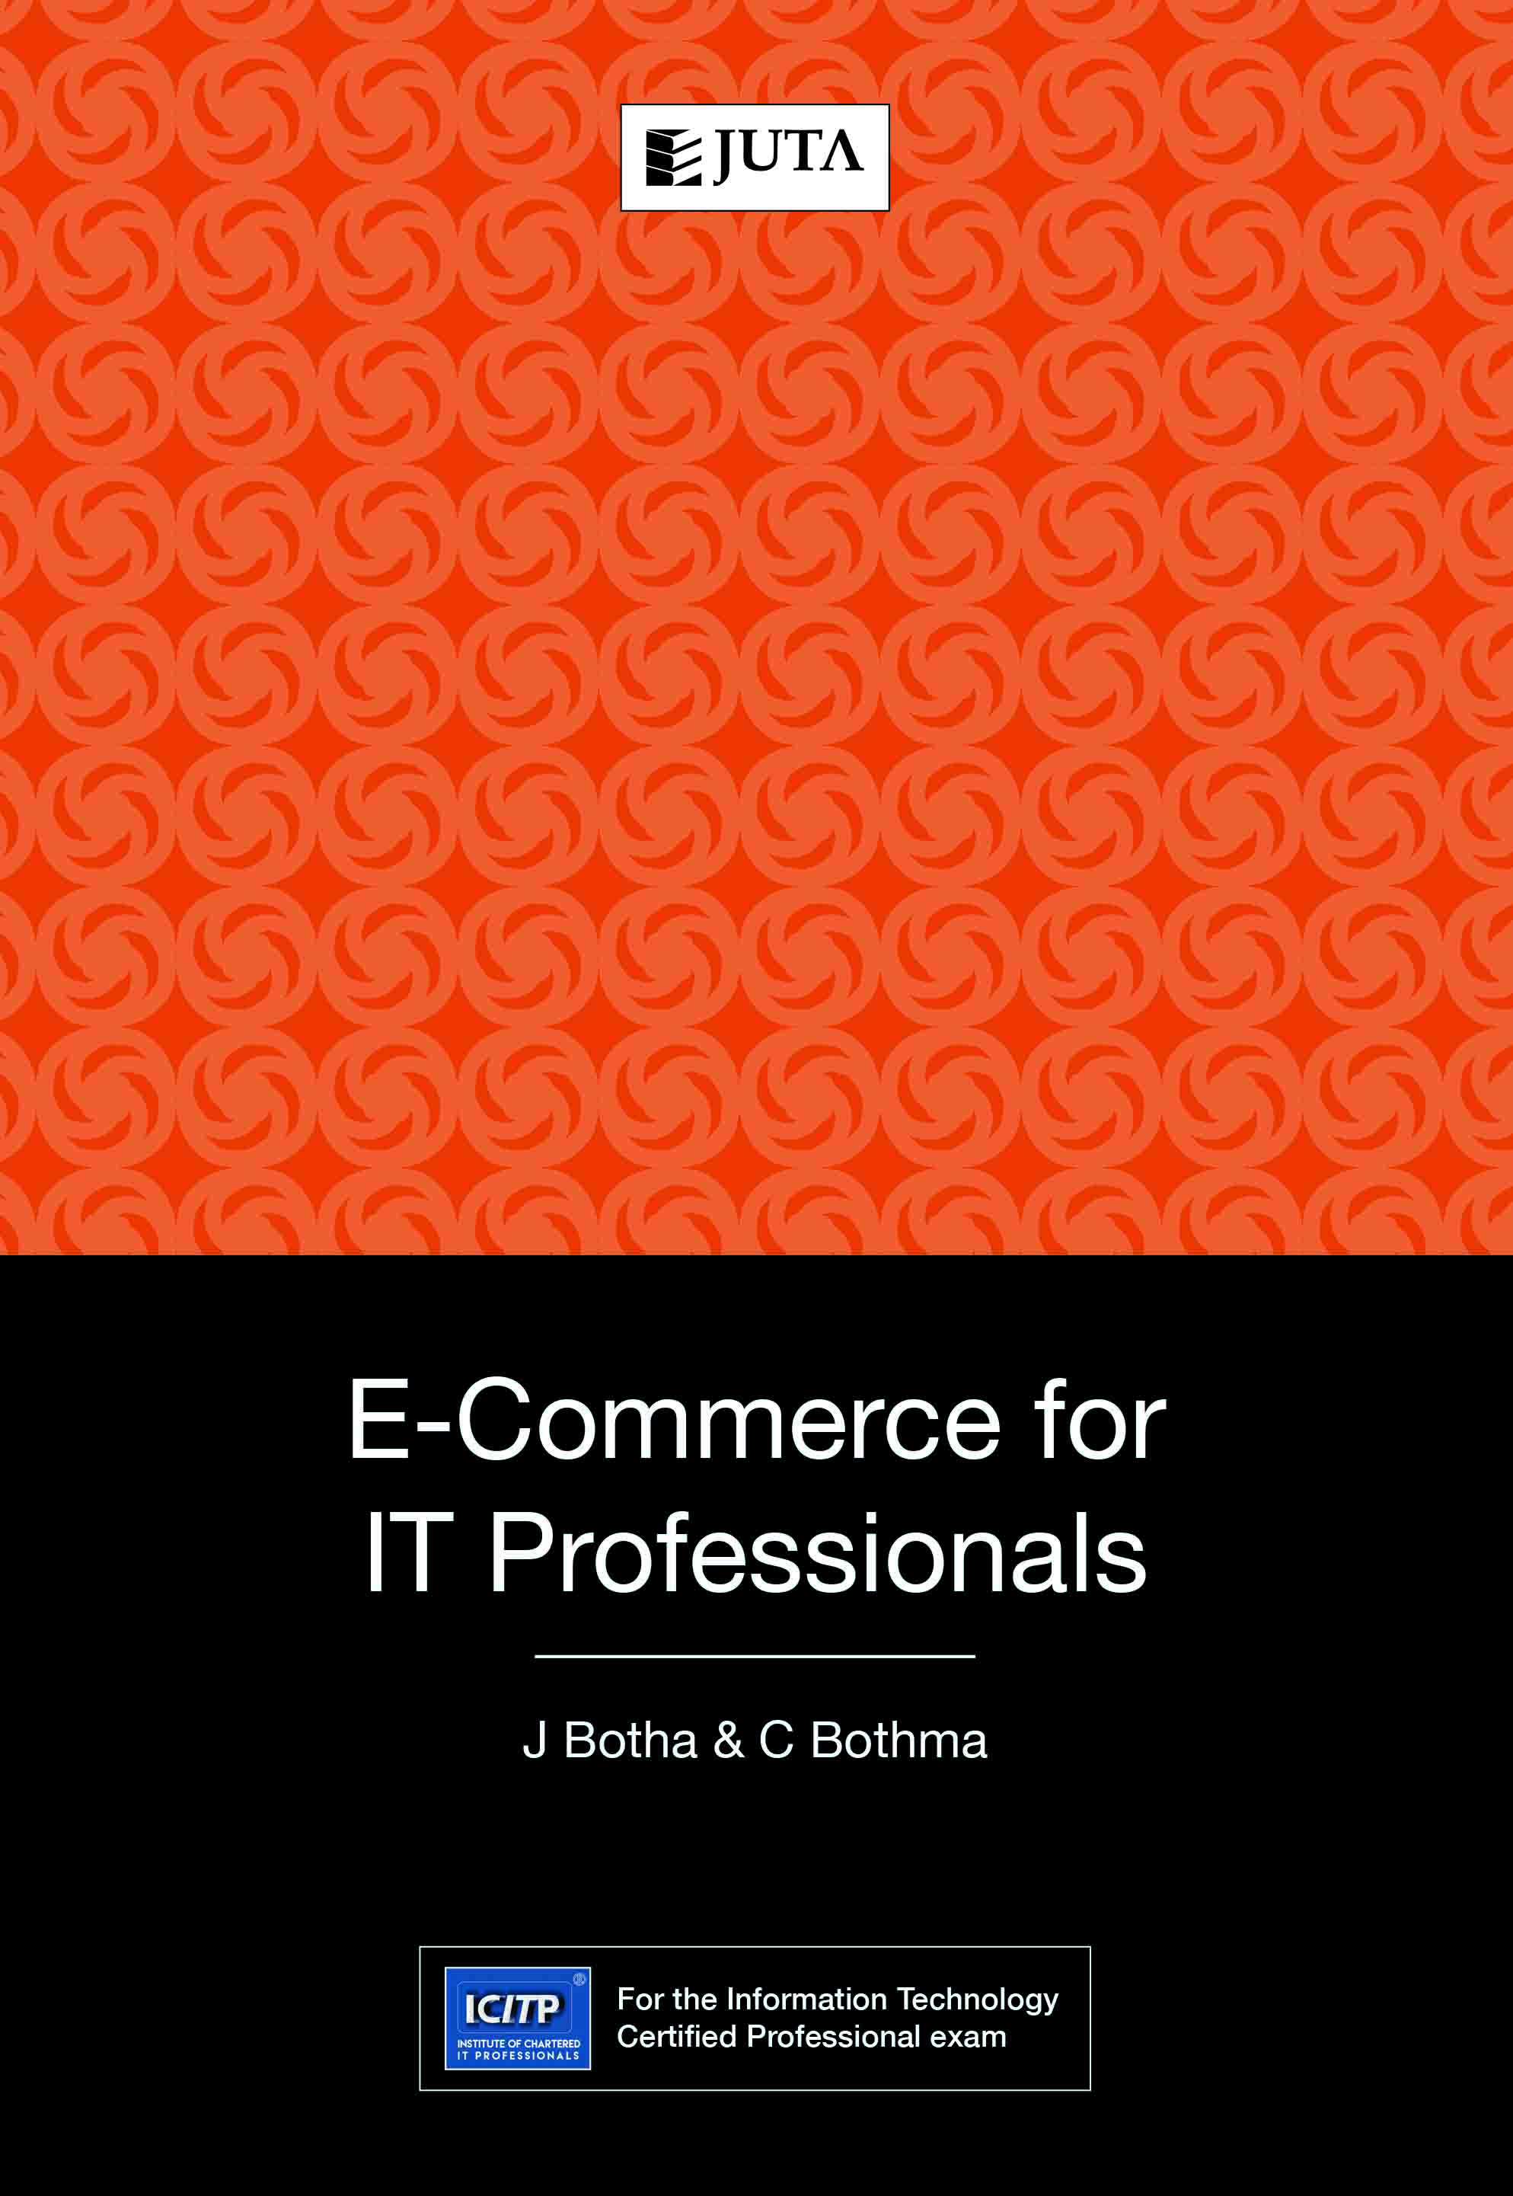

Edition: 1st Edition
Published: 2017
Author/Editors: Botha J ; Bothma C
ISBN: 9781485124665
Format: Soft Cover
Extent: 264 pages
Retail price: R399
For e-commerce to work and be implemented successfully, specific skills and knowledge are required – in the fields of information and communications technology (ICT) and business and marketing management in particular. Research in South Africa indicates a growing need for training in managing e-commerce.
This book attempts to train people in understanding the ICT principles that underlie e-commerce and e-commerce management against the background of this need, in a disciplined and dedicated way that aims to satisfy specific business needs and meet objectives.

Recommended for:
For the Information Technology Certified Professional exam.
Contents:
- Introduction to e-commerce
- Creating web pages
- The online customer
- Establishing an e-commerce store
- Marketing the e-commerce store
- E-tailing
- Managing e-CRM
- Business-to-business e-commerce
- E-commerce planning, strategy and management
- Measuring e-commerce store success

JUTA ACADEMIC SALES CONSULTANTS:
Order Details:
Juta & Company Limited
P O Box 14373, Lansdowne, 7779
Tel: 021 6592300
E-mail: orders@juta.co.za
Eastern Cape, KwaZulu Natal, Lesotho, Swaziland and Mpumalanga
Gladman Buthelezi
Address: 19 Hurst Grove, Clifton Place, 1st Floor, Musgrave, Durban, 4001,
Tel: 031 304 4335;
Fax: 031 337 1819;
Cell: 083 702 2425
E-Mail: gbuthelezi@juta.co.za
Namibia, Western Cape and Eastern Cape ( Port Elizabeth)
Janine Gentle
1st Floor, Sunclare Building, 21 Dreyer Street, Claremont, Cape Town
Tel: 021 659 2300
Fax: 021 659 2647
Cell: 072 375 8006
E-mail: jgentle@juta.co.za
Gauteng, KwaZulu-Natal, Eastern Cape and Free State
Jennie Bowen
60 Wilkes Road Prestbury, Pietermaritzburg 3201
Cell: 083 367 9720
E-mail: jbowen@juta.co.za
Gauteng and North-West Province
Marie Botha
Norfolk House, Sandton Close 2, 3rd Floor, c/o 5th and Norwich Roads, Sandton
Tel: 011 217 7234
Fax: 011 883 8564
Cell: 083 399 9042
E-mail: mbotha@juta.co.za
Gauteng, Limpopo, Mpumalanga, Venda and Botswana
Pieter Smith
Norfolk House, Sandton Close 2,3rd Floor,c/o 5th and Norwich Roads, Sandton
Tel: 011 217 7200
Fax: 011 883 8465
Cell: 083 283 7055
E-mail: psmith@juta.co.za

Contact Details:

