Business Mathematics for IT Professionals
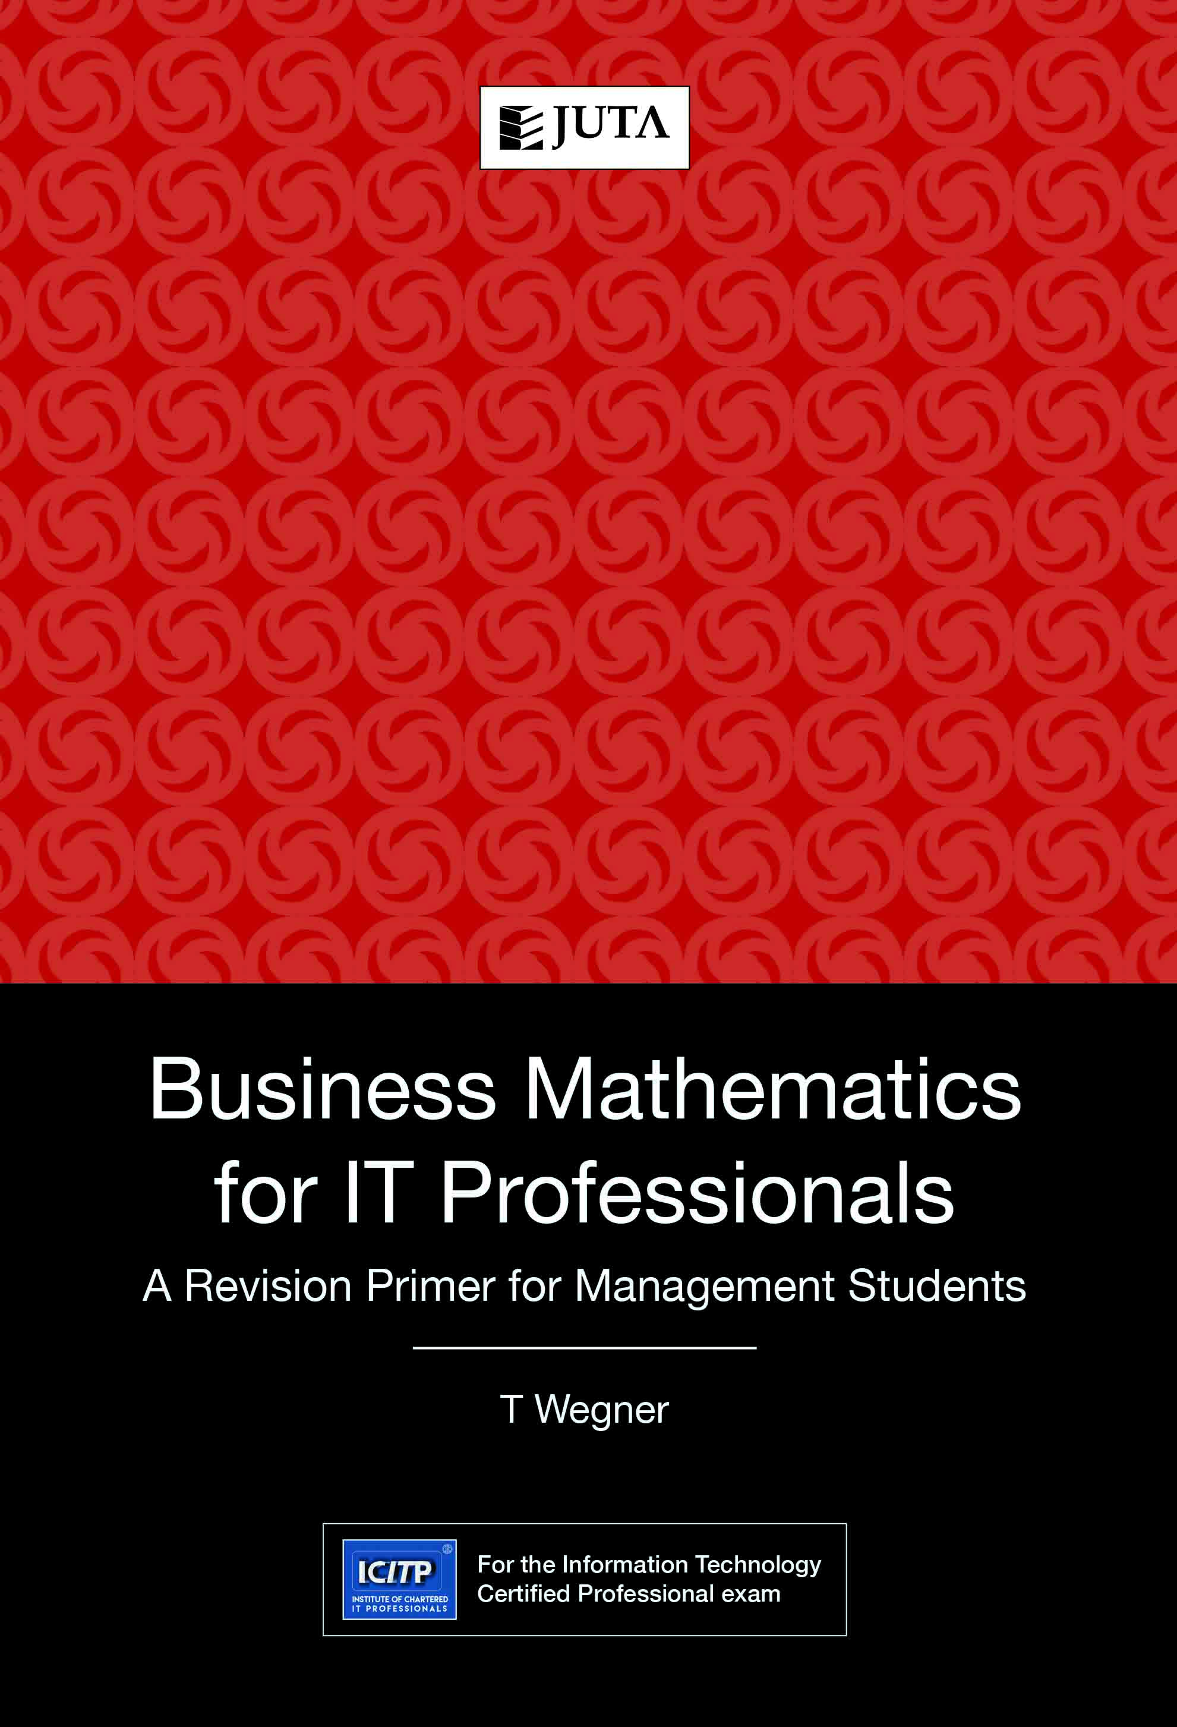

Edition: 1st Edition
Published: 2017
Author/Editors: Wegner, T
ISBN: 9781485124658
Format: Soft Cover
Extent: 164 pages
Retail price: R323
This text provides a general revision of basic mathematical principles, rules and methods. The focus is only on those areas of mathematics required for the GMAT test. This covers four main topics: basic arithmetic, fundamental algebra, geometry and introductory statistics. This is essentially a workbook with a strong emphasis on self-practice. After a brief review of each topic’s basic rules and methods, there is at least one worked example, followed by an extensive set of self-practice exercises.
This revised edition contains a few new topics in basic mathematic and fundamental algebra and is strengthened by additional GMAT-type exercises.

Recommended for:
For the Information Technology Certified Professional exam.
Key Benefits:
ICITP® (the Institute of Chartered IT Professionals) is a recognised professional body for the Information Technology sector worldwide, dedicated to regulating the IT profession, making sure that competency, recognition and professionalism are promoted effectively at all levels. Certified and Chartered IT Professionals play an important role in IT businesses as they help to achieve the overall objective of a business by working as business partners rather than just as employees.
The objective of ICITP® is to create a structured and yet vibrant environment for its members in which they can become the next generation of high-impact entrepreneurs, turning their IT- based skills into business ideas and into start-up and successful ventures.
ICITP® seeks to advance the employability of youth and graduates, entrepreneurship and social inclusion by addressing the challenges around integrating graduates and young people into the employment market, highlighting innovative approaches and uses of ICTs, and providing pathways to boost self-development, knowledge and skills.
ICITP® keeps its qualifications, professional experience requirements and CPD programmes up to date. This ensures that its members are the first choice for employers looking to recruit qualified IT practitioners and trained IT business leaders. ICITP® is committed to upholding the highest ethical and professional standards, and to maintaining public confidence in Information Technology.

Contents:
- Basic arithmetic
- Fundamental algebra
- Geometry
- Basic statistics

Contact Details:

JUTA ACADEMIC SALES CONSULTANTS:
Order Details:
Juta & Company Limited
P O Box 14373, Lansdowne, 7779
Tel: 021 6592300
E-mail: orders@juta.co.za
Eastern Cape, KwaZulu Natal, Lesotho, Swaziland and Mpumalanga
Gladman Buthelezi
Address: 19 Hurst Grove, Clifton Place, 1st Floor, Musgrave, Durban, 4001,
Tel: 031 304 4335;
Fax: 031 337 1819;
Cell: 083 702 2425
E-Mail: gbuthelezi@juta.co.za
Namibia, Western Cape and Eastern Cape ( Port Elizabeth)
Janine Gentle
1st Floor, Sunclare Building, 21 Dreyer Street, Claremont, Cape Town
Tel: 021 659 2300
Fax: 021 659 2647
Cell: 072 375 8006
E-mail: jgentle@juta.co.za
Gauteng, KwaZulu-Natal, Eastern Cape and Free State
Jennie Bowen
60 Wilkes Road Prestbury, Pietermaritzburg 3201
Cell: 083 367 9720
E-mail: jbowen@juta.co.za
Gauteng and North-West Province
Marie Botha
Norfolk House, Sandton Close 2, 3rd Floor, c/o 5th and Norwich Roads, Sandton
Tel: 011 217 7234
Fax: 011 883 8564
Cell: 083 399 9042
E-mail: mbotha@juta.co.za
Gauteng, Limpopo, Mpumalanga, Venda and Botswana
Pieter Smith
Norfolk House, Sandton Close 2,3rd Floor,c/o 5th and Norwich Roads, Sandton
Tel: 011 217 7200
Fax: 011 883 8465
Cell: 083 283 7055
E-mail: psmith@juta.co.za

