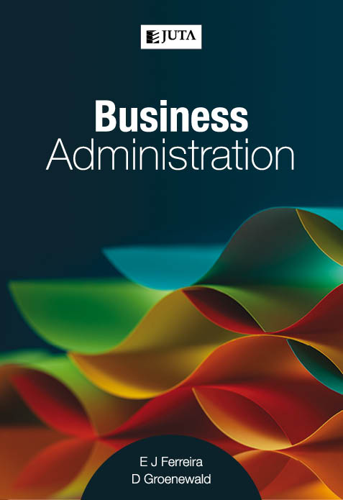
Business Administration

Edition: 1st edition
Published: February 2017
Author/Editors: EJ Ferreira, D Groenewald
ISBN: 9781485122388
Format: Soft cover
Extent: 152 pages
Retail price: R269

A successful and competent administrative manager is integral to any profitable and efficient organisation or office. Business Administration has been written specifically for people working in the field of business administration, as well as those studying Business Administration at higher education institutions. The content is specific to the South African market, and it is the only local textbook on this topic.

Topics include:
• The role of administrative management within an organisation
• Information systems, office systems and the management of information
• Planning, organising, leading, control and problem-solving.

Recommended for:
Any course on Business Administration. This book provides aspirant administrative managers with a good foundation, and offers practising managers the insight that will enable them to manage the administration needs of an organisation more timeously and efficiently, making them invaluable to that organisation.

Contents:
Chapter 1: The role of administrative management within an Organisation
Chapter 2: Information and knowledge management
Chapter 3: Information systems
Chapter 4: Planning function
Chapter 5: Organising in the administrative function
Chapter 6: Leading in the administrative function
Chapter 7: Controlling office activities Quality of writing

JUTA ACADEMIC SALES CONSULTANTS:
Order Details:
Juta & Company Limited
P O Box 14373, Lansdowne, 7779
Tel: 021 6592300
E-mail: orders@juta.co.za
Eastern Cape, KwaZulu Natal, Lesotho, Swaziland and Mpumalanga
Gladman Buthelezi
Address: 19 Hurst Grove, Clifton Place, 1st Floor, Musgrave, Durban, 4001,
Tel: 031 304 4335;
Fax: 031 337 1819;
Cell: 083 702 2425
E-Mail: gbuthelezi@juta.co.za
Namibia, Western Cape and Eastern Cape ( Port Elizabeth)
Janine Gentle
1st Floor, Sunclare Building, 21 Dreyer Street, Claremont, Cape Town
Tel: 021 659 2300
Fax: 021 659 2647
Cell: 072 375 8006
E-mail: jgentle@juta.co.za
Gauteng, KwaZulu-Natal, Eastern Cape and Free State
Jennie Bowen
60 Wilkes Road Prestbury, Pietermaritzburg 3201
Cell: 083 367 9720
E-mail: jbowen@juta.co.za
Gauteng and North-West Province
Marie Botha
Norfolk House, Sandton Close 2, 3rd Floor, c/o 5th and Norwich Roads, Sandton
Tel: 011 217 7234
Fax: 011 883 8564
Cell: 083 399 9042
E-mail: mbotha@juta.co.za
Gauteng, Limpopo, Mpumalanga, Venda and Botswana
Pieter Smith
Norfolk House, Sandton Close 2,3rd Floor,c/o 5th and Norwich Roads, Sandton
Tel: 011 217 7200
Fax: 011 883 8465
Cell: 083 283 7055
E-mail: psmith@juta.co.za

Contact Details:

