Administrative Management
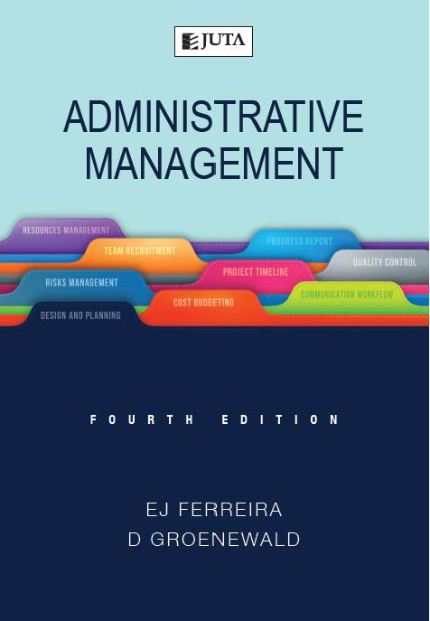

Edition: 4th Edition
Published: 2017
Author/Editors: Ferreira, E.J, Groenewald, D
ISBN: 9781485121275
Format: Paperback
Extent: 592 pages
Retail price: R499

Administrative Management was written specifically for people working in the field of administrative management, as well as those studying administrative management at higher education institutions.
This up-to-date information source will provide both prospective and current information managers and office professionals with the necessary knowledge and insight into information management. It will enable them to manage the information needs of the organisation so that timely, relevant and accurate information is available to managers at all levels so that they can make meaningful decisions.

Recommended for:
This newly updated resource will provide both prospective and current information managers and office professionals with the necessary knowledge and insight into information management. It will enable them to manage the information needs of the organisation so that timely, relevant and accurate information is available to managers at all levels to assist them in making meaningful decisions.

Contents:
Chapter 1
Introduction
1.1 The role of the management function within an organisation
1.2 The role of the administrative function within an organisation
1.3 The role of the administrative manager in an organisation
1.4 The information needs of the organisation
1.5 The relationship between the administrative function and the other functions in an organisation
1.6 The administrative manager of the future
1.7 Conclusion
1.8 Self-assessment
References

Chapter 2
Introduction
2.1 Defining a system
2.2 The objectives of a system
2.3 The elements of a general system
2.4 The characteristics of an efficient information system
2.5 The implementation and modification of information systems
2.6 Different types of information systems
2.7 The integration of systems and the flow of information
2.8 Conclusion
2.9 Self-assessment
References

Chapter 3
Introduction
3.1 The nature of information
3.2 Types of information
3.3 Factors influencing the flow of information
3.4 Perspectives on information management
3.5 Aspects of information management
3.6 Management information
3.7 Knowledge management
3.8 Conclusion
3.9 Self-assessment
References

Chapter 4
Introduction
4.1 The administrative support function
4.2 The profile of the administrative manager
4.3 Events management
4.4 Putting the event together ñ implementation and execution of the plan
4.5 Conclusion
4.6 Self-assessment
References

Chapter 5
Introduction
5.1 The importance of good communication
5.2 The communication process
5.3 Communication channels
5.4 Communication mediums
5.5 Non-verbal communication
5.6 Multicultural communication
5.7 Barriers to effective communication
5.8 Overcoming barriers to effective communication
5.9 Guidelines for effective communication
5.10 Conclusion
5.11 Self-assessment
References

Chapter 6
Introduction
6.1 The written communication process
6.2 Internal and external written communication

6.3 Business letters
6.4 Report writing
6.5 Presenting a report verbally
6.6 Memorandums
6.7 Effective writing techniques
6.8 Using technology to revise your message
6.9 Conclusion
6.10 Self-assessment
References

Chapter 7
Introduction
7.1 Telecommunication systems
7.2 Telecommunication networks
7.3 The Internet
7.4 Modes of electronic communication
7.5 Conclusion
7.6 Self-assessment
References

Chapter 8
Introduction
8.1 What are meetings?
8.2 Types of meeting
8.3 Cycle of a meeting
8.4 Steps in meeting management
8.5 Conducting the meeting
8.6 Following up after the meeting has been held
8.7 Basic meeting terminology
8.8 Conclusion
8.9 Self-assessment
References

Chapter 9
Introduction
9.1 The importance and advantages of effective office design and layout
9.2 The principles of office design and layout
9.3 Steps followed in planning the office layout
9.4 Factors to consider when planning the office layout
9.5 The costing of office space
9.6 Types of office layout
9.7 Specialised areas
9.8 The role of effective office layout in the flow of information
9.9 The role of furniture and equipment in the office layout
9.10 Facilities management
9.11 Conclusion
9.12 Self-assessment
References

Chapter 10
Introduction
10.1 Locating the office building
10.2 Factors to consider in the dÈcor of the office
10.3 The acquisition of office equipment
10.4 The maintenance of office equipment

10.5 Space management
10.6 Conclusion
10.7 Self-assessment
References

Chapter 11
Introduction
11.1 The development of the electronic office
11.2 Features of the electronic office
11.3 Advantages of the electronic office
11.4 The virtual scenario
11.5 Features of the virtual workplace
11.6 The feasibility of the virtual workplace
11.7 Conclusion
11.8 Self-assessment
References

Chapter 12
Introduction
12.1 Quality management
12.2 Total quality management (TQM)
12.3 Management of Administrative policies and procedures
12.4 Systems and processes in quality administrative management
12.5 Systems and process thinking as an approach to quality administrative management
12.6 Business Process Re-engineering and quality administrative management
12.7 Conclusion
12.8 Self-assessment
References

Chapter 13
Introduction
13.1 Productivity
13.2 The role of employees in raising productivity
13.3 The increase of productivity in the office
13.4 Workflow
13.5 Office procedures
13.6 Conclusion
13.7 Self-assessment
References

Chapter 14
Introduction
14.1 The information systems triangle
14.2 Information systems security
14.3 Information systems and the Internet
14.4 Conclusion
14.5 Self-assessment
References

Chapter 15
Introduction
15.1 What is planning?
15.2 Planning at different management levels
15.3 Types of plans and the planning process
15.4 Planning and your subordinates/office workers

15.5 Time management
15.6 Conclusion
15.7 Self-assessment
References

Chapter 16
Introduction
16.1 Organising defined
16.2 Principles of organising
16.3 Centralisation versus decentralisation
16.4 The organising process
16.5 Organisational structures
16.6 Organisational designs
16.7 Conclusion
16.8 Self-assessment
References

Chapter 17
Introduction
17.1 Leadership
17.2 Motivation
17.3 Conclusion
17.4 Self-assessment
References

Chapter 18
Introduction
18.1 The control process
18.2 Characteristics of an effective control system
18.3 Aids for the application of control
18.4 Quality control
18.5 Cost control
18.6 Stock control (also referred to as inventory control)
Conclusion
18.8 Self-assessment
References

Chapter 19
Introduction
19.1 The framework for decision-making
19.2 The basic elements of problem-solving
19.3 Problem-solving abilities
19.4 Steps in the problem-solving process
19.5 Problem-solving aids
19.6 Categories of problems in the administrative department
19.7 Conclusion
19.8 Self-assessment
References

Chapter 20
Introduction
20.1 What is diversity?
20.2 Dimensions of cultural diversity
20.3 Workplace diversity: benefits, problems and challenges
20.4 Reasons for increased diversity in the workplace

20.5 Managing cultural diversity in the workplace
20.6 Best practices
20.7 Conclusion
20.8 Self-assessment
References

Chapter 21
Introduction
21.1 Ethics and value systems
21.2 Views on ethical behaviour
21.3 Myths about business ethics
21.4 Managing ethics in the workplace
21.5 Ethics and the information age
21.6 International business ethics
21.7 The role of ethics in administrative management
21.8 Conclusion
21.9 Self-assessment
References

Chapter 22
Introduction
22.1 The risk management process
22.2 Duties and responsibilities of the administrative manager with regard to risk management
22.3 The financing of risk
22.4 Managing safety
22.5 The loss causation model
22.6 The health and safety programme
22.7 Conclusion
22.8 Self-assessment
References

About the editors:
Professor Edmund Ferreira is a senior lecturer in the Department of Business Management at the University of South Africa. Dr Annatjie Erasmus is currently specialising in quality assurance consultancy and is the sole member of Business Process Engineering CC. Dr Darelle Groenewald is a senior lecturer in the Department of Business Management at the University of Johannesburg.

JUTA ACADEMIC SALES CONSULTANTS:
Order Details:
Juta & Company Limited
P O Box 14373, Lansdowne, 7779
Tel: 021 6592300
E-mail: orders@juta.co.za
Eastern Cape, KwaZulu Natal, Lesotho, Swaziland and Mpumalanga
Gladman Buthelezi
Address: 19 Hurst Grove, Clifton Place, 1st Floor, Musgrave, Durban, 4001,
Tel: 031 304 4335;
Fax: 031 337 1819;
Cell: 083 702 2425
E-Mail: gbuthelezi@juta.co.za
Namibia, Western Cape and Eastern Cape ( Port Elizabeth)
Janine Gentle
1st Floor, Sunclare Building, 21 Dreyer Street, Claremont, Cape Town
Tel: 021 659 2300
Fax: 021 659 2647
Cell: 072 375 8006
E-mail: jgentle@juta.co.za
Gauteng, KwaZulu-Natal, Eastern Cape and Free State
Jennie Bowen
60 Wilkes Road Prestbury, Pietermaritzburg 3201
Cell: 083 367 9720
E-mail: jbowen@juta.co.za
Gauteng and North-West Province
Marie Botha
Norfolk House, Sandton Close 2, 3rd Floor, c/o 5th and Norwich Roads, Sandton
Tel: 011 217 7234
Fax: 011 883 8564
Cell: 083 399 9042
E-mail: mbotha@juta.co.za
Gauteng, Limpopo, Mpumalanga, Venda and Botswana
Pieter Smith
Norfolk House, Sandton Close 2,3rd Floor,c/o 5th and Norwich Roads, Sandton
Tel: 011 217 7200
Fax: 011 883 8465
Cell: 083 283 7055
E-mail: psmith@juta.co.za

Contact Details:

