

UPGRADING INFORMAL SETTLEMENTS IN SOUTH AFRICA: A partnership-based approach
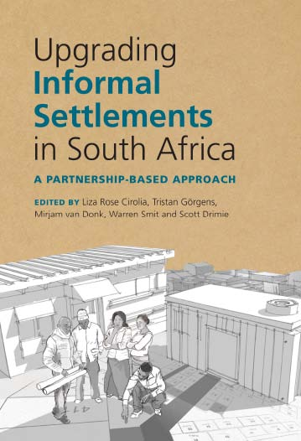
Editors: Liza Cirolia, Tristan Görgens, Mirjam van Donk,
Warren Smit and Scott Drimie
ISBN: 9781775820833 (print)
9781485115694 (Web)
Size: 245 x 168mm
Extent: 546 pages
Illustrations: Over 50
Format: Soft cover
Pub date: October 2016
Rights: World
BISAC: SOC042000
BIC: JFFB
Recommended Retail Price: R550.00 (incl. VAT) / $50.00 / £ 40.00

More than 1.2 million households in South Africa live in informal settlements, without access to adequate shelter, services or secure tenure. There has been a gradual shift to upgrading these informal settlements in recent years, and there have been some innovative experiments. Upgrading Informal Settlements in South Africa: a partnership-based approach examines the successes and challenges of informal settlement upgrading initiatives in South Africa and contextualises these experiences within global debates about informal settlement upgrading and urban transformation. The book discusses:
- The South African informal settlement upgrading agenda from local, national and international perspectives
- South African ‘city experiences’ with informal housing and upgrading
- The role of partnerships, actors and capabilities in pursuing an incremental upgrading agenda
- Tools, instruments and methodologies for incremental upgrading
- Implications of the upgrading agenda for the transformation of cities

The book has been written and edited by a wide range of practitioners and researchers from government, NGOs, the private sector and academia. It covers theory and practice and represents a vast accumulated body of housing experience in South Africa.

Recommended for
Urban planners and policy-makers, government officials, urban and development consultants, NGOs, politicians, students (both undergraduate and postgraduate), and academics in the field of housing, governance, urban studies, informality, Southern cities, development, security and welfare.

About the editors
Liza Cirolia is a researcher on human settlements and informality at the African Centre for Cities, an interdisciplinary urban research institute at the University of Cape Town.
Tristan Görgens, a former policy researcher on urban land and human settlements at Isandla Institute, is a policy analyst in the Policy and Strategy Unit of the Department of the Premier in the
Western Cape government.
Mirjam van Donk is Director of the Isandla Institute, a public interest think-tank with a focus on fostering just, equitable and democratic urban settlements. She is the editor of a number of books on urban policy in South Africa.
Warren Smit is a researcher at the African Centre for Cities at the University of Cape Town with 20 years of experience in housing and policy.
Scott Drimie is a food security specialist, Associate Professor in the Department of Interdisciplinary Health Sciences at Stellenbosch University, Senior Lecturer at the Sustainability Institute and chair of the Advisory Board of Stellenbosch University’s Food Security Initiative. He is also an associate at Isandla Institute.

JUTA ACADEMIC SALES CONSULTANTS:
Order Details:
Juta & Company Limited
P O Box 14373, Lansdowne, 7779
Tel: 021 6592300
E-mail: orders@juta.co.za
Eastern Cape, KwaZulu Natal, Lesotho, Swaziland and Mpumalanga
Gladman Buthelezi
Address: 19 Hurst Grove, Clifton Place, 1st Floor, Musgrave, Durban, 4001,
Tel: 031 304 4335;
Fax: 031 337 1819;
Cell: 083 702 2425
E-Mail: gbuthelezi@juta.co.za
Namibia, Western Cape and Eastern Cape ( Port Elizabeth)
Janine Gentle
1st Floor, Sunclare Building, 21 Dreyer Street, Claremont, Cape Town
Tel: 021 659 2300
Fax: 021 659 2647
Cell: 072 375 8006
E-mail: jgentle@juta.co.za
Gauteng, KwaZulu-Natal, Eastern Cape and Free State
Jennie Bowen
60 Wilkes Road Prestbury, Pietermaritzburg 3201
Cell: 083 367 9720
E-mail: jbowen@juta.co.za
Gauteng and North-West Province
Marie Botha
Norfolk House, Sandton Close 2, 3rd Floor, c/o 5th and Norwich Roads, Sandton
Tel: 011 217 7234
Fax: 011 883 8564
Cell: 083 399 9042
E-mail: mbotha@juta.co.za
Gauteng, Limpopo, Mpumalanga, Venda and Botswana
Pieter Smith
Norfolk House, Sandton Close 2,3rd Floor,c/o 5th and Norwich Roads, Sandton
Tel: 011 217 7200
Fax: 011 883 8465
Cell: 083 283 7055
E-mail: psmith@juta.co.za

