

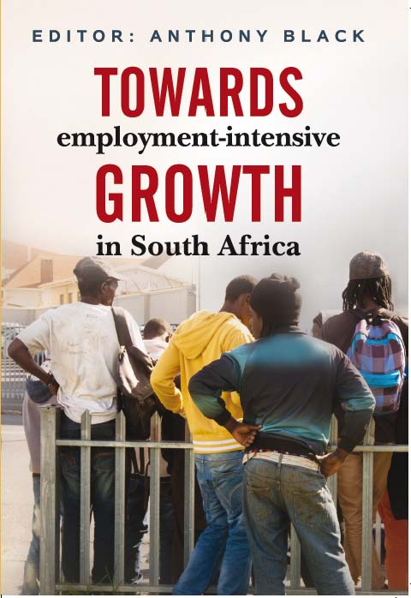
Towards employment-intensive growth in South Africa

Editor: Anthony Black
ISBN: 978 1 77582 007 9 (print)
978 1 77582 166 3 (web pdf)
Size: 245 x 168mm
Extent: 408 pages
Format: Soft cover
Pub date: August 2016
Rights: World
BISAC: BUS068000
BIC: KCFM
Recommended Retail Price: R450 (incl. VAT) / $42.95 / £35.50

South Africa’s high rate of unemployment (26.4%) makes it a complete outlier compared with other middle-income countries. Indeed, the unemployment rate rises to 36% if discouraged workers are taken into account. It underpins extreme poverty and inequality and is a major contributor to social dislocation. If it were not for increased social payments, poverty would have continued to increase since the advent of democracy in 1994. Unemployment also represents a huge cost to growth.
This book focuses on the growth path of the economy. The starting point is that while more rapid economic expansion is an important objective, at any given level of growth, the economy as a whole needs to become more labour-absorbing. The central question posed is how to bring about changes in the economic structure and pattern of development, which would lead to the attainment of this objective.
The authors argue that employment needs to be much more centrally positioned within the economic and social policy arena. They emphasise innovative approaches within a broader focus on the growth path, and employment-intensive growth. And they posit that the negative impact of previous ‘distortions’ requires much more than a levelling of the playing field via market-based reforms. Apart from presenting an alternative growth path which could start to shift the economy in new directions, the book tackles themes which have received only limited attention, such as wage subsidies, youth unemployment and employment growth in rural areas.

Recommended for
Policy-makers and academics in the area of economics, development studies and land reform.

About the editor
Anthony Black is Professor in the School of Economics at the University of Cape Town, South Africa. His main research interests include international trade, foreign investment, industrial development and the automotive industry. He is on the government team of technical experts to develop a ‘post-2020 Automotive Master Plan’.
JUTA ACADEMIC SALES CONSULTANTS:
Order Details:
Juta & Company Limited
P O Box 14373, Lansdowne, 7779
Tel: 021 6592300
E-mail: orders@juta.co.za
Eastern Cape, KwaZulu Natal, Lesotho, Swaziland and Mpumalanga
Gladman Buthelezi
Address: 19 Hurst Grove, Clifton Place, 1st Floor, Musgrave, Durban, 4001,
Tel: 031 304 4335;
Fax: 031 337 1819;
Cell: 083 702 2425
E-Mail: gbuthelezi@juta.co.za
Namibia, Western Cape and Eastern Cape ( Port Elizabeth)
Janine Gentle
1st Floor, Sunclare Building, 21 Dreyer Street, Claremont, Cape Town
Tel: 021 659 2300
Fax: 021 659 2647
Cell: 072 375 8006
E-mail: jgentle@juta.co.za
Gauteng, KwaZulu-Natal, Eastern Cape and Free State
Jennie Bowen
60 Wilkes Road Prestbury, Pietermaritzburg 3201
Cell: 083 367 9720
E-mail: jbowen@juta.co.za
Gauteng and North-West Province
Marie Botha
Norfolk House, Sandton Close 2, 3rd Floor, c/o 5th and Norwich Roads, Sandton
Tel: 011 217 7234
Fax: 011 883 8564
Cell: 083 399 9042
E-mail: mbotha@juta.co.za
Gauteng, Limpopo, Mpumalanga, Venda and Botswana
Pieter Smith
Norfolk House, Sandton Close 2,3rd Floor,c/o 5th and Norwich Roads, Sandton
Tel: 011 217 7200
Fax: 011 883 8465
Cell: 083 283 7055
E-mail: psmith@juta.co.za

