
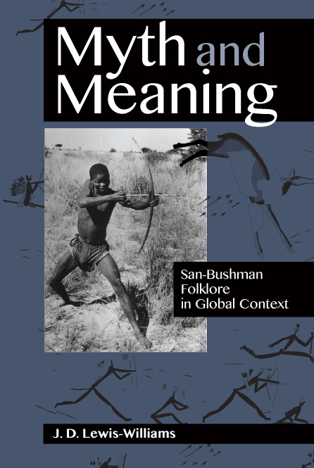
MYTH AND MEANING
San-Bushman folklore in global context

Author: J.D. Lewis-Williams
ISBN: Print: 978 1 77582 2059
Size: 228 x 152mm
Extent: 240 pages
Format: Soft cover
Pub date: July 2015
Rights: Southern Africa only
BISAC: LAW032000
BIC: LAQ

Recommended Retail Price: R299 (incl. VAT)

J.D. Lewis-Williams, a leading South African archaeologist and ethnographer, examines the complex myths of the San-Bushmen to create a larger theory of how myth is used in cultures worldwide. Exploring ethnographic, archival and archaeological lines of research, he extracts the ‘nuggets’, the far-reaching but often unspoken words and concepts of language and understanding that are opaque to outsiders, to establish a more nuanced theory of the role of these myths in the thought-world and social circumstances of the San.

The book
- draws from the author’s own work, the unique 19th-century Bleek & Lloyd Archive, more recent ethnographic work, and San rock art
- includes well-known San stories such as The Broken String, Mantis Dreams, and Creation of the Eland.

Contents
List of Illustrations
Acknowledgements
A note on pronunciation
Prologue: A Broken String?
Chapter 1: Myth in its San incarnation
Chapter 2: Bringing Home the Honey
Chapter 3: The Mantis makes an Eland
Chapter 4: The Fight with the Meerkats
Chapter 5: A Visit to the Lion’s House
Chapter 6: The Mantis Dreams
Chapter 7: Narrating and Painting
Chapter 8: People of the Eland
Chapter 9: The Broken String
Chapter 10: ‘They do not possess my stories’
References
Index
About the Author

Recommended for
Academics, and the general reader, interested in Anthropology, African ethnography, First Peoples, Religion, Folklore, Rock Art and African Studies.

About the author
J.D. Lewis-Williams is Professor Emeritus of cognitive archaeology at Wits University, and is also the founder and former director of the highly regarded Rock Art Research Institute there. He is internationally known for his ground-breaking work on the meanings of rock art, ancient shamanism, the neuropsychology of religious experiences, and the art and beliefs of San culture. He has been awarded an A1 rating by the National Research Foundation. Author of innumerable articles and over 20 books on these topics, he has also been honoured by the American Historical Association, Society for American Archaeology, and Royal Anthropological Institute for his work.

