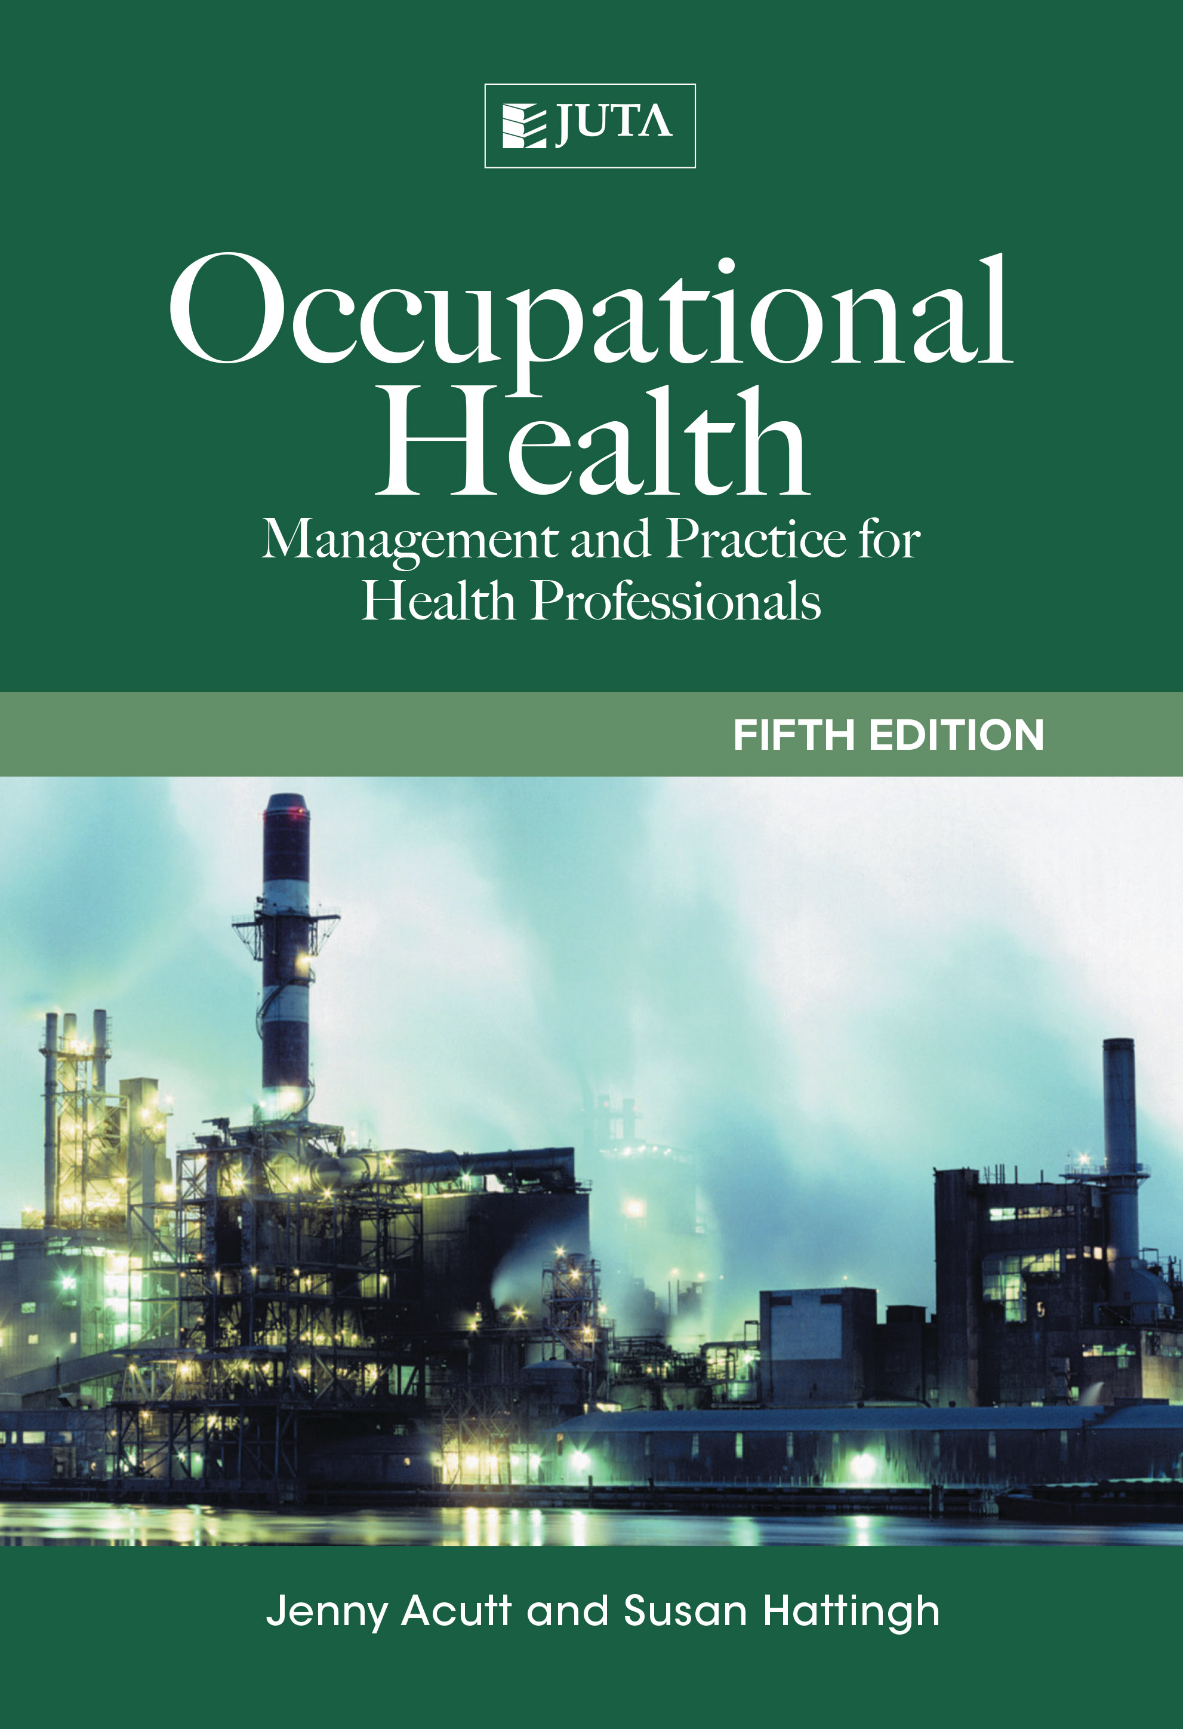
Occupational Health
Management and Practice for Health Practitioners

Author(s) | Jenny Acutt
Author(s) | Susan Hattingh
Book Title | Occupational Health
Subtitle | Management and practice for health practitioners  Fifth edition
ISBN | 9781485112129

Occupational Health: management and practice for health practitioners is the well-known and widely prescribed text in this discipline. The fifth edition has been updated to include a review of the latest legislation affecting the practice of Occupational Health, which is a significant area of study for both the student and practitioner. Applicable Acts are introduced and internet links to the full Acts are provided. The topic of Occupational Medicine has also undergone a complete review, to ensure students and practitioners are aware of the latest research on the topic. Psychological health is looked at from a fresh perspective in this edition.

Drawing on their experience in the field of Occupational Health, the authors explain the relationship between work and health as a two-way process in which the working environment may affect the health of workers, and the workers’ state of health may impact on their ability to do their jobs. The text gives clear guidelines on how to deal with this relationship.

Key features:
•A chapter on environmental health highlights its importance in the broader framework of healthcare.
•A review of the chapter on psychological health, to highlight the importance of treating the patient holistically
Occupational Health: management and practice for health practitioners has been written to meet the needs of anyone working in this field, but particularly those completing the occupational health component of a basic healthcare programme or those pursuing a career in occupational health practice. The new edition has also been peer reviewed by experts in the field

About the authors
Jenny Acutt has been active in the field on occupational health nursing, with all its development and advances in the past 35 years. She has coordinated courses and lectured on the subject since 1982 and is an Honorary Life Member of the South African Society of Occupational Health Nursing Practitioners.
Susan Hattingh is the Associate Dean, King Saud bin Abdulaziz University, Saudi Arabia. She has been a nurse for 45 years and spent many years in the Department of Health Studies at Unisa where, as an Associate Professor, she developed and taught various courses including Occupational Health Nursing on a post-basic level.

JUTA ACADEMIC SALES CONSULTANTS:
Order Details:
Juta & Company Limited
P O Box 14373, Lansdowne, 7779
Tel: 021 6592300
E-mail: orders@juta.co.za
Eastern Cape, KwaZulu Natal, Lesotho, Swaziland and Mpumalanga
Gladman Buthelezi
Address: 19 Hurst Grove, Clifton Place, 1st Floor, Musgrave, Durban, 4001,
Tel: 031 304 4335;
Fax: 031 337 1819;
Cell: 083 702 2425
E-Mail: gbuthelezi@juta.co.za
Namibia, Western Cape and Eastern Cape ( Port Elizabeth)
Janine Gentle
1st Floor, Sunclare Building, 21 Dreyer Street, Claremont, Cape Town
Tel: 021 659 2300
Fax: 021 659 2647
Cell: 072 375 8006
E-mail: jgentle@juta.co.za
Gauteng, KwaZulu-Natal, Eastern Cape and Free State
Jennie Bowen
60 Wilkes Road Prestbury, Pietermaritzburg 3201
Cell: 083 367 9720
E-mail: jbowen@juta.co.za
Gauteng and North-West Province
Marie Botha
Norfolk House, Sandton Close 2, 3rd Floor, c/o 5th and Norwich Roads, Sandton
Tel: 011 217 7234
Fax: 011 883 8564
Cell: 083 399 9042
E-mail: mbotha@juta.co.za
Gauteng, Limpopo, Mpumalanga, Venda and Botswana
Pieter Smith
Norfolk House, Sandton Close 2,3rd Floor,c/o 5th and Norwich Roads, Sandton
Tel: 011 217 7200
Fax: 011 883 8465
Cell: 083 283 7055
E-mail: psmith@juta.co.za

