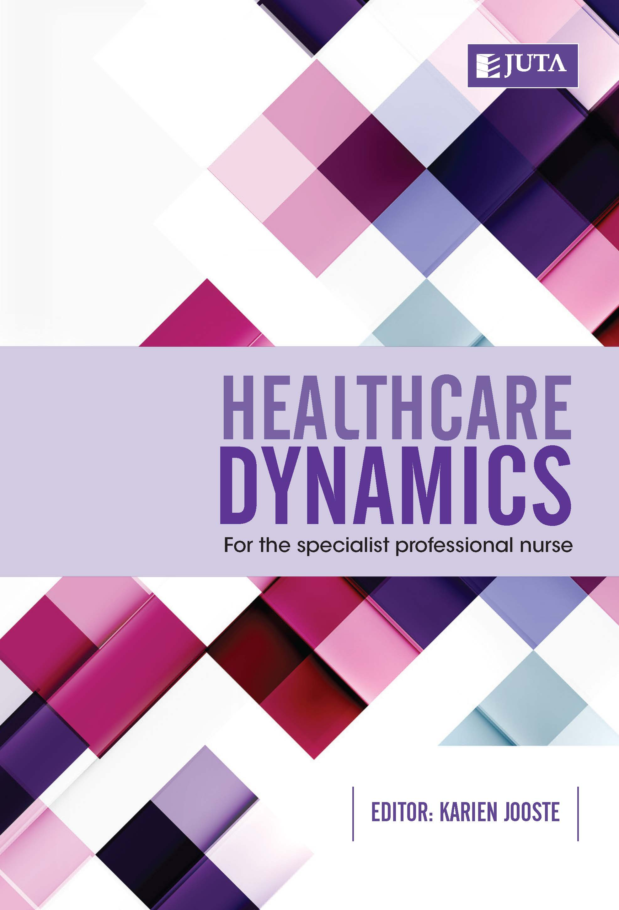
Healthcare Dynamics
for the Specialist Professional Nurse
Edition: 1st Edition
Published: June 2016
Author/Editors: Jooste, K. (ed)
ISBN: 978-1-4851-0397-4
Format: Soft cover
Extent: 312 pages
Retail price: R450.00 (incl. VAT, excl. delivery.)
Please note that price is subject to change
Healthcare Dynamics for the Specialist Professional Nurse is the first text to present important current healthcare practices in the healthcare environment for specialised nurses and healthcare practitioners at district, provincial and national levels. It examines aspects of healthcare dynamics and comprehensive service delivery for all healthcare institutions, within a framework of health legislation, ethics, and professional practice. In addition to fulfilling the developmental needs of specialised nurses, it is a reference tool for healthcare service management for any practising healthcare professional.

This new publication has been peer-reviewed nationally and internationally. It is the result of a collaboration between various academics in the field of nursing and healthcare and is a culmination of their collective experience of management and leadership practice, research and education in the healthcare service context.

Healthcare Dynamics for the Specialist Professional Nurse draws on the insight of expert nursing academics, and healthcare practitioners in the private and public sectors. It reviews:
- specialised healthcare needs and the profile of a community through the lens of health education;
- the role of formal and in-service education programmes for clinical nurse specialists and other team members to ensure best practice in specialised nursing and healthcare services;
- programmes for the personal and professional growth of members of a specialised healthcare team;
- projects in different areas of specialisation that require advisory and facilitative processes;
- consultancy and referral processes through a client and service-centred process;
- evaluation of specialised healthcare units, programmes and services through accredited assessment tools;
- role modelling and mentorship in the specialised healthcare team to develop coping mechanisms for the emotional demand of clinical specialists;
- professional excellence and competence in ethical, legal and policy frameworks, with a focus on human rights, transformation and advocacy;
- the empowerment of patients, families and communities to access existing appropriate resources through continuing health education; and
- quality assurance activities and information systems in specialised healthcare services.

Recommended for:
This book is aimed at specialised nurses and healthcare practitioners at district, provincial and national levels.

About the editors:
Karien Jooste is a Professor in the School of Nursing at the University of the Western Cape with national and international involvements related to nursing management and leadership. She is known for her hallmark ‘leadership’ through her publications, editorial positions, honorary international positions, awards and her personal aim to empower others to lead.

JUTA ACADEMIC SALES CONSULTANTS:
Order Details:
Juta & Company Limited
P O Box 14373, Lansdowne, 7779
Tel: 021 6592300
E-mail: orders@juta.co.za
Eastern Cape, KwaZulu Natal, Lesotho, Swaziland and Mpumalanga
Gladman Buthelezi
Address: 19 Hurst Grove, Clifton Place, 1st Floor, Musgrave, Durban, 4001,
Tel: 031 304 4335;
Fax: 031 337 1819;
Cell: 083 702 2425
E-Mail: gbuthelezi@juta.co.za
Namibia, Western Cape and Eastern Cape ( Port Elizabeth)
Janine Gentle
1st Floor, Sunclare Building, 21 Dreyer Street, Claremont, Cape Town
Tel: 021 659 2300
Fax: 021 659 2647
Cell: 072 375 8006
E-mail: jgentle@juta.co.za
Gauteng, KwaZulu-Natal, Eastern Cape and Free State
Jennie Bowen
60 Wilkes Road Prestbury, Pietermaritzburg 3201
Cell: 083 367 9720
E-mail: jbowen@juta.co.za
Gauteng and North-West Province
Marie Botha
Norfolk House, Sandton Close 2, 3rd Floor, c/o 5th and Norwich Roads, Sandton
Tel: 011 217 7234
Fax: 011 883 8564
Cell: 083 399 9042
E-mail: mbotha@juta.co.za
Gauteng, Limpopo, Mpumalanga, Venda and Botswana
Pieter Smith
Norfolk House, Sandton Close 2,3rd Floor,c/o 5th and Norwich Roads, Sandton
Tel: 011 217 7200
Fax: 011 883 8465
Cell: 083 283 7055
E-mail: psmith@juta.co.za

