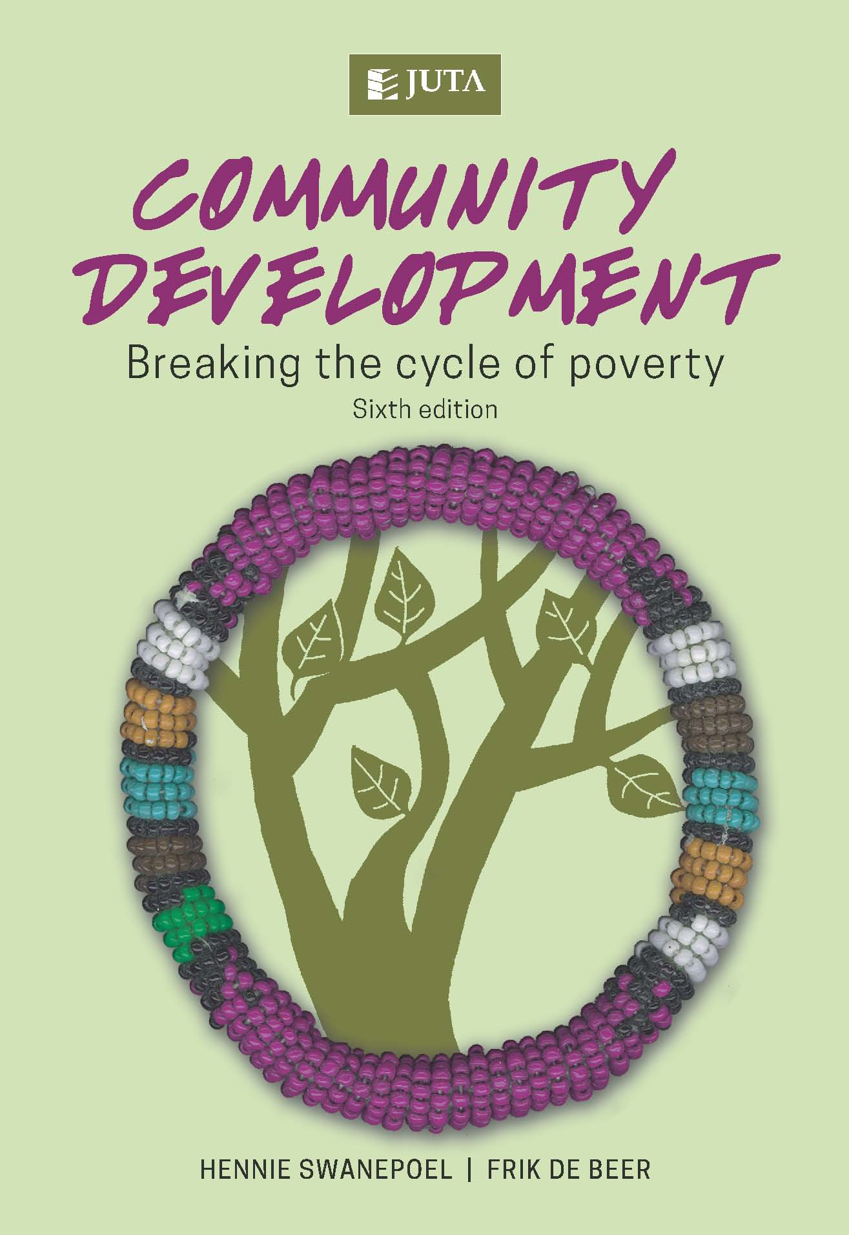
Community Development
-Breaking the cycle of poverty

Edition: 6th Edition
Published: October 2016
Author/Editors: Frik de Beer, Hennie Swanepoel
ISBN: 978-1-4851-1377-5
Format: Soft cover
Extent: 376 pages
Retail price: R341 (incl. VAT, excl. delivery.)

Community development both a collective effort and an achievement driven by individual facilitators with the aim of lifting a community out of poverty
The sixth edition of Community Development: Breaking the cycle of poverty continues to be a definitive guide for community development workers, students and practitioners alike. The book contextualises poverty and explains the process of community development. It pays attention to the development environment and explains concepts such as asset-based community development and the social enterprise sector. In addition to context and process, the book details the skills required by a community development worker to function in the field. It also explains how to empower the development worker to train others in order to build capacity in the community and work towards breaking the cycle of poverty.
This edition of Community Development: Breaking the cycle of poverty is strengthened by the inclusion of extensive support material. More practical case studies, specifically relevant to the South African environment, have been added and questions on the case studies are included in the book.
About the editors:

Professors Hennie Swanepoel and Frik de Beer have spent most of their professional careers working in the Unisa’s Department of Development Studies. They have been involved in research projects locally and internationally. These projects have included rural development, housing, energy use, local government, training and community-based natural resource management. Numerous publications have resulted from the authors’ research, with this text, Community Development: Breaking the cycle of poverty, being the most comprehensive.

Contents:
Chapter 1: Poverty, ill-being and well-being Chapter 2: The development environment
Chapter 3: Stakeholders in community development Chapter 4: The origins of community development Chapter 5: The features and outcomes of community development Chapter 6: The principles of community development Chapter 7: The community as main actor in community development Chapter 8: The place and role of community development workers Chapter 9: Participatory decision-making and management Chapter 10: Communication skills Chapter11: Leadership development and group facilitation Chapter 12: Conflict resolution, mediation and negotiation Chapter 13: Mobilisation and motivation Chapter 14: Operational writing
Chapter 15: Meetings Chapter 16: Public speaking Chapter 17: Contact-making Chapter 18: Participatory research methodology Chapter 19: The start of a project Chapter 20: Planning and implementation Chapter 21: Evaluation and control Chapter 22: The training dialogue
Chapter 23: Planning and facilitating a training workshop
JUTA ACADEMIC SALES CONSULTANTS:
Order Details:
Juta & Company Limited
P O Box 14373, Lansdowne, 7779
Tel: 021 6592300
E-mail: orders@juta.co.za
Eastern Cape, KwaZulu Natal, Lesotho, Swaziland and Mpumalanga
Gladman Buthelezi
Address: 19 Hurst Grove, Clifton Place, 1st Floor, Musgrave, Durban, 4001,
Tel: 031 304 4335;
Fax: 031 337 1819;
Cell: 083 702 2425
E-Mail: gbuthelezi@juta.co.za
Namibia, Western Cape and Eastern Cape ( Port Elizabeth)
Janine Gentle
1st Floor, Sunclare Building, 21 Dreyer Street, Claremont, Cape Town
Tel: 021 659 2300
Fax: 021 659 2647
Cell: 072 375 8006
E-mail: jgentle@juta.co.za
Gauteng, KwaZulu-Natal, Eastern Cape and Free State
Jennie Bowen
60 Wilkes Road Prestbury, Pietermaritzburg 3201
Cell: 083 367 9720
E-mail: jbowen@juta.co.za
Gauteng and North-West Province
Marie Botha
Norfolk House, Sandton Close 2, 3rd Floor, c/o 5th and Norwich Roads, Sandton
Tel: 011 217 7234
Fax: 011 883 8564
Cell: 083 399 9042
E-mail: mbotha@juta.co.za
Gauteng, Limpopo, Mpumalanga, Venda and Botswana
Pieter Smith
Norfolk House, Sandton Close 2,3rd Floor,c/o 5th and Norwich Roads, Sandton
Tel: 011 217 7200
Fax: 011 883 8465
Cell: 083 283 7055
E-mail: psmith@juta.co.za

