Compare: A Journal of Comparative and International Education
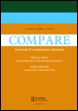
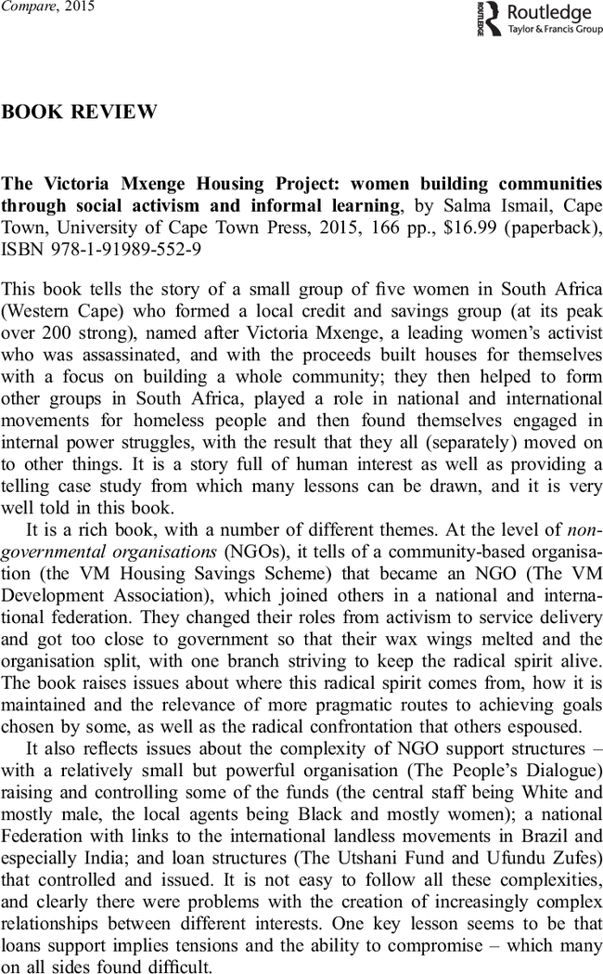
Click to increase image sizeClick to decrease image size

- Information
- Full text
- Reprints & permissions
This book tells the story of a small group of five women in South Africa (Western Cape) who formed a local credit and savings group (at its peak over 200 strong), named after Victoria Mxenge, a leading women's activist who was assassinated, and with the proceeds built houses for themselves with a focus on building a whole community; they then helped to form other groups in South Africa, played a role in national and international movements for homeless people and then found themselves engaged in internal power struggles, with the result that they all (separately) moved on to other things. It is a story full of human interest as well as providing a telling case study from which many lessons can be drawn, and it is very well told in this book.
It is a rich book, with a number of different themes. At the level of non-governmental organisations (NGOs), it tells of a community-based organisation (the VM Housing Savings Scheme) that became an NGO (The VM Development Association), which joined others in a national and international federation. They changed their roles from activism to service delivery and got too close to government so that their wax wings melted and the organisation split, with one branch striving to keep the radical spirit alive. The book raises issues about where this radical spirit comes from, how it is maintained and the relevance of more pragmatic routes to achieving goals chosen by some, as well as the radical confrontation that others espoused.
It also reflects issues about the complexity of NGO support structures – with a relatively small but powerful organisation (The People's Dialogue) raising and controlling some of the funds (the central staff being White and mostly male, the local agents being Black and mostly women); a national Federation with links to the international landless movements in Brazil and especially India; and loan structures (The Utshani Fund and Ufundu Zufes) that controlled and issued. It is not easy to follow all these complexities, and clearly there were problems with the creation of increasingly complex relationships between different interests. One key lesson seems to be that loans support implies tensions and the ability to compromise – which many on all sides found difficult.
Secondly, there is a feminist theme – or rather, a gender dimension, for the role of males in this women's movement runs throughout the story. The challenges to the various patriarchal cultures were also varied, some direct, others indirect. The key challenge was to find the right role for men, how men can encourage and support rather than either lead and control (The People's Dialogue) or walk away (which some male partners of the women did, though several agreed to care for children and other dependents while the women were busy).
Thirdly the book speaks a good deal about learning. This is an area that could have been more fully developed. The women deliberately used formal learning (Salma Ismail became involved when one of the women enrolled in her adult education course at the university), non-formal learning (many short training courses) and informal education (e.g. persuading a skilled workman to teach them brick making and laying, etc.) and certificates became important to some of them. But beyond this lay all the informal learning – unintentional, mainly unconscious, simply learned in the course of coping with all the many problems and issues they had to face day by day. Discussions of learning in these pages tend to concentrate more on skills than on knowledge, and the distinction between hard skills (e.g. drawing plans, building houses, filling in forms, etc.) and soft skills (leadership, interpersonal relations such as dealing with planning officials, etc.) is not made explicit. The huge tacit funds of knowledge and banks of skills that these women accumulated and used during the period were unacknowledged not just by educational institutions (despite a rhetorical commitment to the recognition of prior experiential learning), but often by the women themselves. There is much material in this book about learning through social movements.
Fourthly, the book is an excellent example of an academic research project. It started by accident and became a PhD research project using qualitative (ethnographic) approaches (it was surprising to discover that the book originated as a PhD thesis, for it does not read like one). In various 'me-in-the-thesis' sections scattered through these pages, the author constantly questions her own position in the project – is she observer or participant observer? She ponders on the tension between distance and proximity, which ethnographers describe as inherent in their work. She outlines the ethics of such research (the five women at the heart of the research all gave full knowing consent for their names to be used).
At the heart of this book is the issue that others have raised – in order for learning through social movements to be effective, it seems to be necessary to have some external agency who/which brings some measure of 'theory' onto the stage, some meta-learning that will help make the unconscious conscious. Gramsci suggests this is the work of 'organic intellectuals', but the organic intellectuals here were a small group of women who initiated and led the movement over some 10 years – and it was they who needed some outside spur to become aware of the knowledge and skills they had built up experientially. Ismail suggests this outside catalyst (the grit that produces the pearl) was the international element bringing in concepts of 'popular education', but these elements are not described in any detail: we hear of exchange visits between South Africa and Brazil (MST) and India (Shack/Slum Dwellers International), but nothing of when, to whom, how funded and so on.
This is an unusual book, rich on so many ways. Most PhD theses start off with a theoretical framework and apply it to a case study. This project reverses the process. Startled into looking deeply into a local project by meeting one of its leaders, Salma Ismail decided simply to find out what was going on and what that 'going on' will teach us. The project and the research came first, the PhD later – and that seems to me to be a significant lesson for those who seek to learn from development projects and social movements.
Alan Rogers
School of Education and Lifelong Learning University of East Anglia, Norwich, UK
alan.rogers@uea.ac.uk
© 2015, Alan Rogers
http://dx.doi.org/10.1080/03057925.2015.1074833

