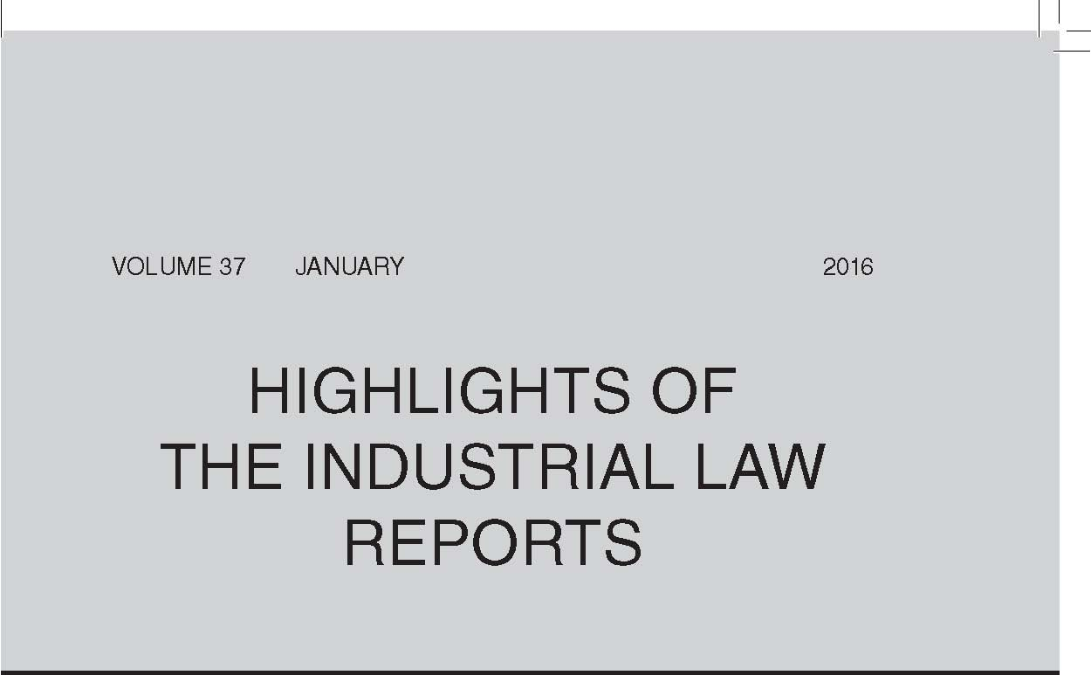
Transfer of Business as Going Concern
In Atlas Packaging (Pty) Ltd v Palierakis: In re Palierakis v Atlas Carton & Litho CC (in liquidation) & others (at 109) the Labour Appeal Court confirmed that, in the case of the transfer of an insolvent business, s 197A(1)(b) of the LRA 1995 only applies if there has been a genuine scheme of arrangement or compromise to avoid the winding-up of the business.
In Maluti-A-Phofung Local Municipality v Rural Maintenance (Pty) Ltd & another (at 128) the Labour Appeal Court found that, where a transfer takes place as a result of official conduct that may be ultra vires, the consequences of the transfer remain until the impugned conduct is properly set aside. It also found that, on an examination of the totality of the business operated by the transferor, no transfer as a going concern had occurred because the transferee could not operate the same business without significant additional investment.
Sexual Harassment
The Labour Appeal Court has found that an older, male employee’s inappropriate sexual advance to a younger, female contractor outside the workplace constituted sexual harassment. Underlying this unwelcome advance lay a power differential that favoured the employee due to both his age and gender, and the mere fact that his conduct was not physical, that it occurred during a single incident, that it was not persisted in, and that it took place outside the workplace did not negate the fact that it constituted sexual harassment. The Constitution afforded the female contractor, and other women, the protection to engage constructively and on an equal basis in the workplace without interference upon their dignity and integrity (Campbell Scientific Africa (Pty) Ltd v Simmers & others at 116).
In Dheaneshwer and Tri Media (at 272) a CCMA commissioner found that, where a newly employed young woman had been sent sexually suggestive and inappropriate text messages by a senior manager, this has rendered her continued employment intolerable. She had been constructively dismissed and was entitled to compensation.
Collective Agreements
The Labour Court was of the view that a bargaining council collective agreement governed by ss 31 and 32 of the LRA 1995 is an agreement of a special type, and it cannot ‘morph’ into a s 23 collective agreement when it is found to be non-compliant with the bargaining council’s constitution (City of Cape Town v Independent Municipal & Allied Trade Union & others at 147).
Strikes, Lock-outs and Pickets
The Labour Court was satisfied in National Union of Metalworkers of SA on behalf of Members v Videx Wire Products (Pty) Ltd & others (at 171) that the union’s demand relating to productivity bargaining amounted to a demand for higher wages; that such a demand could only be negotiated at national level under the auspices of the bargaining council; and that consequently the union and its members could not strike over the demand.
In SA Commercial Catering & Allied Workers Union v Sun International (at 215) the Labour Court considered the exception to the prohibition on the use of replacement labour by an employer which initiates a lock-out. In contrast to an earlier decision of the Labour Court, the court interpreted the words ‘in response to a strike’ in s 76(1)(b) of the LRA 1995 to mean that an employer’s statutory right to hire replacement labour is restricted to the period during which a protected strike pertains and does not continue after the strike has ceased.
In Verulam Sawmills (Pty) Ltd v Association of Mineworkers & Construction Union & others (at 246) the Labour Court had to determine costs after an interdict had been granted compelling the union and its members to comply with a picketing rules agreement and interdicting the union’s members from engaging in unlawful and violent conduct during the course of a protected strike. The court found that the union was obliged to take all reasonable steps to prevent violent conduct and ensure compliance with the picketing rules agreement. As it had failed to do so, the court granted a punitive costs order against the union.
Registar of Labour Relations — Revocation of Designation
Following the revocation of his designation as Registrar of Labour Relations by the Minister of Labour, Mr Crouse approached the Labour Court to review and set aside her decision. It found, inter alia, that the minister’s decision constituted administrative action and was subject to review under the Promotion of Administrative Justice Act 3 of 2000; alternatively, that the minister’s decision was subject to review on the principles of legality. It found further that the minister had ignored materially relevant facts and as a consequence her decision was unreasonable, alternatively irrational; and procedurally unfair. The impugned decision was set aside and Mr Crouse was reinstated in his position as Registrar of Labour Relations (Public Servants Association of SA & another v Minister of Labour & another at 185).
Bargaining Council — Recovery of Costs of Arbitration
The Labour Court has found that, when the SALGBC seeks to recover costs of arbitration proceedings between two litigating parties to the council, it can only do so if a costs award has been made in its favour by an arbitrator. It is not appropriate for the SALGBC to rely on s 33A of the LRA 1995 to enforce costs awards — it must rely on the execution provisions of its main agreement, alternatively s 143 of the LRA to do so (SA Local Government Bargaining Council v Ally NO & another at 223).
Residual Unfair Labour Practice — Promotion
In KwaZulu-Natal Department of Transport v Hoosen & others (at 156) the Labour Court found that, where a public service employee is permitted to remain in an upgraded post with a higher salary and rank designation when returning from deployment to another unit, this constitutes a promotion. In this matter the promotion of an employee who did not meet the minimum qualifications for the post was unfair as it impeded the career prospects of his colleagues who were wrongly blocked from ascending to that post.
Unfair Discrimination — Arbitrary Ground
The employer offered a provident fund, which included savings, retirement, funeral and disability schemes, to all employees who had completed five years’ service. Certain employees who had less than five years’ service contended that this conduct was arbitrary and constituted unfair discrimination in terms of s 6 of the Employment Equity Act 55 of 1998. A CCMA commissioner agreed with the employees, finding that there was no objective basis for the cut-off period of five years. The differentiation was arbitrary and lacking in logic and constituted unfair discrimination (Ndlela & others and Philani Mega Spar at 277).
Dismissal — Comments on Social Media
An employee was dismissed for making offensive comments on Facebook regarding her pending retrenchment. A bargaining council arbitrator found that, in circumstances where the employee was emotional distressed, unprepared and overwhelmed by the announcement of her potential retrenchment and where she regretted making the comment and removed the post the next day, the making of the post on Facebook did not constitute serious misconduct justifying dismissal (Robertson and Value Logistics at 285).
Protected Disclosure
In Nxumalo v Minister of Correctional Services & others (at 177) the Labour Court refused to grant an urgent interdict to stop disciplinary proceedings against the employee on the grounds that he had made a protected disclosure. The court was satisfied that the transcript relied on by the employee did not contain information that disclosed or tended to disclose forms of criminal or other misconduct, and was therefore not the subject of protection under the Protected Disclosures Act 26 of 2000.
Reinstatement
Where a bargaining council arbitrator had refused to award reinstatement for the substantively unfair dismissal of two employees merely because of the unexplained lengthy delay in finalising the matter, the Labour Court on review confirmed that a lengthy period of delay is not a bar to reinstatement but may affect its practicability. It was satisfied that in this matter there was no evidence of the impracticability of reinstatement and that the arbitrator ought to have ordered the employer to reinstate the employees (Zuma & another v Public Health & Social Development Sectoral Bargaining Council & others at 257).
Practice and Procedure
The Labour Court found, in Chauke v Safety & Security Sectoral Bargaining Council & others (at 139), that it is not permissible to raise an exception in motion proceedings before the court.
In Makuse v Commission for Conciliation, Mediation & Arbitration & others (at 163) the Labour Court confirmed that, where there has been a flagrant failure to comply with prescribed time-limits and the applicant for condonation has given no compelling explanation for the egregious delay, condonation may be refused without considering the prospects of success.
Quote of the Month:
Myburgh AJ, commenting on the implicit obligation on a union ‘to take all reasonable steps’ to ensure compliance by its members with the terms of a picketing rules agreement, in Verulam Sawmills (Pty) Ltd v Association of Mineworkers & Construction Union & others (2016) 37 ILJ 246 (LC):
‘To my mind, this is a fundamentally important obligation. Not only are picketing rules there to attempt to ensure the safety and security of persons and the employer’s workplace, but if they are not obeyed and violence ensues resulting in non-strikers also withholding their labour, the strikers gain an illegitimate advantage in the power play of industrial action, placing illegitimate pressure on employers to settle. Typically, one of two things then happens — either the employer gives in to the pressure and settles at a rate above that reflecting the forces of demand and supply (which equates to a form of economic duress) or the employer digs in its heels and refuses to negotiate or settle while the violence is ongoing (which inevitably causes strikes to last longer than they should). Either way, the orderly system of collective bargaining that the LRA aspires to is undermined — and ultimately, economic activity and job security are threatened.’

