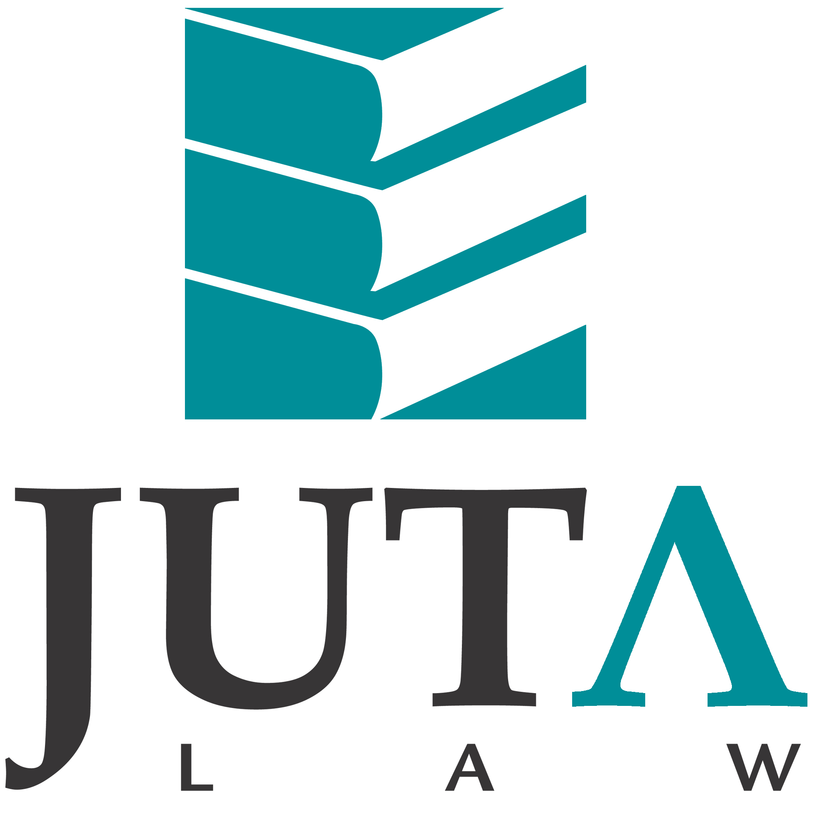

JUTA'S ADVANCE NOTIFICATION SERVICE

JANUARY 2016

Dear South African Law Reports and Criminal Law Reports subscriber

Herewith the cases in the January law reports.

JUDGMENTS OF INTEREST IN THE JANUARY EDITIONS OF THE SALR AND SACR LAW REPORTS.

- Click on the case name to download the original judgment.

SOUTH AFRICAN LAW REPORTS

Perpetual guarantee for insolvent airline
A private domestic airline requested the court to annul the government’s issue of a R5 billion loan guarantee to SAA, the insolvent state-owned airline, which guarantee was later converted into a perpetual guarantee. Comair Ltd v Minister of Public Enterprises 2016 (1) SA 1 (GP)

Lengthy affidavits
The court noted with disfavour the length of the answering affidavit at 40 pages, without annexures, and that it contained hearsay and legal opinion on matters the court was required to decide. Venmop 275 (Pty) Ltd and Another v Cleverlad Projects (Pty) Ltd and Another 2016 (1) SA 78 (GJ)

Private funding of political parties
The applicant asserted that the details of the private funding of political parties registered for elections to all legislative bodies were required for the exercise of the right to vote; that the Constitution consequently obliged Parliament to enact legislation allowing access to this information; and that it had failed to do so. My Vote Counts NPC v Speaker of the National Assembly and Others 2016 (1) SA 132 (CC)

SOUTH AFRICAN CRIMINAL LAW REPORTS

Dolus eventualis and directus
In his written plea, the accused conceded that he had dolus eventualis, but claimed that he lacked the intention to kill. Was the court bound by his statement, and could it infer dolus directus from the brutal murder and robbery? S v Asele 2016 (1) SACR 13 (NCK)

What constitutes sexual grooming
Manipulation of a child’s sexual psyche by an adult for his own amusement is harmful conduct which may have far-reaching consequences for the child, even if the adult had no intention of ultimately performing any overt sexual act. S v RC 2016 (1) SACR 34 (KZP)

Trial conducted in indigenous language
Advancing the status and use of indigenous languages, particularly in the lower courts at this stage, was to be encouraged. However, there were not proper structures in place that could adequately and timeously attend to the transcription of records from the nine indigenous languages for the purposes of appeals or reviews. S v Damani 2016 (1) SACR 80 (KZP)

WE WELCOME YOUR FEEDBACK

Please send any comments or queries to lawreports@juta.co.za

Kind Regards

The Juta Law Reports Team

SOUTH AFRICAN LAW REPORTS

JANUARY 2016

TABLE OF CASES

- Comair Ltd v Minister of Public Enterprises and Others 2016 (1) SA 1 (GP)
- Mayo NO and Others v De Montlehu 2016 (1) SA 36 (SCA)
- YB v SB and Others NNO 2016 (1) SA 47 (WCC)
- KS v MS 2016 (1) SA 64 (KZD)
- TM v ZJ 2016 (1) SA 71 (KZD)
- Venmop 275 (Pty) Ltd and Another v Cleverlad Projects (Pty) Ltd and Another 2016 (1) SA 78 (GJ)
- Asmal v Essa 2016 (1) SA 95 (SCA)
- Minister of Defence and Military Veterans v Thomas 2016 (1) SA 103 (CC)
- Minnaar v Van Rooyen NO 2016 (1) SA 117 (SCA)
- Snyders NO v Louistef (Pty) Ltd and Others 2016 (1) SA 123 (GP)
- My Vote Counts NPC v Speaker of the National Assembly and Others 2016 (1) SA 132 (CC)
- Panamo Properties 103 (Pty) Ltd v Land and Agricultural Development Bank of South Africa 2016 (1) SA 202 (SCA)
- Engela v Road Accident Fund 2016 (1) SA 214 (GJ)
- Zietsman and Another v Directorate of Market Abuse and Another 2016 (1) SA 218 (GP)
- Four Arrows Investments 68 (Pty) Ltd v Abigail Construction CC and Another 2016 (1) SA 257 (SCA)
- Ruiters v Minister of Human Settlements and Another 2016 (1) SA 239 (WCC)
- Gap Merchant Recycling CC v Goal Reach Trading 55 CC 2016 (1) SA 261 (WCC)
- Graham and Another v Law Society, Northern Provinces and Others 2016 (1) SA 279 (GP)
- Ellis and Another v Cilliers NO and Others 2016 (1) SA 293 (WCC)
- Minister of Mineral Resources and Others v Mawetse (SA) Mining Corporation (Pty) Ltd 2016 (1) SA 306 (SCA)

FLYNOTES

COMAIR LTD v MINISTER OF PUBLIC ENTERPRISES AND OTHERS (GP)
FABRICIUS J
2015 MAY 5–14; JUNE 6

Aviation—National airline—State funding—Loan guarantee—Legality—Compliance with statutory framework—Impact of likely inability of national airline to repay loan—Strategic role of national airline—Non-financial considerations relevant—Guarantee lawful—Public Finance Management Act 1 of 1999, s 70.
State—Finance—Loan guarantee—Issuing of loan guarantee constituting executive action subject to principle of legality—Not for court to secondguess financial wisdom of guarantee—Public Finance Management Act 1 of 1999, s 70.

MAYO NO AND OTHERS v DE MONTLEHU (SCA)
BOSIELO JA, LEACH JA, MAJIEDT JA, WILLIS JA and ZONDI JA
2015 AUGUST 31; SEPTEMBER 23
[2015] ZASCA 127

Company—Winding-up—Claim against company in liquidation—Proof—Late proof—Statutory framework—Time period stipulated in s 44(1) of Insolvency Act 24 of 1936 not affected by s 366(2) of Companies Act 61 of 1973—Three-month period for lodging of claims applying to both sequestrations and liquidations.
Statute—Interpretation—‘Mutatis mutandis’—Meaning ‘subject to necessary alterations’—Necessary changes must be required, not merely permitted.

YB v SB AND OTHERS NNO (WCC)
RILEY AJ
2015 AUGUST 13

Marriage—Divorce—Proprietary rights—Accrual system—Assets held in trust—Transactions reflecting trust as acquiring assets simulated—Assets part of husband’s estate—Whether assets could be taken into account in calculating accrual—Matrimonial Property Act 88 of 1984, ss 3 and 4.

KS v MS (KZD)
KRUGER J
2015 MARCH 2; MAY 25

Marriage—Divorce—Proprietary rights—Accrual system—Proof of accrual—When determined—Litis contestatio, not date of divorce—Matrimonial Property Act 88 of 1984, s 3(1).

TM v ZJ (KZD)
MOKGOHLOA J
2015 APRIL 14, 16; SEPTEMBER 2

Marriage—Divorce—Maintenance—Spouse—Maintenance pendente lite—Marriage under Islamic law—No bar to obtaining relief in terms of rule—Uniform Rules of Court, rule 43.

VENMOP 275 (PTY) LTD AND ANOTHER v CLEVERLAD PROJECTS (PTY) LTD AND ANOTHER (GJ)
PETER AJ
2015 FEBRUARY 3; AUGUST 3

Practice—Applications and motions—Affidavits—Length of—Caution as to—Practice to include statement by deponent that he made legal submissions based on legal advice, followed by such submissions—Criticism of practice.
Review—Procedure—Record on review—Applicant’s duty to select relevant material from record, to serve as evidence—Consideration of—Uniform Rules of Court, rule 53(3).
Evidence—Admissibility—Statement that is part of negotiations for settlement of dispute.
Arbitration—Procedure—Times fixed under Act—Extension of, if ‘good cause’ shown—Nature of ‘good cause’—Arbitration Act 42 of 1965, s 38.
Arbitration—Award—Setting-aside of—Right to apply for—Doctrine of peremption can be applied to right—Arbitration Act 42 of 1965, s 33(1).
Discovery and inspection—Failure to discover documents—Application to court to order their production—Whether court has discretion to not order production of relevant documents—Uniform Rules of Court, rule 35(7).

ASMAL v ESSA (SCA)
MPATI P, LEWIS JA, MAYA JA, SHONGWE JA and MATHOPO AJA
2014 MARCH 14; MAY 14
[2013] ZASCA 62

Credit agreement—Consumer credit agreement—Whether agreement subject to NCA—Loan covered by blank cheque and profit share to be determined by borrower—Profit share not fee, charge or interest—Loan agreements not ‘credit agreements’ covered by NCA—National Credit Act 34 of 2005, s 8(3) and s 8(4).

MINISTER OF DEFENCE AND MILITARY VETERANS v THOMAS (CC)
MOGOENG CJ, MOSENEKE DCJ, CAMERON J, FRONEMAN J, JAFTA J, KHAMPEPE J, MADLANGA J, MOLEMELA AJ, NKABINDE J, THERON AJ and TSHIQI AJ
2015 MAY 19; AUGUST 25

Labour law—Compensation for occupational injuries and diseases—Preclusion of delictual claim against employer—State as employer—Not regarded as single entity—Court allowing provincial employee to claim compensation from province and delictual damages from national government—Compensation for Occupational Injuries and Diseases Act 130 of 1993, s 35(1).
State—Ambit of concept—State as employer—State not regarded as single employer for all employees working in three different spheres of government.
Constitutional law—Co-operative government—Autonomy of spheres of government—State not regarded as single employer for all employees working in three different spheres of government.
Delict—Exclusion of liability—Statutory barring of claim by employee against employer for occupational injury—Meaning of ‘employer’—State not regarded as single employer for all employees working in three different spheres of government.

MINNAAR v VAN ROOYEN NO (SCA)
LEWIS JA, TSHIQI JA, MAJIEDT JA, DAMBUZA JA and BAARTMAN AJA
2015 AUGUST 24; SEPTEMBER 10
[2015] ZASCA 114

Company—Directors and officers—Liability for debts of company—Court cannot make prescribed finding of recklessness or intent to defraud without hearing evidence—Grant by default of order under s 424(1) of Companies Act 61 of 1973 not permitted.

SNYDERS NO v LOUISTEF (PTY) LTD AND OTHERS (GP)
JANSE VAN NIEUWENHUIZEN J
2015 JULY 7

Minerals and petroleum—Petroleum—Fuelling station—Site licence—Purported sale—Licence not merx or res vendita—Sale accordingly null and void—Petroleum Products Act 120 of 1977, s 2.

MY VOTE COUNTS NPC v SPEAKER OF THE NATIONAL ASSEMBLY AND OTHERS (CC)
MOGOENG CJ, MOSENEKE DCJ, CAMERON J, FRONEMAN J, JAPPIE AJ, KHAMPEPE J, MADLANGA J, MOLEMELA AJ, NKABINDE J, THERON AJ and TSHIQI AJ
2015 FEBRUARY 10; SEPTEMBER 30
[2015] ZACC 31

Constitutional law—Human rights—Right of access to information—Details of private funding of political parties—Assertion that Parliament had failed to fulfil its constitutional obligation to enact legislation giving access to these details—Applicant seeking order that Parliament do so—True nature of applicant’s case an attack on validity of PAIA—Failure, contrary to principle of subsidiarity, to attack PAIA’s validity—Constitution, 1996, s 32; Promotion of Access to Information Act 2 of 2000.

PANAMO PROPERTIES 103 (PTY) LTD v LAND AND AGRICULTURAL DEVELOPMENT BANK OF SOUTH AFRICA (SCA)
LEWIS JA, PILLAY JA, WILLIS JA, SCHOEMAN AJA and GORVEN AJA
2015 MAY 7, 22
[2015] ZASCA 70

Mortgage—Mortgage bond—Validity—May secure debt arising from enrichment claim.

ENGELA v ROAD ACCIDENT FUND (GJ)
MASHILE J
2015 JUNE 15

Delict—Specific forms—Loss of support—Dependant’s action—Extension—Permanent heterosexual relationships—Extension applying also where divorced parties reconciled and lived together as family again, but deceased made no promise to remarry nor expressly agreed to support illegitimate child.

ZIETSMAN AND ANOTHER v DIRECTORATE OF MARKET ABUSE AND ANOTHER (GP)
TUCHTEN J and AVVAKOUMIDES AJ
2015 AUGUST 17; OCTOBER 1

Stock exchanges—Market abuse—Insider trading and disclosure of inside information—Nature of inside information—Specific and precise—Finality not required—Belief that information not inside information constituting defence only if reasonably held—Price sensitivity of information—Penalty in line with potential or expected profits in order—Securities Services Act 36 of 2004, s 73; Financial Markets Act 19 of 2012, s 78.

RUITERS v MINISTER OF HUMAN SETTLEMENTS AND ANOTHER (WCC)
DONEN AJ
2015 APRIL 30; AUGUST 12

Housing—Consumer protection—Unregistered builder—Owner builder—Exemption from registration and enrolment—Grounds for refusal—Not valid ground for refusal that building works already commenced with at time of application for exemption—Owner builder prima facie satisfying requirements for granting of exemption—Housing Consumers Protection Measures Act 95 of 1998, ss 10, 10A, 14 and 29.

FOUR ARROWS INVESTMENTS 68 (PTY) LTD v ABIGAIL CONSTRUCTION CC AND ANOTHER (SCA)
LEWIS JA, MHLANTLA JA, WILLIS JA, SALDULKER JA and SWAIN JA
2015 SEPTEMBER 8, 17
[2015] ZASCA 121

Land—Agricultural land—Portion—Option to purchase—Prohibited without written ministerial consent—Subdivision of Agricultural Land Act 70 of 1970, s 3(e)(i).

GAP MERCHANT RECYCLING CC v GOAL REACH TRADING 55 CC (WCC)
ROGERS J
2014 MARCH 27; APRIL 15

Company—Winding-up—Application—Debt that is basis of application bona fide disputed on reasonable grounds—Rule that winding-up precluded in these circumstances—Nature and scope of rule—Meaning of ‘bona fide’ anda ‘disputed on reasonable grounds’.
Company—Winding-up—Application—Counterclaim that is bona fide and on reasonable grounds—Whether court has discretion to dismiss liquidation application.

GRAHAM AND ANOTHER v LAW SOCIETY, NORTHERN PROVINCES AND OTHERS (GP)
MURPHY J
2015 AUGUST 20, 26

Attorney—Law Society—Disciplinary enquiry—Investigation of complaint—Delay in completion—Law Society applying for expanded orders to overcome obstacles—Client seeking more extensive relief than Law Society in counter-application—Attorney’s attempt to have counter-application set aside as irregular step simply delaying tactic to frustrate and avoid scrutiny—Punitive costs order justified.

ELLIS AND ANOTHER v CILLIERS NO AND OTHERS (WCC)
BLOMMAERT AJ
2015 APRIL 29; JULY 3

Land—Sale—Contract—Terms—Warranties—Voetstoots clause—Latent defect—Defect—What constitutes—Undisclosed alterations to house, complicating purchasers’ intended renovation thereof, constituting latent defect.
Sale—Warranties—Voetstoots clause—Non-latent defects—Unusual or abnormal qualities of res vendita—Purchaser may avoid consequences of voetstoots clause as result of seller’s non-disclosure thereof.

MINISTER OF MINERAL RESOURCES AND OTHERS v MAWETSE (SA) MINING CORPORATION (PTY) LTD (SCA)
NAVSA ADP, LEACH JA, MAJIEDT JA, ZONDI JA and MEYER AJA
2015 MAY 7, 28
[2015] ZASCA 82

Minerals and petroleum—Mining and prospecting rights—Prospecting rights—Expiry—Duration of right to be calculated from date applicant informed of granting thereof—Mineral and Petroleum Resources Development Act 28 of 2002, s 56(a).
Minerals and petroleum—Mining and prospecting rights—Prospecting rights—Granting—Minister may lawfully require applicant for prospecting rights to be BEE-compliant—Mineral and Petroleum Resources Development Act 28 of 2002, s 17(4) read with s 2(d).
Minerals and petroleum—Mining and prospecting rights—Prospecting rights—Granting of—Not contractual in nature—Amounting to unilateral administrative act by Minister or delegate under their statutory powers under Mineral and Petroleum Resources Development Act 28 of 2002.

SOUTH AFRICAN CRIMINAL LAW REPORTS

JANUARY 2016

TABLE OF CASES

- S v Machaba and Another 2016 (1) SACR 1 (SCA)
- S v Asele 2016 (1) SACR 13 (NCK)
- S v RC 2016 (1) SACR 34 (KZP)
- S v Magwaza 2016 (1) SACR 53 (SCA)
- Minister of Safety and Security v Morudu and Others 2016 (1) SACR 68 (SCA)
- S v Damani 2016 (1) SACR 80 (KZP)
- S v Fongoqa and Others 2016 (1) SACR 88 (WCC)
- Ntsoko v National Director of Public Prosecutions 2016 (1) SACR 103 (GP)

FLYNOTES

S v MACHABA AND ANOTHER (SCA)
MPATI P, MAJIEDT JA and SCHOEMAN AJA
2015 MARCH 16; APRIL 8
[2015] ZASCA 60

Evidence—Admissibility—Record of bail proceedings—Admission of exculpatory nature made by accused during application for bail—Record handed up in subsequent trial in terms of s 60(11B)(c) of CPA—Court had to assess whole statement, including exculpatory part—No reason why court should have regard only to incriminating part—Criminal Procedure Act 51 of 1977, s 60(11B)(c).

S v ASELE (NCK)
KGOMO JP, OLIVIER J and MAMOSEBO AJ
2015 JUNE 1; JULY 3

Plea—Plea of guilty—Written statement in terms of s 112(2) of CPA—Concession by state that statement correct—Effect of—Accused conceding he had dolus eventualis but claiming he lacked intention to kill—Court inferring dolus directus, despite state’s concession accused had only dolus eventualis—Court not bound by statement—Inference that accused had dolus directus only reasonable inference to be drawn in circumstances.

S v RC (KZP)
HENRIQUES J, OLSEN J and NAIDOO AJ
2015 APRIL 14; AUGUST 11, 21

Sexual offences—Sexual grooming—What constitutes—Section strikes at two forms of adult misconduct—Difference between conduct with intention to ‘encourage or persuade’ child to perform sexual act and intention to ‘diminish or reduce any resistance or unwillingness’ on part of child to engage in sexual act—While it might be an answer to first form to deny that one would have proceeded, it would not be to second form—Manipulation of child’s sexual psyche by adult for own amusement harmful conduct which may have far-reaching consequences for child, even if adult had no intention of ultimately performing any overt sexual act—Criminal Law (Sexual Offences and Related Matters) Amendment Act 32 of 2007, s 18(2)(b).

S v MAGWAZA (SCA)
PONNAN JA, MAYA JA, MHLANTLA JA, ZONDI JA and MEYER AJA
2015 MARCH 16, 25
[2015] ZASCA 36

Evidence—Confession—Admissibility of—Confession made to police officer—Explanation of accused’s rights—Constitutional right not to be regarded as satisfied simply by some incantation which detainee might not understand—Purpose of informing accused of rights was in order to allow him or her to decide whether to exercise them—Could not do that if accused did not understand what rights were—Failure to properly inform detainee of constitutional rights rendered them illusory.
Evidence—Confession—Admissibility of—Confession made to police officer—Explanation of accused’s rights—Not warned of consequence of not remaining silent or of entitlement to services of legal representative at state expense—Deficiencies occasioned by inadequate warning by arresting officer not cured by detailed warning given to accused by police captain before he took confession.

MINISTER OF SAFETY AND SECURITY v MORUDU AND OTHERS (SCA)
NAVSA ADP, BRAND JA, SALDULKER JA, MBHA JA and DAMBUZA AJA
2015 MAY 12, 29
[2015] ZASCA 91

Police—Liability of minister for delictual acts of police officer—Liability of state for criminal acts committed by police officer on duty—Policeman, member of fingerprint unit, using unmarked police vehicle to drive to home of deceased, whom he believed was his wife’s lover, and shooting him using his personal firearm—Radical deviation from his tasks—Significant that policeman’s duties in fingerprint unit, not division of police to which public would intuitively turn for protection—Insufficiently close link between policeman’s actions for own interests and his duties as policeman, for employer to be vicariously liable.

S v DAMANI (KZP)
NDLOVU J and NKOSI J
2014 DECEMBER 9

Trial—Language—Use of indigenous languages—Although use of indigenous languages in court should be promoted, until issue of language policy in lower-court proceedings officially resolved by competent authority, not salutary for magistrate at own discretion to conduct proceedings in indigenous language.

S v FONGOQA AND OTHERS (WCC)
HENNEY J and STEYN J
2015 MARCH 6; MAY 13

Verdict—Accused entitled to verdict in respect of each count to which he pleads—Accused charged with two counts of rape, although committed multiple rapes—Magistrate convicting accused of only one count without indicating which count—Accused entitled to verdict on other count and in terms of s 106(4) of CPA entitled to be acquitted on that count.

NTSOKO v NATIONAL DIRECTOR OF PUBLIC PROSECUTIONS (GP)
PRINSLOO J, MAVUNDLA J and LOUW J
2015 FEBRUARY 25; APRIL 23

Prevention of crime—Forfeiture order—Reviewability of decision—Owner of property sought to be declared forfeit facing criminal charges and claiming that being compelled to do so in order to protect property infringed right to fair trial because it required him to forgo right to silence—Decision by NDPP to proceed in terms of ch 6 rather than less onerous (to accused) method of forfeiture under ch 5 not reviewable in terms of PAJA but subject to legality review—Where danger of loss or devaluation of proceeds of crime, this had to outweigh person’s right to silence.

