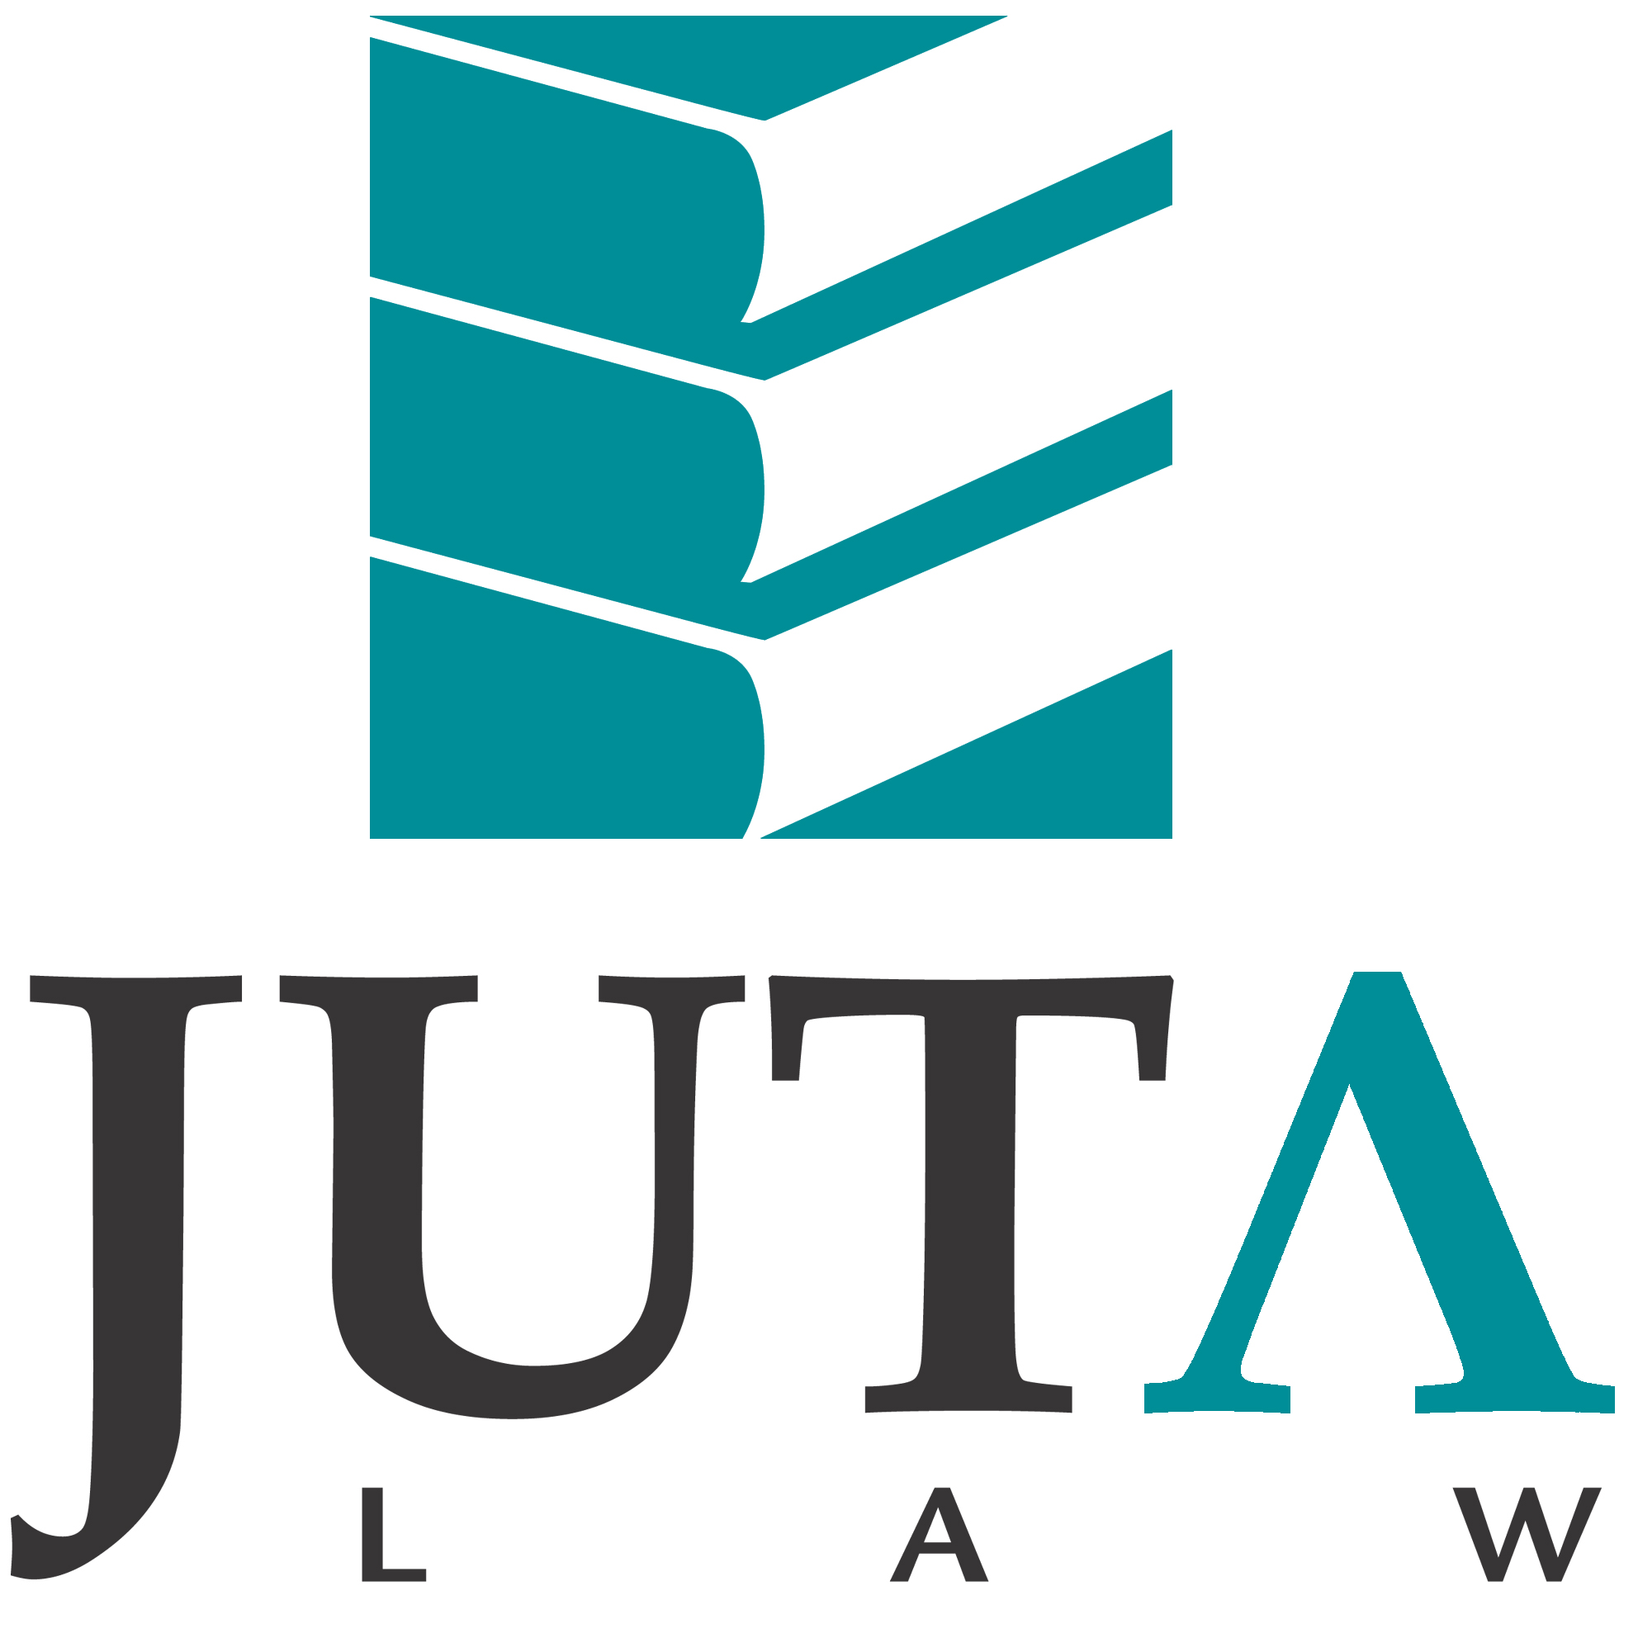

JUTA'S ADVANCE NOTIFICATION SERVICE

DECEMBER 2015

Dear South African Law Reports and Criminal Law Reports subscriber

Herewith the cases in the December law reports.

JUDGMENTS OF INTEREST IN THE DECEMBER EDITIONS OF THE SALR AND SACR LAW REPORTS.
- Click on the case name to download the original judgment.

SOUTH AFRICAN LAW REPORTS

Home owner’s duty to protect visiting children
Did the duty of the home owner extend beyond warning the parents of a toddler of the danger of a fishpond, or did they have to go further with preventative measures? BS v MS and Another 2015 (6) SA 356 (GP)

Robust debate essential to democracy
Politicians had to realise that high trees caught more wind. The public was entitled to have views aired that politicians might not agree with. Journalists should not have to look over their shoulders every time they wrote articles, to ensure that they did not offend politicians. Kgothule v Majonga and Others 2015 (6) SA 389 (FB)

Legal representation at commission of inquiry
Miners, injured or arrested during the Marikana strike and shooting, turned to Legal Aid to fund representation at the ensuing commission of inquiry. Was Legal Aid’s refusal of funding a violation of their constitutional rights and right to a fair public hearing? Legal Aid South Africa v Magidiwana and Others 2015 (6) SA 494 (CC)

SOUTH AFRICAN CRIMINAL LAW REPORTS

Extraterritorial jurisdiction
The accused was charged in the High Court for various terrorist activities committed in Nigeria, but he challenged the jurisdiction of the South African court to try him, and contended that his activities were in the in the exercise of the people’s legitimate right of self-determination and freedom from aggression. S v Okah 2015 (2) SACR 561 (GJ)

The Master deserves 15 years
The Master was a high-ranking official in a position of trust. He dealt with the assets of vulnerable people and entities that were in financial distress whose interests had to be protected. Stealing large sums from the Guardian’s Fund deserved nothing less than 15 years imprisonment. S v Masoanganye and Others 2015 (2) SACR 577 (NWM)

Restorative justice
The rape victim did not seek the imprisonment of the accused, rather compensation, and the accused was willing to compensate her with a Toyota motor vehicle and payment of R240 000. S v Seedat 2015 (2) SACR 612 (GP)

WE WELCOME YOUR FEEDBACK

Please send any comments or queries to lawreports@juta.co.za

Kind Regards

The Juta Law Reports Team

SOUTH AFRICAN LAW REPORTS

DECEMBER 2015

TABLE OF CASES

- Krok and Another v Commissioner, South African Revenue Service 2015 (6) SA 317 (SCA)
- Mthimunye-Bakoro v Petroleum and Oil Corporation of South Africa (SOC) Ltd and Another 2015 (6) SA 338 (WCC)
- BS v MS and Another 2015 (6) SA 356 (GP)
- Ackermans Ltd v Commissioner, South African Revenue Service 2015 (6) SA 364 (GP)
- Hennie Lambrechts Architects v Bombenero Investments (Pty) Ltd 2015 (6) SA 375 (FB)
- Kgothule v Majonga and Others 2015 (6) SA 389 (FB)
- Premier, Eastern Cape and Others v Ntamo and Others 2015 (6) SA 400 (ECB)
- Chetty t/a Nationwide Electrical v Hart and Another NNO 2015 (6) SA 424 (SCA)
- Tshwane City v Link Africa and Others 2015 (6) SA 440 (CC)
- Legal Aid South Africa v Magidiwana and Others 2015 (6) SA 494 (CC)
- Cape Town City v South African National Roads Agency Ltd and Others 2015 (6) SA 535 (WCC)

FLYNOTES

KROK AND ANOTHER v COMMISSIONER, SOUTH AFRICAN REVENUE SERVICE (SCA)
MAYA JA, MHLANTLA JA, WALLIS JA, DAMBUZA AJA and MEYER AJA
2015 MAY 15; AUGUST 20
[2015] ZASCA 107

Revenue—Double taxation agreement—Amendment of to provide for mutual assistance in tax recovery—Whether applicable to tax debts arising prior to such amendment becoming effective.

MTHIMUNYE-BAKORO v PETROLEUM AND OIL CORPORATION OF SOUTH AFRICA (SOC) LTD AND ANOTHER (WCC)
DAVIS J
2015 JULY 23; AUGUST 4

Company—Directors and officers—Board of directors—Meetings—Validity—Exclusion of director—Board may, due to manifest conflict of interest that would otherwise obtain, exclude director from meeting dealing with his or her suspension—Companies Act 71 of 2008, s 75(5).
Company—Directors and officers—Board of directors—Resolutions—Validity—Suspension of director—Majority of directors passing resolution to suspend director without director being present—Board may, due to manifest conflict of interest that would otherwise obtain, exclude director from meeting dealing with his or her suspension—Companies Act 71 of 2008, s 75(5).
Company—Directors and officers—Director—Fiduciary duty—Duty to avoid conflict of interest—Duty to abstain from participating in board meeting a which matter in which he or she has personal financial interest to be considered—Duty triggered when meeting deals with his or her suspension, even if on full pay—Companies Act 71 of 2008, s 75(5).
Company—Principles of corporate governance—Collective governance by board of directors—Exclusion of minority (executive) directors from meeting by majority (non-executive) directors—Justified if meeting held to decide matter on which minority were manifestly conflicted—Companies Act 71 of 2008, s 75(5).

BS v MS AND ANOTHER (GP)
KOLLAPEN J
2015 APRIL 16, 17; JUNE 17; SEPTEMBER 10

Delict—Elements—Unlawfulness or wrongfulness—Liability for omission—Duty of property owners to protect visiting children from injury or harm on their property—Sufficiency of warning to parents of danger posed by fishpond.

ACKERMANS LTD v COMMISSIONER, SOUTH AFRICAN REVENUE SERVICE (GP)
MOTHLE J
2014 NOVEMBER 5–7; 2015 FEBRUARY 20

Revenue—Assessment to tax—Additional assessment—Review—Jurisdiction—High Court’s jurisdiction to review Commissioner’s decision to raise additional assessment confirmed—Tax Administration Act 28 of 2011, s 157; Constitution, ss 169 and 237.
Revenue—Assessment to tax—Additional assessment—Raising of after three years from last assessment—Time limits with which Commissioner must comply—Application of proviso in Income Tax Act 58 of 1962, s 79(1)(c)(i)(aa).

HENNIE LAMBRECHTS ARCHITECTS v BOMBENERO INVESTMENTS (PTY) LTD (FB)
MOCUMIE J, MOLOI J and LEKALE J
2013 NOVEMBER 25; 2014 FEBRUARY 20

Company—Proceedings by and against—Security for costs—Application for furnishing of—Approach of court—New Companies Act lacking provision allowing court to order company to furnish security for costs of opponent—Court developing common law to fill gap left by omission—Company to show it has sufficient funds to pay costs.

KGOTHULE v MAJONGA AND OTHERS (FB)
KRUGER J
2015 JULY 28, 29; SEPTEMBER 10

Media—Freedom of expression—Limitations—Defamation—Public official—Article in newspaper critical of performance of MEC in annual ‘report card’—Statements not defamatory—Editor acting reasonably and not negligently—Court cautioning politicians to realise high trees caught more wind: robust debate was essential to democracy and public was entitled to airing of views politicians might not agree with.

PREMIER, EASTERN CAPE AND OTHERS v NTAMO AND OTHERS (ECB)
PICKERING J, SANDI J and PLASKET J
2015 AUGUST 7, 18

Customary law—Headmen—Identification—Explained—Eastern Cape Traditional Leadership and Governance Act 4 of 2005, s 18 (EC).

CHETTY t/a NATIONWIDE ELECTRICAL v HART AND ANOTHER NNO (SCA)
CACHALIA JA, WILLIS JA, SALDULKER JA, MATHOPO JA and GORVEN AJA
2015 AUGUST 24; SEPTEMBER 4
[2015] ZASCA 112

Company—Business rescue—Moratorium on legal proceedings against company—Meaning of ‘legal proceeding’—Companies Act 71 of 2008, s 133(1).
Company—Business rescue—Moratorium on legal proceedings against company—Requirement that party obtain practitioner’s consent to commence or proceed with legal proceedings against company—Effect of not obtaining consent—Party who may invoke non-compliance with requirement—Companies Act 71 of 2008, s 133(1)(a).

TSHWANE CITY v LINK AFRICA AND OTHERS (CC)
MOSENEKE DCJ, CAMERON J, FRONEMAN J, JAFTA J, KHAMPEPE J, MADLANGA J,
MOLEMELA AJ, NKABINDE J, THERON AJ and TSHIQI AJ
2015 MAY 12; SEPTEMBER 23
[2015] ZACC 29

Constitutional law—Human rights—Right to property—Deprivation of property—What constitutes—Statutory right of network operator to use city infrastructure for installation of telecommunications network—Common law of servitudes and statute itself protecting property rights—No arbitrary deprivation—Provisions valid—Electronic Communications Act 36 of 2005, s 22 and s 24.
Telecommunication—Network—Installation—Statutory right of network operator to use city infrastructure to install network—Not violating property rights—Provisions valid—Electronic Communications Act 36 of 2005, s 22 and s 24.
Servitude—Public servitude—What constitutes—Statutory right of service provider to install and maintain telecommunications network—‘Due regard to applicable law’—Importation of common-law principles—Civiliter modo requirement.

LEGAL AID SOUTH AFRICA v MAGIDIWANA AND OTHERS (CC)
MOSENEKE DCJ, CAMERON J, FRONEMAN J, JAFTA J, KHAMPEPE J, MOLEMELA AJ,
NKABINDE J, THERON AJ and TSHIQI AJ
2015 MAY 14; SEPTEMBER 22
[2015] ZACC 28

Constitutional law—Human rights—Right of access to courts—Right to legal representation before commission of inquiry—No obligation on Legal Aid South Africa to fund such legal representation—Constitution, s 34.

CAPE TOWN CITY v SOUTH AFRICAN NATIONAL ROADS AGENCY LTD AND OTHERS (WCC)
BINNS-WARD J and BOQWANA J
2015 AUGUST 11–14, 17–18; SEPTEMBER 30

Administrative law—Administrative action—Review—Application—Delay in bringing application—Condonation—Approach to—Semble: Court may decline to recognise agreement between parties to extend time limits in appropriate circumstances—Promotion of Administrative Justice Act 3 of 2000, ss 7(1) and 9.
Road—Toll road—Declaration of portion of national road as toll road—Ministerial approval—Powers and functions of Minister—Not limited to procedural oversight role—Minister having final say over any proposal to declare toll road—South African National Roads Agency Limited and National Roads Act 7 of 1998, ss 27(1) and 27(4).
Environmental law—Identified activities—Authorisation—Construction and/or upgrading of roads as toll roads—Whether competent authority compelled to consider socioeconomic impact of tolling—Environment Conservation Act 73 of 1989, ss 21 and 22.

SOUTH AFRICAN CRIMINAL LAW REPORTS

DECEMBER 2015

TABLE OF CASES

- Moussa v The State and Another 2015 (2) SACR 537 (SCA)
- S v Maxabaniso 2015 (2) SACR 553 (ECP)
- S v Okah 2015 (2) SACR 561 (GJ)
- S v Masoanganye and Others 2015 (2) SACR 577 (NWM)
- S v Seedat 2015 (2) SACR 612 (GP)
- S v Maringa and Another 2015 (2) SACR 629 (SCA)
- S v Kok 2015 (2) SACR 637 (WCC)

FLYNOTES

MOUSSA v THE STATE AND ANOTHER (SCA)
NAVSA ADP, PONNAN JA, MHLANTLA JA, MBHA JA and ZONDI JA
2014 MARCH 5; APRIL 14
[2015] ZASCA 61

Prosecuting authority—Prosecutor—Authority of—Ad hoc prosecutor appointed in terms of s 38 of National Prosecuting Authority Act 32 of 1998—Validity of appointment challenged as being in conflict with s 179(4) of Constitution, as such prosecutors were not required to take oath like permanently appointed prosecutors in terms of s 32—Ad hoc prosecutors normal prosecutors under control of senior NPA officers—Section 38 constitutionally sound.

S v MAXABANISO (ECP)
SANDI J and PLASKET J
2015 APRIL 15; MAY 5

Rape—Charge—Correct way of charging—Where victim raped more than once in course of single encounter—Proper to charge with one count of rape.

S v OKAH (GJ)
CJ CLAASSEN J
2012 OCTOBER 1–DECEMBER 14; 2013 JANUARY 21

Jurisdiction—High Court—Extraterritorial jurisdiction—Jurisdiction in terms of Protection of Constitutional Democracy against Terrorist and Related Activities Act 33 of 2004—Ambit of s 1(4) of Act—Court holding that militant campaign against Government of Nigeria excluded from ambit of s 1(4) once members of armed struggle had been granted amnesty.

S v MASOANGANYE AND OTHERS (NWM)
KGOMO JP, RAMPAI AJP and HENDRICKS J
2013 AUGUST 12, 13

Theft—Sentence—Theft of money held in trust—Accused were Master of High Court, Assistant Master and an attorney—Large sums of money involved in theft over period of one year—Accused abused positions of trust, and severe sentences appropriate.

S v SEEDAT (GP)
MAVUNDLA J and STRAUSS AJ
2015 APRIL 23; MAY 12

Rape—Sentence—Restorative justice—When applicable—Complainant not seeking imprisonment of accused, rather wanted compensation—Accused willing to compensate—Magistrate erring in not considering option of imposing sentence in terms of s 297 of Criminal Procedure Act 51 of 1977—Sentence of imprisonment set aside on appeal and replaced with order that sentence postponed for accused to compensate complainant.
Appeal—Application for hearing of further evidence—On face of it part of evidence sought to be led was perjured—Evidence in any event speculative and would not have helped to determine whether state had proven its case or not—Application dismissed.

S v MARINGA AND ANOTHER (SCA)
NAVSA ADP, LEACH JA, WILLIS JA, SCHOEMAN AJA and MEYER AJA
2015 MARCH 11, 23
[2015] ZASCA 28

Indictment and charge—Joinder of accused—Participants in scheme to commit fraud—Purpose of provisions to avoid multiplicity of trials where number of accused—Evidence that needed to be led would prove existence of grand scheme to defraud municipality, even though some accused were not charged with all counts of fraud—State would suffer prejudice if compelled to have separate trial—Joinder competent—Criminal Procedure Act 51 of 1977, ss 155 and 156.

S v KOK (WCC)
HENNEY J and LE GRANGE J
2014 JULY 2

Sentence—Suspension of—Conditions of suspension—On condition accused repay large amount to state—Magistrate giving accused grace of one year in which to pay, in erroneous belief that debts to state had to be repaid within one year—Requirement unduly onerous—Matter remitted to court for imposition of sentence afresh.

