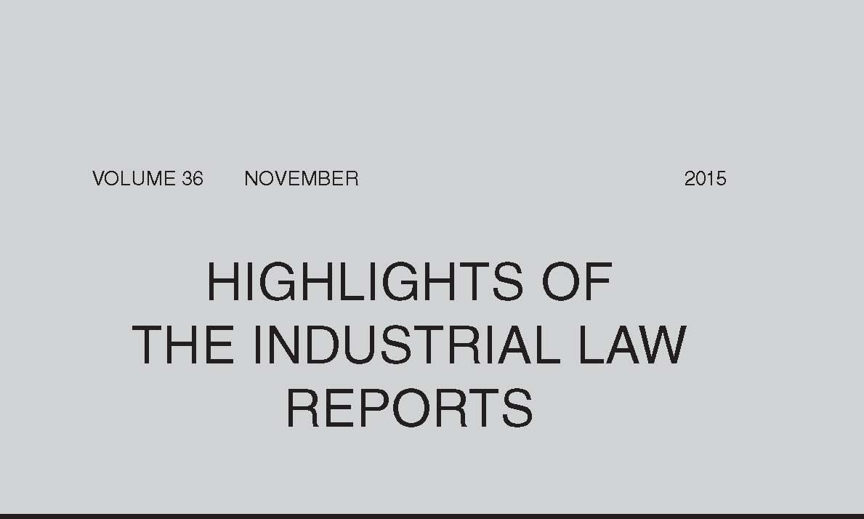
Compensation for Occupational Injuries and Diseases Act 130 of 1993
In Minister of Defence & Military Veterans v Thomas (at 2751) the Constitutional Court considered the concept of the state and whether the state was a single employer or not. It found that, for purposes of s 35 of COIDA, the state as employer is not a single entity, and that the employer of an employee in provincial government is the member of the executive council responsible for the particular department and not the state as a single entity.
Retrenchment
In DB Contracting North CC v National Union of Mineworkers & others (at 2773) the Labour Appeal Court found that the union had failed to adduce evidence that the employees had accepted the employer’s reasonable offer proposing an alternative to retrenchment. There had, therefore, been no acceptance of a reasonable offer to avoid retrenchment and the retrenchment had not been premature or unfair.
Arbitration Awards — Test for Review
In Head of Department of Education v Mofokeng & others (at 2802) the Labour Appeal Court considered the consequences of an arbitrator’s failure to have regard to material facts or issues, noting that irregularities or errors in relation to the facts or issues may or may not produce an unreasonable outcome or provide an indication that the arbitrator misconceived the enquiry. The court said that, in the final analysis, it depends on the materiality of the error or irregularity and its relation to the result — whether the irregularity or error is material must be assessed and determined with reference to the distorting effect it may or may not have had on the arbitrator’s conception of the enquiry, the delimitation of the issues to be determined and the ultimate outcome. The method of analysis provided by the LAC in this matter was followed in Shoprite Checkers v Commission for Conciliation, Mediation & Arbitration & others (at 2908), where the court found that the distorting effect of the CCMA commissioner’s failure to consider a host of material facts was of such a nature as to cause an unreasonable, and thus reviewable, award.
Arbitration Awards — Review — Security for Costs
The Labour Court has interpreted the provisions of the newly introduced s 145(7) and (8) of the LRA 1995 which provide for the stay of enforcement of arbitration awards pending review on the payment of security for costs. It found that the court’s discretion is not fettered, and that it has a discretion to determine whether security must be put up and the amount of such security (Free State Gambling & Liquor Authority v Commission for Conciliation, Mediation & Arbitration & others; Free State Gambling & Liquor Authority v Motake NO & others at 2867).
Employment Relationship
The Labour Court had found that most of the presumptions of employment outlined in s 200A of the LRA 1995 applied in an ordained pastor’s situation and that he was an employee of his church (see Universal Church of the Kingdom of God v Commission for Conciliation, Mediation & Arbitration & others (2014) 35 ILJ 1678 (LC)). However on appeal, the Labour Appeal Court found that the presumption of employment contained in s 200A was not applicable where there was no contractual relationship between the parties. In this matter the pastor had not proved any intention on the part of the parties to enter into a contractual arrangement of any sort. The court was satisfied that the mutually agreed relationship between the pastor and his church was one in which the pastor rendered voluntary devotional service to the church under circumstances where both he and the church never intended that the relationship would constitute an employment relationship, producing legally enforceable rights and obligations under the LRA. The court also expressed the view that the resolution of disputes with religious spiritual connotations or arising from internal church doctrinal governance should be left to the leadership of the church concerned unless there is a real compelling reason for a court to get involved (Universal Church of the Kingdom of God v Myeni & others at 2832).
Trade Union — Compliance with Constitution
The Labour Court has considered two matters dealing with disputes between trade unions and their members, in both instances finding that it had jurisdiction, in terms of s 158(1)(e)(i) of the LRA 1995, to determine a dispute between a union and any of its members regarding any alleged non-compliance with the union’s constitution. In General Industries Workers Union of SA v Maseko & others (at 2874) the court found that the disciplinary procedure set out in the union’s constitution had not been followed and that the ensuing disciplinary action taken against certain members was null and void. Similarly, in Zondo & others v SA Transport & Allied Workers Union (at 2916) the court found that the suspension of office-bearers pending disciplinary proceedings was not provided for in the union’s constitution and that the suspension was therefore ultra vires and unlawful.
Bargaining Levels
The employer and trade union parties in the private security sector traditionally negotiated terms and conditions within their sector at national level and placed a memorandum of agreement setting out their recommendations before the Minister of Labour for consideration before the publication of a sectoral determination. When the employees proposed strike action over matters covered by the memorandum, the Labour Court held that the employees were entitled to do so (see CSS Tactical (Pty) Ltd v Security Officers Civil Rights & Allied Workers Union & others (2014) 35 ILJ 3140 (LC)). On appeal, the Labour Appeal Court confirmed that the memorandum was not all embracing and that the issues in demand in the employees’ strike notice could properly be determined at company level. The strike was accordingly protected (CSS Tactical (Pty) Ltd v Security Officers Civil Rights & Allied Workers Union & others at 2764).
Where the Labour Appeal Court had earlier ruled on the demand over which the employees could legitimately strike and the Labour Court later interpreted this judgment (see Unitrans Fuel & Chemical (Pty) Ltd v Transport & Allied Workers Union of SA & another (2010) 31 ILJ 2854 (LAC) and Transport & Allied Workers Union of SA & others v Unitrans Fuel & Chemical (Pty) Ltd (2013) 34 ILJ 1785 (LC)), the LAC upheld the interpretation by the Labour Court. It found that the central finding of the earlier LAC judgment was that substantive issues had to be negotiated at central level, and that the only legitimate strike demand related to the employer’s unilateral change to the wages of seven particular employees. A strike on any other demand was, therefore, unprotected (Transport & Allied Workers Union of SA & others v Unitrans Fuel & Chemical (Pty) Ltd at 2822).
Temporary Employment Service
The CCMA recently interpreted the newly introduced deeming provision in s 198A(3)(b) of the LRA 1995 and declared that the employees of the temporary employment service were deemed to be the employees of the client (see Assign Services (Pty) Ltd and Krost Shelving & Racking (Pty) Ltd & another (2015) 36 ILJ 2408 (CCMA)). On review, the Labour Court found that the CCMA did not have jurisdiction to decide the question of law — arbitrators are only empowered, in terms of s 198D, to determine disputes ‘arising from’ the interpretation of the amended s 198, but not the actual interpretation of the section. This question should properly have been before the Labour Court at first instance. The court found further that there is nothing in s 198A(3)(b) which invalidates the contract of employment between the TES and the employee or relieves the TES of its statutory obligations merely because a parallel set of obligations has been created for the client. The deeming provision makes the client the employer for the purposes of the LRA and no other purpose and nothing in the deeming provision invalidates the contract of employment between the TES and the employee. According to the court, the correct interpretation of s 198A(3)(b) is that the employees are ‘placed dually’ for the purposes of the LRA (Assign Services (Pty) Ltd v Commission for Conciliation, Mediation & Arbitration & others at 2853).
Labour Court — Jurisdiction
A temporary employment service brought an urgent application to interdict and restrain its client from soliciting, enticing or persuading any of its employees placed with the client to perform services directly for the client. It relied on a restraint clause in its employees’ contracts. The Labour Court found that there had been no breach of the restraint clause, which meant that the remedy sought by the TES could not be based on the enforcement of the restraint. The cause of action was clearly not based on breach of contract but appeared to have been brought to deter the client from poaching its employees. As this was not a matter concerning a contract of employment, the court had no jurisdiction (Concord Employment Contractors (Pty) Ltd v Bidfreight Port Operations (Pty) Ltd & others at 2864).
Bargaining Councils — Jurisdiction
The MEIBC considered its jurisdiction to arbitrate dismissal disputes where its dispute-resolution agreement had expired and the new agreement had not been extended to non-parties in National Union of Metalworkers of SA on behalf of Mavimbela and J & L Lining Consultants CC (at 2954) and Olivier & another and Ibhayi Service Manufacturers (Pty) Ltd & another (at 2963).
Dismissal — Existence of Dismissal
In Life Healthcare Group t/a Eugene Marais Hospital v Hlatshwako NO & others (at 2886) the Labour Court found that it was not clear from the arbitration record if the CCMA commissioner had dealt with the issue whether the employee had in fact been dismissed. Because this was a jurisdictional issue, it could be raised for the first time before the review court. As the court was unable to determine the issue on the record before it, it directed the employee to institute proceedings for an order declaring that she had been dismissed.
Strike — Dismissal for Misconduct during Protected Strike
The employees were dismissed for ‘brandishing’ or ‘wielding’ dangerous weapons during a protected strike in contravention of the employer’s disciplinary code and picketing policy. The CCMA commissioner was satisfied that the sticks carried by the employees could be considered to be ‘dangerous weapons’, but found that the employees had merely carried the sticks and not brandished or wielded them. As the employees had only partially breached the employer’s code and policy, dismissal was not appropriate. They were reinstated without backpay and subject to a final written warning (National Union of Metalworkers of SA on behalf of Rowls & others and Pailprint (Pty) Ltd at 2931).
Public Service Employee — Promotion and Job Grading
On review in Member of the Executive Council, Department of Sport, Recreation, Arts & Culture, Eastern Cape v General Public Service Sectoral Bargaining Council & others (at 2893) the Labour Court noted the difference between promotion and job grading in the public service. It found that the employee in this matter merely sought an increase in his salary. This was a matter of mutual interest and not an unfair labour practice dispute. The bargaining council, therefore, had no jurisdiction to determine his dispute.
Resignation
In Nemaungani and Associated Risk Consultants (at 2947) a CCMA commissioner found that, even if a letter of resignation purportedly signed by the employee was valid, the employee was intoxicated at the time. He was not in sound and sober senses and was, therefore, not legally competent to terminate the contract of employment.
Evidence — Collusion
In National Union of Mineworkers & another v Mogale Gold, A Division of Mintails (SA) (Pty) Ltd (at 2815) the Labour Appeal Court noted the approach to be adopted when an inference is sought to be drawn from other facts. As the inference of collusion involves drawing an inference from other facts that are themselves inferences from the primary facts, the initial inferences must be interrogated. Only when the proper facts including the inferences made from those facts have been satisfactorily established, may the final inference of collusion be attempted.
Quote of the Month: Lyster C in National Union of Metalworkers of SA on behalf of Rowls & others and Pailprint (Pty) Ltd (2015) 36 ILJ 2931 (CCMA):
‘It is trite to say that what the police in this country do, or omit to do, in a given situation, whether they intervene and/or arrest people, or how they behave with regard to one class of citizenry vis-à-vis another, cannot be considered to be a reliable indicator of the legality or otherwise of the situation at hand.’

