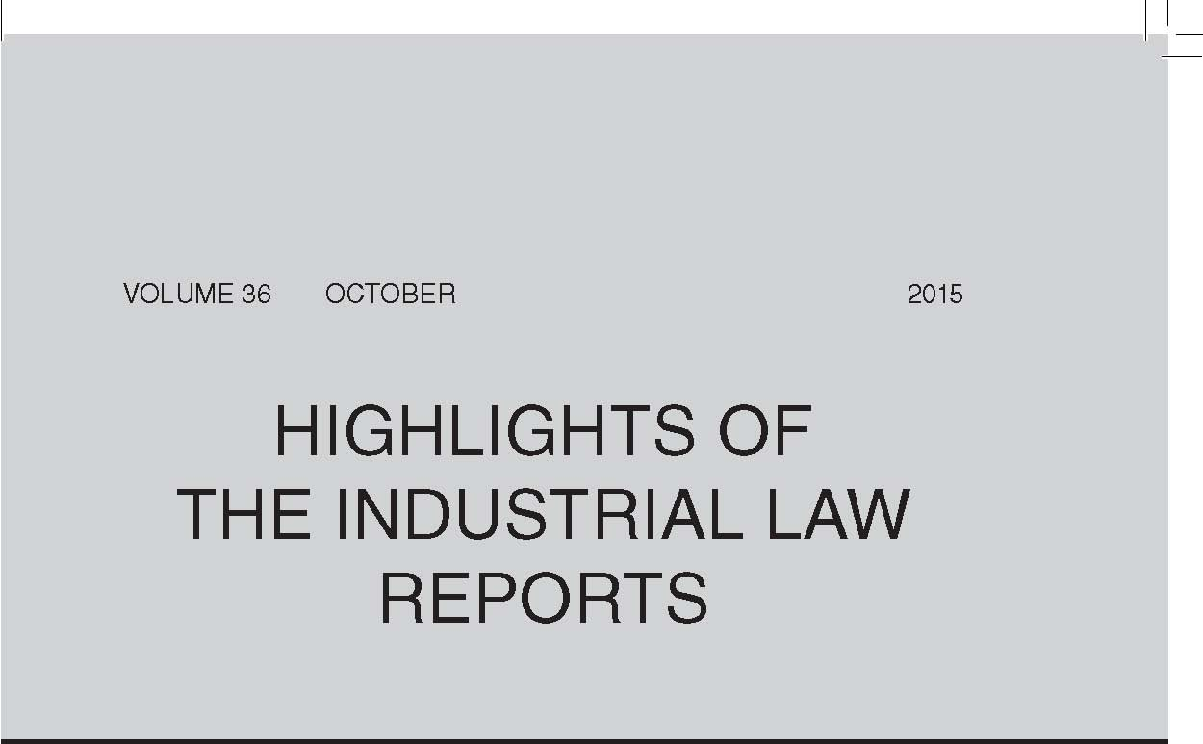
Occupational Health and Safety — Report by Inspector into
Workplace Incident
The High Court, in Industrial Health Resource Group & others v Minister of Labour & others (at 2547), granted an application to compel the Minister of Labour to furnish copies of an inspector’s report into a workplace incident in terms of s 32 of the Occupational Health and Safety Act 85 of 1993. The court held that an interpretation of s 32 that entitled interested parties to access such a report respected, protected and promoted various rights and values enshrined in the Constitution and allowed employees and unions to hold employers accountable for past and future conduct by ensuring compliance with the recommendations and findings contained in the inspector’s report. Furthermore, without access to an inspector’s report employers and trade unions were hampered in their ability to ensure a safe and healthy workplace and it could not be determined whether employers and manufacturers had breached any of their duties imposed in terms of OHSA.
Emoluments Attachment Orders
In University of Stellenbosch Legal Aid Clinic & others v Minister of Justice & Correctional Services & others (SA Human Rights Commission as Amicus Curiae) (at 2558) the High Court considered the validity of emoluments attachment orders issued in terms of s 65J(2) of the Magistrates’ Courts Act 32 of 1944. It examined foreign jurisdictions that had recognised the problems arising from the abuse of EAOs by unscrupulous creditors, and the protective measures adopted by those jurisdictions; international statutory instruments on the protection of wages; and the constitutional right to dignity and the protection of employees’ socio-economic rights. The court found that the provisions of s 65J(2)(b), to the extent that they authorised the issue of EAOs without judicial oversight, were inconsistent with the Constitution and invalid. It also found that the reliance by credit providers on consents to jurisdiction in terms of s 45 of the MCA to bypass courts in the areas where debtors or their employers resided to obtain judgments in courts which would otherwise not have jurisdiction amounted to forum shopping, was contrary to the National Credit Act 34 of 2005, and rendered the safeguards afforded to debtors by s 65J meaningless.
Labour Court — Powers and Jurisdiction
The Labour Appeal Court and Labour Court are empowered to develop their own principles and rules of general application by adopting from pre-existing provisions found in other jurisdictions, but this does not mean that they are bound by the statutes from which they have imported selected provisions. In L’Oreal SA (Pty) Ltd v Kilpatrick & another (at 2617) the Labour Court found that the Superior Courts Act 10 of 2013 does not apply to the Labour Court, but it can import or adopt selected provisions which are complementary to the court’s own rules, provisions and processes by virtue of its powers in terms of s 158(1) of the LRA 1995 and rule 11(3)-(4) of the Labour Court Rules.
In Rhan v Cheil SA (Pty) Ltd (at 2657) the Labour Court considered the amendment to s 158(1)(b) of the LRA 1995 in terms of which the employer’s consent is no longer needed when the court decides whether it is expedient for the court to sit as an arbitrator and determine a dispute as an arbitrator. It found in this matter that, if the employee was unsuccessful with her claim of automatically unfair dismissal, and the court considered it expedient to hear the alternative claim of unfair dismissal, it would have the jurisdiction to do so.
CCMA — Jurisdiction
The respondent municipality argued that the consent to arbitration of an unfair discrimination dispute in terms of s 10 of the Employment Equity Act 55 of 1998 which the employee had obtained from the municipal manager was a nullity. The CCMA commissioner ruled that a prima facie agreement existed and that only the Labour Court could determine the validity of the consent given by the municipality. The commissioner gave the municipality 30 days within which to make application to the Labour Court, failing which the matter would be enrolled for arbitration (Govender and Umgungundlovu District Municipality at 2671).
Unfair Dismissal Dispute — Referral of Dispute to Arbitration
In SA Municipal Workers Union on behalf of Manentza v Ngwathe Local Municipality & others (at 2581) the Labour Appeal Court held that, on a proper interpretation, s 191(5) of the LRA 1995 entitles an employee to refer an unresolved unfair dismissal dispute or unfair labour practice dispute for arbitration or adjudication upon the occurrence of either of two events: the issue of a certificate of outcome of the dispute or the expiry of the 30-day period from receipt of the referral by the CCMA or bargaining council. The employee’s entitlement to refer a dispute to arbitration or adjudication does not arise from any election by the employee, but rather from whichever of the two jurisdictional events occurs first in sequence of time.
Disciplinary Penalty — Poor Work Performance
In Transnet Rail Engineering v Mienies & others (at 2605) the Labour Appeal Court found that, if an employee displays shortcomings in the performance of his or her duties, fairness requires that the employee should not only be informed that his or her performance is deficient and in what respects, but he or she should also be given an opportunity to improve. Dismissal is always an action of last resort and is unnecessary if, given a reasonable opportunity and reasonable assistance, the employee could meet the required standard.
Liquidation of Corporate Entity — Abandonment of Civil Proceedings
In two matters the Labour Court considered the applicability of s 359 of the Companies Act 61 of 1973, which provides that if a litigant fails to notify the liquidator of a company of the continuation of civil proceedings within a prescribed period, the proceedings are deemed to have been abandoned. In Direct Channel KwaZulu-Natal (Pty) Ltd (in liquidation) v Naidu & others (at 2611) the employees were retrenched and referred an unfair dismissal dispute to the court. Thereafter the employer company was placed in liquidation, but the employees and their union failed to give the liquidator notice as envisaged by s 359 despite the fact that they had knowledge of the appointment of the liquidator and had been called upon to file their claims with him. The court found that the unfair dismissal proceedings were deemed to have been abandoned by the employees. In Visagie v Nylsvlei Game Dealers CC & others (at 2662) the employee claimed that her dismissal had been automatically unfair. She also failed to notify the employer close corporation’s liquidator within the prescribed period that she intended to continue with the proceedings, and the court found that her Labour Court claim was deemed to have been abandoned. The court found further that, as the principal matter had been abandoned, the employee could not seek to join further parties to the abandoned proceedings.
Restraint of Trade — Application to Enforce Restraint Interdict Pending Appeal
In an application to enforce a restraint of trade order pending appeal, the Labour Court, in the exercise of its powers in terms of s 158(1) of the LRA 1995 and rule 11(3)-(4) of the Labour Court Rules, imported those provisions of s 18 of the Superior Courts Act 10 of 2013 dealing with
the enforcement of judgments pending appeal which were compatible with the dispute-resolution functions and processes of the labour courts. The court found that the purpose of a restraint interdict is the immediate protection of the applicant’s protectable interest, and this is thwarted by the respondent simply proceeding with an appeal — the appeal process itself, and not the appeal outcome, defeats the restraint and the objective it is designed to achieve (L’Oreal SA (Pty) Ltd v Kilpatrick & another at 2617).
Collective Agreement — Interpretation and Application
A collective agreement provided for salary increases to employees below a certain threshold who fell within the scope of the agreement. In the past the employer had relied on the agreement as a yardstick to increase the salaries of employees who fell outside the scope of the agreement. It changed this practice, and the union referred an unfair labour practice dispute to MIBCO. The bargaining council arbitrator found no reason to disregard the express wording of the agreement, which clearly distinguished between employees above and below the threshold. He found further that, although the employees above the threshold had no right to an increase in terms of the agreement and there was no duty on the employer to consult, fairness dictated that it should do so. He was satisfied that the briefings held by the employer constituted consultations, and concluded that the employer’s conduct in changing the practice did not constitute an unfair labour practice (National Union of Metalworkers of SA & others and Johnson Matthey (Pty) Ltd & others at 2713).
Pre-dismissal Arbitrations
In National Union of Metalworkers of SA v Murray & Roberts Projects (Pty) Ltd & another (at 2647) the Labour Court considered the purpose of s 188A of the LRA 1995. It found that, where a collective agreement governing disciplinary processes provided for the consent of an employee to pre-dismissal arbitration, the request had been ‘in accordance with a collective agreement’ as required by s 188A(1), and the employer did not have to comply with the requirements of s 188A(4)(a).
Disciplinary Code and Procedure — Delay in Holding Enquiry
A CCMA commissioner, in Siwela and Agricultural Research Council (at 2676), had to determine whether the employer was prevented from bringing charges against the employee because of the excessive delay in instituting disciplinary proceedings. He found that, although an employer which failed to hold a disciplinary hearing expeditiously might be deemed to have waived the right to dismiss an employee, in this matter the employer had instituted action against the employee as soon as an investigation into his misconduct was completed. Waiver was, therefore, not proved.
Evidence
Although the Labour Court had decided whether the Turquand rule applied in Hudson & another v SA Airways SOC Ltd (2014) 35 ILJ 3407 (LC), on appeal the Labour Appeal Court found that the matter turned exclusively on the proper approach to the determination of a dispute of fact within the context of application proceedings. Having noted the well-established rules adopted by the courts in deciding a case on application where no oral evidence is presented, the court found that the dispute of fact in this matter could not be resolved on the papers and dismissed the appeal (Hudson & another v SA Airways SOC Ltd at 2574).
The Labour Court found that, although it has a discretion to admit unlawfully obtained documents and to consider evidence presented in relation to such documents, it has to take a balanced approach and consider fairness to both parties when exercising its discretion. In this matter, where the respondents’ bank statements had been obtained unlawfully by the employee, the court found that the respondents’ constitutional right to privacy had been violated and, in the absence of any explanation why it had been necessary to violate a constitutional right to place evidence before the court, it was compelled to find that the unlawfully obtained bank statements were not admissible (Visagie v Nylsvlei Game Dealers CC & others at 2662).
Legal Practitioners — Conduct
In Motor Industry Bargaining Council v Suliman (at 2644) the Labour Court noted its concern with the practice by legal representatives of advancing a proposition on the basis that the court has ‘decided’ a particular issue when the court has not done so.
Practice and Procedure
The Labour Court, in Ralo v Transnet Port Terminals & others (at 2653), stated that the Practice Manual contains a series of directive that the Judge President is entitled to issue. It sets out what is expected of practitioners to meet the imperatives of respect for the court as an institution and the expeditious resolution of labour disputes. Its provisions are not mere guidelines to be adhered to or ignored by parties at their convenience.
In Wilcox and Nicola Wilcox & Associates Optometrists Inc t/a Classic Eyes (at 2698) a CCMA commissioner ruled that, where the employer was a separate corporate entity, the employee had no right to demand that a particular director represent the employer at the CCMA.
Shortly after the applicant bargaining council sought to enforce compliance with its main agreement, one of the respondent cooperatives approached the Labour Court for a declaratory order that it was not an employer for purposes of the LRA 1995. It then raised a special plea of lis alibi pendens at the council arbitration proceedings. The arbitrator ruled that the arbitration proceedings had commenced prior to the Labour
Court application and that the special plea was therefore not appropriate (National Bargaining Council for the Clothing Manufacturing Industry and Glamour Fashions Workers’ Primary Co-operative Ltd & others at 2706).
Quote of the Month:
Desai J in University of Stellenbosch Legal Aid Clinic & others v Minister of Justice & Correctional Services & others (SA Human Rights Commission as Amicus Curiae) (2015) 36 ILJ 2558 (WCC):
‘For debtors who work in low paid and vulnerable occupations, their salaries or wages are invariably their only asset and means of survival. A substantial reduction of this asset has the potential of reducing human dignity. The state, if it is a party to the grant of the [emoluments attachment order], has the duty to refrain from conduct which results in the debtor being left impoverished or facing a life of “humiliation and degradation” (see Minister of Home Affairs & others v Watchenuka & another 2004 (4) SA 326 (SCA) paras 27-32). The ability of people to earn an income and support themselves and their families is central to the right to human dignity (see s 10 of the Constitution). Any court order or legislation which deprives a person of their means of support or impairs the ability of people to access their socio-economic rights constitutes a limitation of their right to dignity.’

