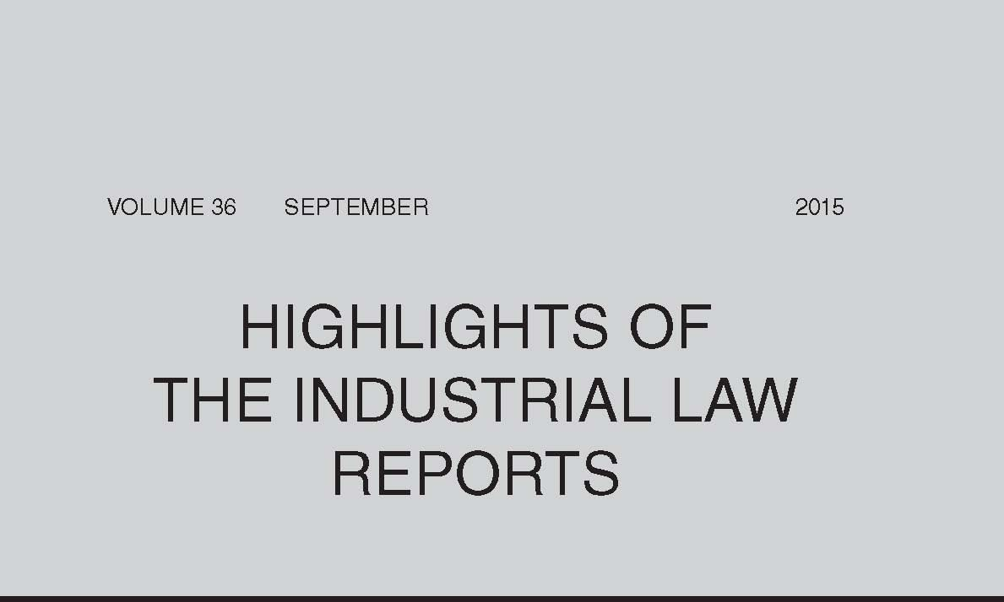
Temporary Employment Service — Deeming Provision in Section 198A(3)(b) of LRA 1995
Both the CCMA and the NBCRFLI have interpreted the recently introduced deeming provision contained in s 198A(3)(b) of the LRA 1995 to determine whether the temporary employment service or the client was the employer of the employees. In Assign Services (Pty) Ltd and Krost Shelving & Racking (Pty) Ltd & another (at 2408) the CCMA commissioner rejected the dual employment approach as it could lead to uncertainty and confusion and was not aligned with the purpose of the amendments to s 198, which was to address abusive practices associated with temporary employment services and provide greater protection to vulnerable employees. In Mphirime and Value Logistics Ltd & another (at 2433) the bargaining council arbitrator found that the temporary employment service and the client remained jointly and severally liable for breaches referred to in s 189(4), ie breaches of the Basic Conditions of Employment Act 75 of 1997, sectoral determinations, collective agreements and awards regulating terms and conditions of employment. However, once the deeming provision in s 198A(3)(b) applied, an employer-employee relationship existed between the client and the employee and the client assumed the responsibility to ensure that the duties and obligations in terms of the LRA were met. This interpretation addressed the abusive practices the amendment of s 198 sought to curb, and any claim by an employee in terms of the LRA had to be brought against the client.
Constructive Dismissal
In Conti Print CC v Commission for Conciliation, Mediation & Arbitration & others (at 2245) the Labour Appeal Court held that the test for review of a constructive dismissal was that laid down in earlier LAC judgments and that the Labour Court was not competent to make a finding which differed from those judgments. It also confirmed the three requirements that had to be met to establish a constructive dismissal, finding that in this matter the employee failed to show that the employer’s conduct had rendered continued employment intolerable. However, in National Health Laboratory Service v Yona & others (at 2259), the LAC found that the employee demonstrated that it had been the employer’s unfair conduct, viewed objectively, that created the unbearable situation which led to her resignation.
Disciplinary Penalty — Zero Tolerance Policy
The Labour Appeal Court, in Shoprite Checkers (Pty) Ltd v Commission for Conciliation, Mediation & Arbitration & others (at 2273), held that the law does not allow an employer to adopt a zero tolerance approach for all infractions, regardless of its appropriateness or proportionality to the offence, and then expect a commissioner to fall in line with such an approach. The touchstone of the law of dismissal is fairness and an employer cannot contract out of it or fashion, as it were, a ‘no-go area’ for commissioners.
Disciplinary Penalty — Worker Safety
In Sasol Mining (Pty) Ltd v Commission for Conciliation, Mediation & Arbitration & others (at 2359) the Labour Court noted that the safety of employees at the workplace is paramount and cannot be compromised. An employer cannot be expected to wait until an employee is maimed or has lost his or her life, before taking decisive action against an employee who has exposed fellow employees to danger. Procedures which are intended to prevent injury and fatality, particularly in the mining industry, need to be complied with properly because a lapse can have disastrous consequences. Exposing employees to the risk of injury and fatality is inexcusable when one is charged with the responsibility to protect them.
Dismissal — Derivative Misconduct
The nature and development of the concept of ‘derivative misconduct’ through the case law were considered by the Labour Appeal Court in Western Platinum Refinery Ltd v Hlabela & others (at 2280), which pointed out that it did not constitute a new category of misconduct. An employee bound implicitly by a duty of good faith towards his or her employer breaches that duty by remaining silent about knowledge possessed by the employee regarding the business interests of the employer being improperly undermined. Non-disclosure by an employee, who is innocent of the primary misconduct, of knowledge of misconduct committed by fellow employees is a breach of the duty of good faith. The dismissal of an employee who consciously chooses not to disclose that information to the employer is derivatively justified.
Strike — Unprotected Strike
The Labour Court, in Algoa Bus Co (Pty) Ltd v Transport Action Retail & General Workers Union & others (at 2292), granted the employer’s application for compensation for loss sustained as a result of an unprotected strike. The court found that, although the union appeared to be in a financially perilous state, this did not mean that it was immune from the financial consequences of reckless conduct by certain of its members and office-bearers. However, the effects of a compensation award could be ameliorated by making it payable on extended terms and by making both the union and its members who participated in the unprotected strike liable for payment of the award in monthly instalments.
Where a referral of a dispute to the CCMA and a strike notice had been issued by a person who belonged to a faction of the union and was no longer an office-bearer or shop steward of the union, the court found that he had no authority to make the referral or to issue the strike notice on behalf of the union. There had, therefore, been no valid referral or strike notice, and the strike was unprotected ( Johannesburg Roads Agency v SA Municipal Workers Union & others at 2310).
Contract of Employment — Breach of Contract
In both Ramabulana v Pilansberg Platinum Mines (at 2333) and Somi v Old Mutual Africa Holdings (Pty) Ltd (at 2370) the Labour Court held that it was empowered to grant specific performance to an employee dismissed in breach of a contract of employment which incorporated the employer’s disciplinary code or policy.
Contract of Employment — Unlawful Contract
Where a municipal manager had signed contracts of employment of several employees after the expiry of his term of office and the employees’ employment was later terminated on the basis that the contracts were unlawful, the Labour Court found that it was in the interests of justice that the declaration of invalidity of the municipal manager’s actions in signing the contracts be suspended pending the proper resolution of the employees’ continued employment in terms of the LRA 1995 (Imbabazane Municipality v Independent Municipal & Allied Trade Union on behalf of Gumbi & others at 2297).
Restraint of Trade
The Labour Court noted, in TUV Sud SA (Pty) Ltd v Branders & another (at 2398), that the reasonableness of a restraint of trade agreement is determined by balancing the interests of the parties at the time of enforcement and includes a consideration of the nature, extent and duration of the restraint and factors peculiar to the parties and their respective powers and interests.
Trade Union — Dispute between Union and Members
In SA Transport & Allied Workers Union v Zondo & others (at 2348) the Labour Court confirmed that it had jurisdiction to determine disputes between a trade union and its members concerning alleged non-compliance with the union’s constitution. The court found that a resolution by the union’s central executive committee which gave it certain powers was in conflict with the union’s constitution, was ultra vires and could not trump a member’s rights espoused in the constitution.
SA Police Service — Failure to Exhaust Internal Remedies
The employee, who had been discharged from the SA Police Service for misconduct, failed to exhaust his internal remedies as required by a provision contained in the schedule to the SAPS constitution before referring an unfair dismissal dispute to the SSSBC. The Labour Court was satisfied that the provision was contained in a binding collective agreement, was peremptory and had to be complied with by the employee. Moreover, the duty to exhaust internal remedies was well settled in law and the court would only condone non-compliance in exceptional circumstances, which did not exist in this matter (Madondo v Safety & Security Sectoral Bargaining Council & others at 2314).
Unfair Labour Practice — Benefits
In Konigkramer and National Regulator for Compulsory Specifications (at 2421) a CCMA commissioner found that the employer was bound by the terms and conditions of the employee’s contract of employment, including the acting allowance policy, and that the employee was therefore entitled to be paid an acting allowance for the entire period that he continued to act in a more senior position.
Bargaining Council Arbitrator — Powers
The Labour Court found that the earlier judgment in SA Municipal Workers Union on behalf of Jacobs v City of Cape Town & others (2015) 36 ILJ 484 (LC), which found that an the arbitrator, empowered by a collective agreement read with s 138(9) of the LRA 1995 to issue a declaratory order, ought to have issued an order that the disciplinary hearing was null and void for non-compliance with the peremptory time-limit contained in the collective agreement, was wrong. This was so because an arbitrator exercises an administrative function and is therefore limited as to the type of declaratory orders he or she can make. The power to issue declaratory orders is not the same as the jurisdiction to declare acts unlawful and invalid. Arbitrators and commissioners cannot set aside irregular
proceedings as unlawful; this task has always fallen on the courts (Tsengwa v Knysna Municipality & others at 2392).
Practice and Procedure
In Swart v Minister of Correctional Services & another (at 2381) the Labour Court found that it was not appropriate for a party to wait for contempt proceedings to challenge the correctness of an order after it had abandoned its remedies of rescission and review. Furthermore, the court could not set aside its own order even if it was tainted with illegality — only a court of higher authority could do so.
In SA Social Security Agency v National Education Health & Allied Workers Union on behalf of Punzi & others (at 2345) the Labour Court questioned how an unfair labour practice dispute before a CCMA commissioner or bargaining council arbitrator which hinged on the fairness of the employer’s conduct could be decided, in the absence of a stated case, without the parties giving oral evidence.
In Sedibeng District Municipality v Petlane & others (at 2364) the Labour Court upheld a CCMA commissioner’s decision to continue with arbitration proceedings in the absence of the applicant despite the fact that she was aware that the applicant had applied to the Labour Court to stay the proceedings. In the absence of a court order barring her from proceeding, nothing prevented the commissioner from hearing and determining the matter.
Quote of the Month
Landman JA in Shoprite Checkers (Pty) Ltd v Commission for Conciliation, Mediation & Arbitration & others (2015) 36 ILJ 2273 (LAC):
‘As the code of good practice enjoins, commissioners will accept a zero tolerance approach if the circumstances of the case warrant the employer adopting such an approach. ... But the law does not allow an employer to adopt a zero tolerance approach for all infractions, regardless of its appropriateness or proportionality to the offence, and then expect a commissioner to fall in line with such an approach. The touchstone of the law of dismissal is fairness and an employer cannot contract out of it or fashion, as it were, a “no-go area” for commissioners. A zero tolerance policy would be appropriate where, for example, the stock is gold but it would not necessarily be appropriate where an employee of the same employer removes a crust of bread otherwise assigned for the refuse bin. … Commissioners should be vigilant and examine the circumstances of each case to ensure that the constitutional right to fair labour practices, more particularly to a dismissal that is fair, is afforded to employees.’

