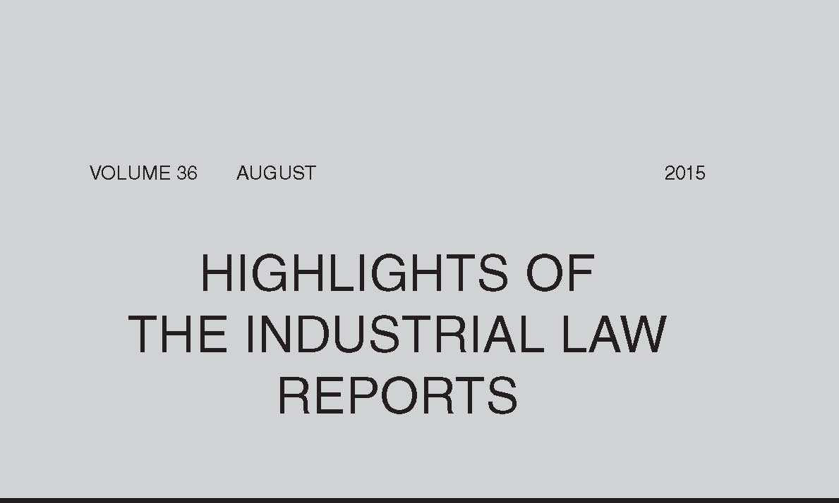

Reinstatement

In *Coca Cola Sabco (Pty) Ltd v Van Wyk* (at 2013) the Labour Appeal Court confirmed that the effect of a reinstatement order is to revive the contract of employment that was terminated by dismissal. Although a commissioner may order that the reinstatement is effective from the date of the award or retrospectively from any date not earlier than the date of dismissal, the LRA 1995 does not cater for relief between the date of the award and the date of the implementation of the award. Therefore, where there is a delay in the implementation of the reinstatement award, the employee is not automatically entitled to payment for the period between the award and the date of implementation. He has a contractual claim that has to be pursued in the civil courts or the Labour Court in terms of s 77 of the Basic Conditions of Employment Act 75 of 1997. In this matter the Labour Court had erroneously found that the amount owing could be quantified by way of affidavit for the purposes of a writ of execution, and this finding was set aside on appeal.

Strikes and Lock-outs

In *Putco (Pty) Ltd v Transport & Allied Workers Union of SA on behalf of Members & another* (at 2048) the Labour Appeal Court considered the purpose of a lock-out, and specifically whether, where the members of two unions have embarked on a strike, the employer is entitled to lock out the members of another union who continue to tender their services. The court found that a lock-out is an important component of an effective collective bargaining system. A lock-out aimed at all employees in the bargaining unit promotes collective bargaining at sectoral level and seeks to give effect to the majoritarian principle which is at the heart of the collective bargaining dispensation. A lock-out is a deadlock breaking mechanism when the process of collective bargaining fails. The employer is, therefore, entitled to consider all employees in the bargaining unit as parties to the dispute, including the non-striking workers, and to issue its lock-out notice accordingly.

In *Rooipoort Developments (Pty) Ltd v Association of Mineworkers & Construction Union & others* (at 2125) the Labour Court noted that employers are precluded from behaving in a manner which will encroach on their employees’ right to strike or disturb them when exercising their right to strike and to picket. However, the right to strike and to picket does not create an obligation on the employer to enhance the striking employees’ right to picket and make their strike more effective.

Probationary Employees

When dealing with a person on probation in a responsible position like a professional assistant, where the person claims to have the necessary experience to do the job, it is not unreasonable for the employer simply to point out the perceived shortcomings of the probationer and to emphasise the importance of improving her performance if she wants to be permanently appointed. The Labour Court found, on review, that the bargaining council arbitrator had failed to appreciate this, and appeared to believe that the employer had to treat such a probationer as someone who was still in training who needs training, instruction, guidance and counselling before dismissal (*Rheinmetall Denel Munition (Pty) Ltd v National Bargaining Council for the Chemical Industry & others* at 2117).

An employment contract entered into by a probationary employee obliged her to pay, on premature termination, compensation for in-house training quantified at three times her monthly cost to company. When the employer sought to enforce this provision, the Labour Court found that the provision amounted to a penalty stipulation in terms of the Conventional Penalties Act 15 of 1962 and was glaringly excessive. In addition, the court found that the employer was attempting to recover training costs in respect of training it was in fact obliged to provide as part and parcel of probation during the probationary period it terms of item 8(1)*(e)* of the Code of Good Practice: Dismissal (*Syrex (Pty) Ltd v Ramfolo* at 2132).

Basic Conditions of Employment Act 75 of 1997 — Transportation

In *TFD Network Africa (Pty) Ltd v Singh NO & others* (at 2142) the Labour Court interpreted s 17(2)*(b)* of the Basic Conditions of Employment Act, which provides that an employer may only require an employee to perform night work if ‘transportation is available between the employee’s place of residence at the commencement and conclusion of the employee’s shift’. Following a common-sense, purposive approach, the court found that the purpose of the regulation of night work is to avoid or minimise health risks and risks to the safety of workers. Based on this interpretation, the court was of the view that an employer must ensure that transportation is available between the workplace and the employee’s place of residence on each occasion that the employee has to work beyond 18:00 and not only where that employee regularly performs night work or where his or her shift falls predominantly during the hours after 18:00 and before 06:00.

Labour Appeal Court — Powers

In *National Union of Mineworkers & another v Commission for Conciliation, Mediation & Arbitration & others* (at 2038) the Labour Appeal Court found that it was empowered to determine a matter on appeal despite the fact that the Labour Court had ordered that the matter be remitted to the CCMA for a new hearing.

Settlement Agreement — Mandate of State Attorney

A legal representative from the office of the state attorney had acted on behalf of both the Minister of Public Service & Administration and the Minister of Justice & Constitutional Development when he entered into a settlement agreement with several employees. In proceedings to have the agreement made an order of court, the Minister of Justice argued that he had not signed the agreement and it was not binding on him. The court found that an attorney has ostensible authority to conclude a settlement agreement on his client’s behalf and that the state attorney has an even wider general authority than an ordinary attorney as he derives his authority from statute. Thus, even if a senior government official is unaware of or has not expressly approved of a settlement agreement, this does not entitle the government to avoid the agreement. The court accordingly found that the settlement agreement was binding on the Minister of Justice (*Myburgh & others v Minister of Public Service & Administration & others* at 2090).

Residual Unfair Labour Practices and the Public Finance Management Act 1 of 1999

In *Western Cape Gambling & Racing Board v Commission for Conciliation, Mediation & Arbitration & others* (at 2166) the Labour Court found that a public entity employees’ ex lege right to fair labour practices could not be limited by their employer’s obligations in terms of the Public Finance Management Act and the employer could not rely on the prescripts of the PFMA as a defence to prima facie unfair conduct in respect of the provision of benefits. This would violate constitutionally entrenched rights of the employees of public bodies, and would preclude such employees from the protection of ex lege rights applicable to private sector employees, offending against their fundamental right to equality and fair labour practices.

Local Authorities — Precautionary Suspension of Managers

The Labour Court, in *Tsietsi v City of Matlosana Local Municipality & another* (at 2158), considered the prescripts and purpose of regulation 6 of the Local Government: Disciplinary Regulations for Senior Managers 2010, and noted that a suspension in terms of regulation 6 was precautionary and not punitive and that regulation 6 contained safeguards of no loss of remuneration and a limited period of operation. Consequently, the jurisprudence of the court in dealing with regulation 6 should not be read as setting the bar so high that the duty to investigate financial irregularities by officers in municipalities is rendered near impossible to carry out.

Arbitrators and Commissioners — Functions and Duties

In *National Union of Metalworkers of SA & another v Wainwright NO & others* (at 2097) the Labour Court detailed the standards of behaviour, values and ethics which are expected of CCMA commissioners and bargaining council arbitrators. It highlighted that a purpose of the CCMA and bargaining councils is to promote social justice, a concept best described by the term ‘ubuntu’, which is achieved by treating all users equally with dignity and respect and by being accessible to the public in a language of choice and in a non-intimidating environment.

Demarcation Disputes

In *Workforce Group (Pty) Ltd v Deyzel NO & others* (at 2173) the Labour Court found that there was no law or practice that a demarcation dispute had to be referred to conciliation before it could be heard. The court also followed earlier authority that found that employees of a temporary employment service who are placed with a client are not involved or associated in a common purpose with the TES in the conduct of its own business activities, but fall within the sector and within the registered scope of the bargaining council to which the client belongs.

In *Workforce Group (Pty) Ltd v Van Zyl NO & others* (at 2182) the Labour Court found that the employer could not, in enforcement proceedings in terms of s 33A of the LRA, seek the adjournment of the proceedings in terms of s 62(3A) on the basis that the collective agreement was ultra vires. Section 62(1)*(b)* was not applicable to a challenge to the validity or lawfulness of an agreement itself. Furthermore, an application for adjournment in terms of s 62(3A) could only be sought pending the finalisation of a demarcation dispute and, in this matter, there had been no referral of a demarcation dispute to the CCMA.

Dismissal — Failure to Disclose Material Information

Where an employee had been dismissed for failure to disclose to the employer that he had previously been dismissed by the same employer, a CCMA commissioner found that the information had not been within the exclusive knowledge of the employee; that there had been no duty on the employee to disclose the information; and that his failure to disclose did not amount to misrepresentation or dishonest conduct (*Muifha and Capital Outsourcing Group* at 2214).

Review of CCMA Awards

Where a CCMA commissioner, faced with conflicting versions by the employer’s and the employee’s witnesses, decided the dispute on the basis of the onus of proof, the Labour Court found on review that the commissioner had misconceived the nature of the enquiry and his duties as a commissioner. The commissioner ought to have accepted that both versions were mutually destructive and that both could not stand, and should then have assessed the credibility of the witnesses, their reliability, and the probabilities before finally determining whether the onus of proof had been discharged (*Assmang (Assmang Chrome Dwarsriver Mine) v Commission for Conciliation, Mediation & Arbitration & others* at 2070). In *Mokoena and Murray & Roberts Cementation (Pty) Ltd* (at 2203) a CCMA commissioner confronted with two competing versions, assessed the credibility of the witnesses, their reliability and the probabilities of their respective versions and concluded that the probabilities supported the employer’s version that the employee, an HR officer, had solicited payment in return for providing employment.

Practice and Procedure

In two matters the Labour Appeal Court considered when it would exercise its discretion to hear an appeal despite the mootness of the matter. It confirmed that it would do so where a discrete legal issue of public importance has arisen that will affect matters in the future and on which the adjudication of the court is required. In *Karoo Hoogland Municipality v Nothnagel & another* (at 2021) the court considered the appeal because it was not in the public interest to leave uncorrected the Labour Court’s incorrect dicta on the doctrine in *Oudekraal Estates (Pty) Ltd v City of Cape Town & others* 2004 (6) SA 222 (SCA). However, in *National Employers’ Association of SA v Metal & Engineering Industries Bargaining Council & others*

(at 2032) the court found that a judgment from it was not required because there was contemporaneous and incomplete litigation on the identical issue before the Labour Court. It, therefore, declined to exercise its discretion in favour of hearing the legal question and dismissed the appeal for mootness.

In an application for absolution from the instance the Labour Court, after restating the principles applicable, found that the employees had not even established that there had been a dismissal on the date alleged, much less that they had been locked out to compel them to accept a demand. As they had led no evidence to bring their claim within the scope of an automatically unfair dismissal in terms of s 187(1)*(c)* of the LRA 1995, the application for absolution had to succeed (*Commercial Stevedoring Agricultural & Allied Workers Union on behalf of Dube & others v Robertson Abattoir* at 2080).

In *Transport & Allied Workers Union of SA v Algoa Bus Co (Pty) Ltd & others* (at 2148) the Labour Court granted an urgent application by a trade union to stay the execution of a writ where it appeared that another union who was party to the same judgment had secured a stay of execution pending determination of its appeal against the judgment. The court was of the view that it would be iniquitous not to grant the union a reprieve in circumstances where the underlying causa under attack by both unions, albeit acting independently, was the same and arose from the same material facts.

*Quote of the Month:*

Venter AJ in *National Union of Metalworkers of SA & another v Wainwright NO & others* (2015) 36 *ILJ* 2097 (LC):

‘In promoting social justice, commissioners should respect diversity, treat the employee and employer parties appearing before them equally and with respect and dignity, should make them feel welcome, comfortable and not intimidated, conduct themselves with integrity and impartiality, never appear irritated or impatient with a party and assist the parties in the process where necessary, particularly where a party is unrepresented. A commissioner should conduct him/herself in an even-handed, objective, courteous and fair manner and should avoid the display of favouritism or bias by either his words or his conduct. ... In addition to promoting social justice, when exercising their powers and functions in terms of s 138(1) of the LRA, commissioners of the CCMA and bargaining councils are expected to exhibit certain values and ethics and are expected to conduct not only the arbitration proceedings but also themselves with a high level of integrity.’