Book Review

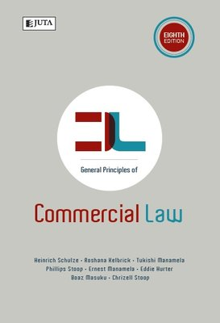

GENERAL PRINCIPLES OF COMMERCIAL LAW
By Heinrich Schulze. Roshana Kelbrick. Tukishi Manamela. Philip Stoop. Ernest Manamela. Eddie Hurter. Boaz Masuku. Chrizell Stoop

Eight Edition
(567 pages)

Juta & Co. Ltd
www.jutalaw.co.za

First published in 1992, this updated edition serves as an excellent introductory guide for a broad range of non-lawyers who need an understanding of the general principles of commercial law in South Africa.
Written by an experienced team from the Department of Mercantile Law at the University of South Africa, the text is readable and concise and provides an overview of the fundamental concepts of the law of contract and corporate law. It also deals with specific contracts such as sale, lease, insurance and credit agreements. Aspects of commercial law covered include agency, labour law, franchising, competition, banking, consumer protection, insolvency and trusts.
The book is also available in Afrikaans as Algemene Beginsels van Kommersiële Reg. Publisher Juta and the authors have geared the contents to meet the requirements not only of students across the board, but also the emerging small and medium-sized business sector. The selection of topics was influenced by the competency framework of the South African Institute for Chartered Accountants and also the syllabus for law courses of the Institute of Bankers.
Well-indexed, well-organised, with references to further reading and sources at the end of each of the 30 chapters, this is a highly recommended on-your-desk reference.
Review by Louis Rood, BA LLB (UCT), Chairman of Fairbridges Attorneys in Cape Town.

