Testing done on www.juta-academic-staging.byteorbit.com

Test | Pass/fail | Comments
Admin can add support item | Pass
Admin can amend support item | Pass
Admin can publish support item | Pass
Admin can Unpublish support material item | Pass
Admin can add image to support item | Pass
Admin can remove image from support item | Pass
Admin can add sample support resource | Pass
Admin can remove the sample support material | Fail | If there is no sample, the link still displays.
User can access support sample | Pass | “View Sample Support Material” label must change to “View Sample”
Admin can delete support material item | Fail | If support material is soft-deleted it should not display on the site.
Admin can add resources | Pass | Not all resources not appearing on FE Only URL’s are showing (On Support Material page) (All resources are showing on the “My Resources” page though)  Styling must be addressed – only first item has a bullet point  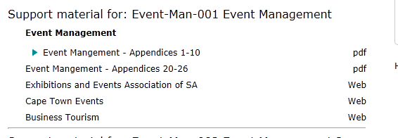
Admin can remove resources from a support item | Pass
Admin can add more than one resource to an item. | Pass
User can access support resource | Fail | Can not access URL link from FE:  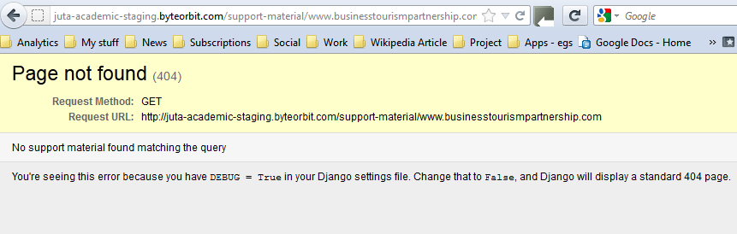  Link must open in separate window
Admin can add course | Pass | Label for “Course Products” should be “Prescribed Textbooks”
Admin can amend course information | Pass | Add student no’s, remove student no’s, add/remove products were tested
Admin can set a course to expire by clicking on “Expired” checkbox. | Pass
Admin can set a course to expire by changing the expiry date | Fail | The course detail is saved, but the state of the course is not changed to expired and the student can continue to access support material.
Admin can delete courses | Pass
Admin can upload a list of student numbers. | Pass
Remove list of students | Fail | When the “Clear” option is selected, the list is not cleared and a message is displayed.  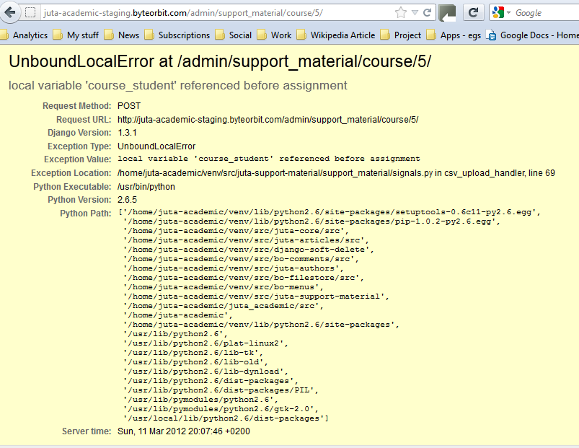  Can’t reupload a list – csv is shown as “Current”, but the list is empty  Clearing the list should rather be separated from the CSV file, as the changes here apply to the whole list, not just those items uploaded in the CSV. Change this to “Toggle” select all / unselect all items that can be deleted.
Admin can remove individual student numbers | Pass
Admin can add individual student numbers | Pass
Admin can add a student to more than one course and student can access multiple support material items and resources. | Pass
Create student user: with matching student number | Pass | The profile is created, but get this error message on “Submit”:  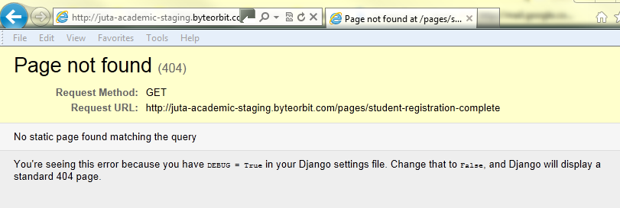  Student user does not have a space for the student number in the BE. Only Course code (Applicable only to lecturers)
Create student user: without matching student number | Fail | The system must reapply the check of the student number when the user has made a change to the number during the registration process.  Currently, the test is only done once, if the user goes back to the first page of the registration from the lightbox message and makes a change to the student number, the system does not re-check the number against the student list.
Create lecturer user: without course | Pass | The profile is created, but get an error message on submit. 404 page not found (Same as above)
Admin can approve lecturer course | Pass | When a lecturer goes onto the “My Resources”page before their course has been approved, the system offers a message “None of your registered courses has been approved”, but when they have been approved the message stays the same if the course is not in the system. Screen messages for login processes need to be written along the same lines as those written for the registration processes (I will take care of these WM)
Create lecturer user: with course | Pass | The profile is created, but get an error message on submit. 404 page not found (Same as above)
General issues:
- The system must not keep the user logged in when the browser has been closed (Backend and Frontend)
- List of products in the backend must default to show only academic titles.
- “Add academic product” must be renamed to “Add product” (BE)
- Product categories, when uploading images must only show academic’s categories. Categories in the “categories” list in the backend do not show when uploading images.
- After uploading image to image store, click on save and the window doesn’t go away. Have to manually close the window and then reselect the item to upload. Sometimes, the content of the window goes away and a blank window remains, but sometimes the text remains and has to be closed. (see #31 on BB)
- From within product – click on Add author – create new author. The author is not selected after it’s been created – have to go back and select it a second time. (see #31 on BB)
- Page extent should not only allow numerical values, but alpha characters too.
- Support material widget is showing regardless of whether a product has support material or not (FE)
- The styling of the sub-heading of a product item must be improved – maybe slightly bigger font/bold?
- Description of Support material item must be widened (FE)

