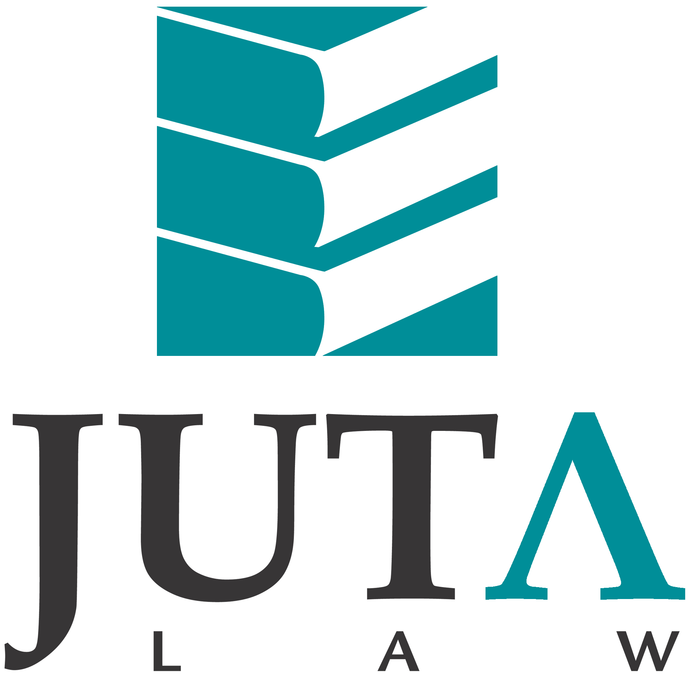

JUTA'S TAX LAW REVIEW

AUGUST 2011

Dear Subscriber to Juta's Tax publications
Welcome to the August edition of Juta's Tax Law Review. We thank you for your constructive suggestions and comments about this electronic review.

Allow us to communicate with you in accordance with the Consumer Protection Act 68 of 2008 Register now for newsletters, notifications of new editions and law titles of interest to you!
To keep you informed of important legal developments and engage in direct marketing activities in accordance with the Consumer Protection Act, we need your permission to communicate with you. Please register to receive information and updates based on your particular areas of interest. Click on the appropriate link in the footer of this e-mail to register and manage your Juta subscriber profile. Customers may unsubscribe from receiving newsletters or marketing material at any time.
Should you require any assistance regarding the creating of your profile or updating of your existing profile please contact Customer Services for assistance on www.cserv@juta.co.za

SOME POINTS ABOUT THE CASE NOTES:
The case notes, classified by subject, are not intended as comprehensive summaries of the various judgments referred to. Rather, their focus is to identify those aspects most likely to be of interest to tax practitioners, and to provide a concise evaluative commentary.
Following each case note is a link to the full text of the judgment on Juta Law's website. The successive reviews and judgments are incorporated in your Juta's Tax Library, providing a comprehensive record of tax case law.
Please continue to send feedback to the publisher, Anita Kleinsmidt (akleinsmidt@juta.co.za)
Kind regards
The Juta Law Marketing Team

TAX COURT
Retirement Benefits
Case number 2011/12895: XYZ v CSARS

Where no ambiguity exists, the meaning of the legislature should be found in the words used.

The facts of the case were briefly that a dispute arose whether the pre 1 March 1998 benefits still apply after the introduction on 29 June 1998 of para (eA)(ii) of the definition of ‘gross income’. Under the above-mentioned paragraph two-thirds of an amount from a pension fund is included in gross income.

The taxpayer argued that despite the use by the legislature of the word ‘amount payable’ in para (eA)(ii) it was never the intention to include benefits that were exempt prior to 29 June 1998 in gross income. This is made clear in the Explanatory Memorandum issued with the Bill that introduced para (eA) to the gross income definition. To hold otherwise would mean that para (eA) has retrospective application. SARS, on the other hand, argued that where the intention of the legislature is clear, no room exists to seek the intention of the legislature in, for example, the explanatory memorandum.

The court looked at previous recent judgments in which a so-called purposive approach was followed and held that in the absence of ambiguity no room exists to find the intention of the legislature other than in the words used by it. As a result, the taxpayer was not entitled to exclude from the withdrawal benefit, benefits that were exempt from tax prior to 1 March 1998.
HIGH COURT
Place of Effective Management
Case number 2011/22556/09: The Oceanic Trust Co Ltd NO v SISM

The place of effective management of a trust is where the key management and commercial decisions that are necessary for the conduct of the trust’s business are in substance made.

The facts of case were briefly that the trust applied to court for a declaratory order that it was not resident in South Africa and that it did not conduct business in this country through a permanent establishment, The applicant, a company registered and incorporated in Mauritius, is the sole trustee of a trust, Specialised Insurance Solutions, (Mauritius) (‘SISM’) which was established and registered in Mauritius on 23 November 2000. The trust deed provided that the trust would be governed by the law of Mauritius and that the business of the trust will be conducted from premises in Mauritius.

SARS required information from SISM under the provisions of s 74A of the Income Tax Act. SISM responded and subsequent to these correspondence SARS issued an assessment in excess of R1,5 billion inter alia on the basis that as SISM had its place of effective management in South Africa, it was a resident of South Africa. Alternatively, if SISM was not a South African resident, it was still taxable as the source of the income was in South Africa. SARS also gave the taxpayer notice that it intends filing a certificate under s 91(1)(b) for the amount, of which the effect would be that a tax court order was obtained. SARS also appointed Standard Bank as the trustee’s agent under which appointment Standard Bank paid over R20m.

SISM approached the High Court for a declaratory order that:
- it was not a South African resident;
- it did not conduct business in South Africa through a permanent establishment for purposes of the non-resident interest deduction in s 10(1)(h); and
- SARS had to repay the R20m paid on behalf of SISM under the agency provision.

The first issue before the High Court was whether the trust was attempting to avoid the assessment by asking the court for a declaratory order. The court found that as the taxpayer did not ask the court to express a view on the validity of the assessment, but merely to find whether it was a South African resident or not, it was entitled to ask for a declaratory order regarding its tax status.

In deciding whether SISM was resident in South Africa, the judge analysed the tax treaty between South Africa and held that the trust would be resident where its place of effective management is situated. The High Court made it clear that it would adjudicate on the matter as long as the facts were not in dispute.

Regarding the meaning of the term ‘place of effective management’ (‘POEM’), the court accepted the taxpayer’s reliance on a recent decision of the England and Wales Court of Appeal in Commissioner for Her Majesty’s Revenue and Customs v Smallwood and Anor [2010] EWCA Civ 778 delivered on 10 July 2010 in which it was held that the POEM of a trust is where the key management and commercial decisions that are necessary for the conduct of the entity’s business are in substance made. Although no definite rule can be laid down as all relevant facts and circumstances need to be examined, an entity’s place of effective management will ordinarily be where the most senior group of people (eg the board of directors) makes its decision or where the actions taken by the entity as a whole are determined.

On the facts of the particular case, the court held that, on the basis of the Smallwood test, the possibility could not be excluded that SISM’s place of effective management was in South Africa.

(Editorial comment: It is submitted that it would be wrong to use the case as authority for the view that the place of effective management is always where the central management of an entity is situated. Not only did the court make it clear that all factors have to be taken into account, but it also merely decided the case on the test laid down in the Smallwood decision. It did not decide that the test in the Smallwood decision is the only test.)

The test to determine whether the SISM had a permanent establishment in South Africa does not depend on whether it carried on business wholly or partly through a fixed place of business in South Africa. As the High Court does not have jurisdiction to make factual findings, the court could not rule on the question.

As far as the third issue was concerned, the court also dismissed the application. An agent can only be appointed under s 99 for taxes that are due. Although the agent was appointed after the assessment was issued, the tax was only due on or after the date set for payment. However, interest on the outstanding amount was immediately payable once the assessment was raised.

As a result the court refused to grant the declaratory order and dismissed the application with cost.

Suspension of Payment
Case number 2010/26078: Capstone 556 (Pty) Ltd v CSARS and Kluh Investments (Pty) Ltd v CSARS

The amended s 88, which provides for a list of factors that SARS has to take into account to decide whether to suspend payment of tax, is only a confirmation of its existing practice.

Section 88 gives SARS the right to suspend payment of outstanding taxes. The section was amended to provide for a specific list of factors to be taken into account in deciding whether payment should be suspended.

Exchange Control
Case number 2010/295: Oilwell (Pty) Ltd v Protec International Ltd 2011 (4) SA 394 (SCA)]

The absence of the necessary exchange control approval does not render a transaction null and void.

The facts of the Oilwell case were briefly that a South African resident disposed of a trademark to a non-resident without any approval. Oilwell, a South African company, relied on the decision in Couve and Another v Reddot International (Pty) Ltd and Another 2004 (6) SA 425 (W), in which it was argued that rights to patent applications were capital and that an assignment of such rights by a resident to a non-resident without approval of the South African Reserve Bank was invalid as it contravened regulation 10(1)(c).

The court held that legislation that creates criminal and administrative penalties, as the Exchange Control Regulations do, should be interpreted restrictively. The court held that:
- A trade mark does not qualify as ‘capital’ or a ‘right to capital’ and as a result regulation 10(1)(c) should not be interpreted to include the assignment of a trade mark;
- A trade mark, similar to other intellectual property rights, is territorial in nature and can as a result not be ‘exported’.
- Where Exchange Control approval was not obtained for the assignment of a trademark, the transaction is not ab initio null and void.
- It is theoretically possible to obtain exchange control approval ex post facto.

Editorial comment: Although the transaction is not null and void, it will still be regarded as disposal for the purposes of capital gains tax. Alternatively, depending on whether any deductions were previously claimed the trademark, a recoupment may also arise.

Payment of Outstanding Tax Debts
Case number 2008/54768: King v CSARS

SARS may sell immovable property to collect outstanding taxes.

The facts of the case were that Mr King resisted sale in execution by SARS of immovable property owned by him on the basis that SARS had an ulterior motive in selling the property. Mr King argued that as his tax debt far exceeded the value of the immovable property, selling the immovable property is not an effective remedy. SARS thus merely wants to sell the immovable property to harass and embarrass him.

The High Court found on the facts of the case that SARS had no ulterior motive in selling the immovable property, but merely wanted to collect outstanding taxes.

VAT
Case number 2010/A6421: CSARS v Fastmould Specialist CC

An assessment is not always required before SARS can file a certificate with a competent court in an attempt to collect outstanding taxes.

On 18 February 2010 SARS filed a certificate with a magistrate court for outstanding VAT and employees’ tax. On 28 July 2010 the judgment was rescinded. SARS then appealed against the rescission.

On the basis of the decision in Singh v CSARS 2003 (4) SA 520 (SCA), the taxpayer argued that SARS could not file a certificate to collect outstanding taxes, before the issuing of an assessment. The court did not agree. In the case of outstanding VAT no certificate has to be issued. As the taxpayer submitted returns stating its VAT liability and as SARS accepted these returns, no need arose for SARS to issue an assessment. VAT becomes due the moment SARS accepts the correctness of the vendor’s return. In the Singh case it was made clear that SARS may start collection procedures once an amount is due. As in the Singh case an assessment was raised but no notice given to the taxpayer, that case can be distinguished from the present case.

